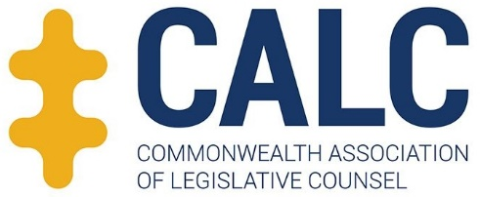 | 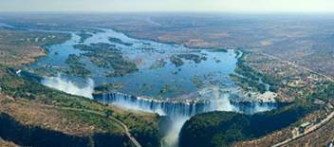
Change and continuity in legislative drafting
1-3 April 2019 – Avani Hotel, Livingstone, Zambia
Personal information: First Name…………………..
Surname
Title |  | Name of organisation
Address |  |  |  |  | Tel
Postal code Tel …………..…………
Email
Reception and Dinner
I will attend the reception at the Avani Hotel (1 April 2019.) Yes No
I will attend the dinner at the Avani Hotel (3 April 2019.) Yes No
Guest(s) Yes No
Guest(s) name(s)
Dietary Restrictions No Yes Which
Fees and Payment
The Conference fee is $450USD (or GBP equivalent – £350); includes both reception and dinner
The Guest fee is $60USD (or GBP equivalent – £45) for each guest; includes both the reception and dinner
Payment can be made either by PayPal or Bank Transfer. Payment details will be included on your invoice.
Cancellation
Before February 24: $25USD (£20GBP)
February 25-March 24: 50% of registration fees
After March 24: No refund
At any time, a participant may be replaced by another person without charge.
Accommodation:
Participants are required to make their own hotel reservations. The conference hotel is the Avani Hotel, Livingstone. CALC members attending can book accommodation there using this link.
Registration
Participants are encouraged to register for the conference as quickly as possible as the number wishing to attend the last two CALC conferences exceeded the number of places available.
Please register by 11 March 2019. Later applications may not be accepted.
Email this completed form to calc.treas@gmail.com to register and receive an invoice

