|  |
| --- |
| Newsletter |

Published in Canberra, Australia, by the Commonwealth Association of Legislative Counsel

**Online** at [calc.ngo/publications/newsletters](http://www.calc.ngo/publications/newsletters)

Editor: Ross Carter, c/- Parliamentary Counsel Office, Level 13 Reserve Bank Building, No 2 The Terrace, Wellington, New Zealand.

In this issue―

CALC President’s Report—December 2020 2

Recent case law in the UK, Canada, and New Zealand 6

Some items of interest 8

Bennion, Bailey, & Norbury on Statutory Interpretation 6

New CALC members 10

Secretary’s contact details 11

## If you would like to join CALC, use our [online registration form](http://www.calc.ngo/user/register).

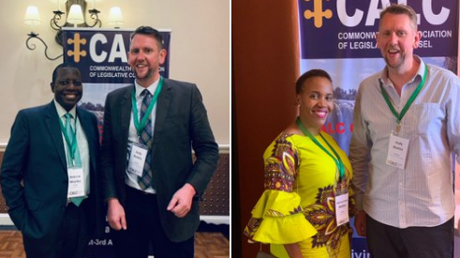

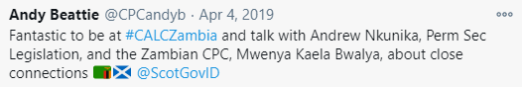

## CALC President’s Report—December 2020

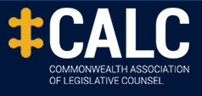

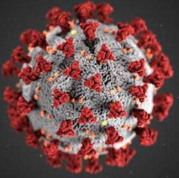

Dear CALC members

**COVID-19 pandemic**

As the world continues to be ravaged by the pandemic, I hope that all CALC members and their families, friends, and colleagues remain safe and well.

**Cancellation of CALC biennial conference, July 2021**

In the September 2020 *CALC Newsletter*, I reported that your CALC Council had agreed that, since the circumstances that will exist in 2021, especially with respect to international travel, are impossible to predict, remaining flexible with respect to conference arrangements seemed the best approach at that stage. The Council agreed at a virtual meeting that the Council should continue to explore arrangements for a physical conference in 2021, but should also investigate an online option.

With just over 6 months until the scheduled conference, the Council has reassessed the situation. It seems clear from the current state of the world that a physical conference in July 2021 is out of the question. It is highly doubtful that international travel will be possible then, even with the vaccines that are now becoming available.

The Council has therefore decided to cancel the July 2021 biennial conference. Consideration was given to whether the conference could be held later in 2021, after the hurricane season in the Caribbean. For several reasons, including the cost of holding conferences later in the year and the sitting schedules of legislatures in many jurisdictions at that time of year, this was not considered feasible.

The Council also considered whether a virtual conference should be held instead of a physical conference. The view of Council members was that this would not be a viable substitute for a physical conference with an ordinary general meeting. One of the attractions and great benefits of CALC conferences is the opportunity to meet in person.

At an appropriate time next year, your Council will consider whether it is feasible to hold a physical conference (with ordinary general meeting) in 2022. It is hoped that this conference could still be held in The Bahamas.

I thank the working groups formed by the CALC Council to organise and deliver the 2021 conference in The Bahamas. This work will be of great assistance in organising the conference that we now hope to deliver in 2022.

**Virtual conference(s) planned for 2021**

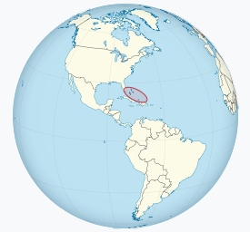The Council has agreed to look to organise a short virtual conference, or a series of short regionally focussed virtual conferences, in 2021. CALC has invested in Zoom webinar software, and this was successfully used for a webinar held by the Australasia and the Pacific region last week (*see* below).

More details will be provided in the next *CALC Newsletter* early next year.

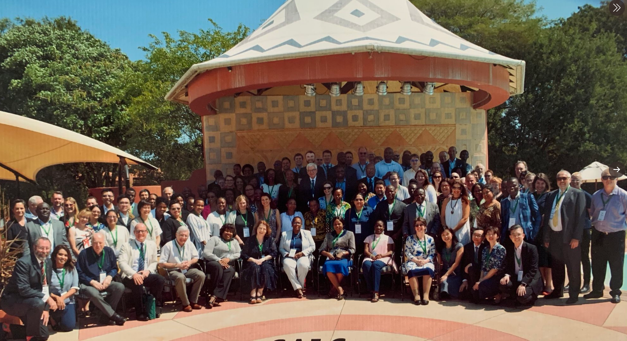

**Commonwealth Lawyers Association conference, September 2021**

At this stage, the CLA is still planning to hold its biennial conference in September 2021 in The Bahamas. Any CALC members who attend that conference (if it proceeds) might consider gathering informally at the conference.

Registration details for the CLA conference are available at—

[www.commonwealthlawyers.com/clc-2021/#CLC20201_programme](http://www.commonwealthlawyers.com/clc-2021/#CLC20201_programme)

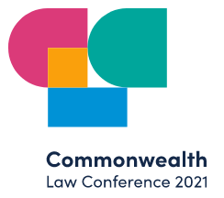



**Inaugural CALC webinar held by Australasia and the Pacific Region**

The Australasia and the Pacific region of CALC hosted a webinar on Friday, 11 December 2020. Drafting offices from New Zealand, Canberra (Commonwealth), Queensland, Victoria and Western Australia participated in the webinar. Contributors from each jurisdiction discussed the legislative responses to the pandemic in their jurisdictions, the impact of the pandemic on their offices and lessons learned from the pandemic. CALC members who attended the webinar were able to pose questions for the panel to respond to.

This webinar was recorded, and will (if practicable) be made available to CALC members via CALC’s website: [www.calc.ngo](http://www.calc.ngo).

Feedback from attendees indicates that the webinar format proved very successful, and CALC hopes that it will be possible for similar webinars to be hosted by other CALC regions early next year.

**Compliments of the season and very best wishes for 2021**

Finally, I wish everyone the compliments of the season, and a safe and productive 2021.

 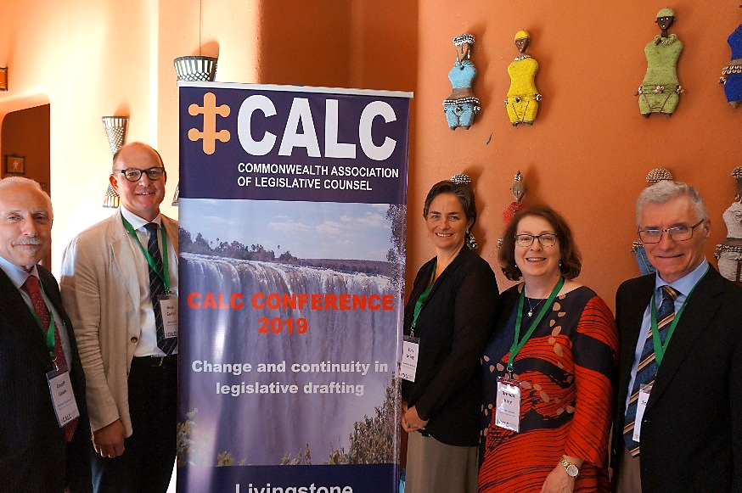

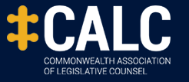

Geoff Lawn

CALC President, December 2020

**Recent case law in the UK, Canada, and New Zealand**

In the UK, the EWCA on 1 December 2020 dismissed a challenge to lockdown regulations. Contrary to [Lord Sumption’s recent Covid-19 Lecture](https://www.youtube.com/watch?app=desktop&v=amDv2gk8aa0) ([transcript here](https://resources.law.cam.ac.uk/privatelaw/Freshfields_Lecture_2020_Government_by_Decree.pdf)), the Court of Appeal did not use the principle of legality to read down, and so perhaps hold to be unfit for purpose, regulation-making powers in the Public Health (Control of Disease) Act 1984 (UK).

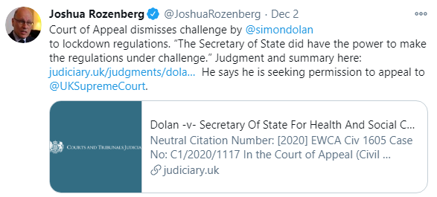

<https://www.judiciary.uk/judgments/dolan-v-secretary-of-state-for-health-and-social-care-2/>

The UKSC later refused permission to appeal:

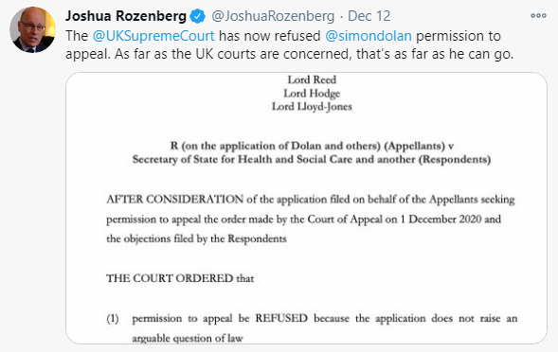

In Canada, the Canadian Lawyer includes [a story](https://www.canadianlawyermag.com/practice-areas/litigation/hudsons-bay-co.-asks-for-judicial-review-of-retail-lockdown-measures-in-toronto-and-peel-region/336159?utm_source=GA&utm_medium=20201215&utm_campaign=LTW-Newsletter-20201215&utm_content=6C1524AC-991C-413E-BCA2-BD02E0648C7E&tu=6C1524AC-991C-413E-BCA2-BD02E0648C7E) about a court challenge to some pandemic regulations. It is being brought by one of Canada’s largest retail chains and is largely based on the differential application of the regulations:





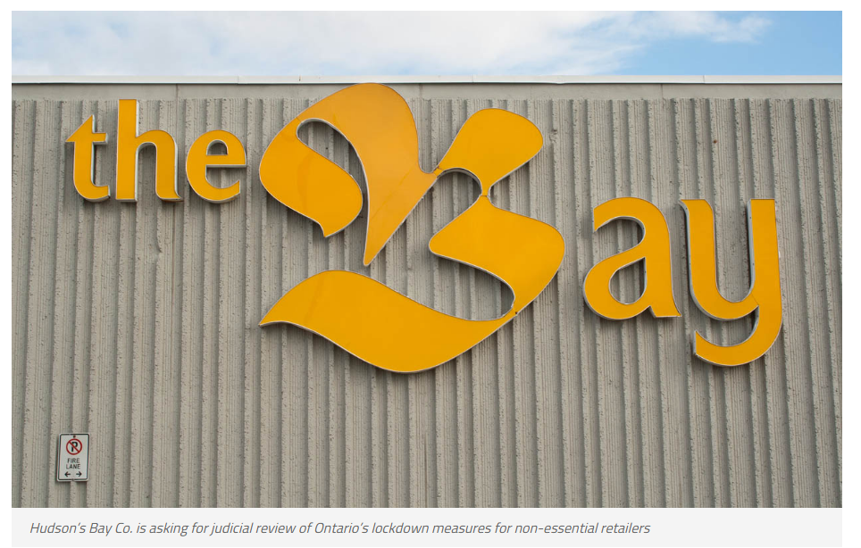



In New Zealand, [this item](https://adls.org.nz/Story?Action=View&Story_id=213) confirms Dr Jim Farmer QC has been briefed on the NZCA Borrowdale case, which was a challenge to secondary legislation and government announcements.

See the High Court’s decision [here](https://www.courtsofnz.govt.nz/cases/borrowdale-v-director-general-of-health-1-1).

Earlier, barrister Tiho Mijatov appeared for Borrowdale.

Victoria Casey QC is instructed to appear again for the Crown.

Some items of interest

**Pacific Islands Toolkit: From policy to legislation**

Congratulations to the Pacific Islands Law Officers' Network (PILON) and Australian Attorney-

General's Department on launching this Toolkit.

The Toolkit is available for download [here](https://pilonsec.org/digital-library/pacific-toolkit/).



**Improving public access to New Zealand case law – judgments as data**

[This recent report](https://static1.squarespace.com/static/5ca2c7abc2ff614d3d0f74b5/t/5fcfce15053015467a40e5e1/1607454251991/Judgments+as+data+-+9+December+2020.pdf) is of great interest, and mentions NZ PCO's access functions (eg, at [34], [185], and [262]). Among other things, it says "Given the expertise [NZ] PCO already holds, and the broad similarity between its present tasks and the task of making case law digital-first, [NZ] PCO may be a place to go to for guidance and advice." The report could prompt much-needed improvements in free public access to (mostly publicly-funded) case law.

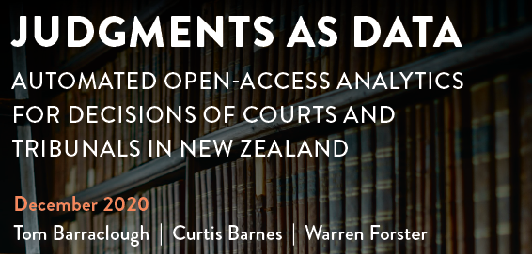

**Seasonal humour**



**Bennion, Bailey, & Norbury on Statutory Interpretation**

On 24 November 2020, CALC member Luke Norbury Tweeted, “Delighted to have finished reading the proofs for the next edition of *Bennion on Statutory Interpretation*. Can’t wait to see it in print.”

UK First Parliamentary Counsel Elizabeth Gardiner responded: “Your [OPC UK](https://www.gov.uk/government/organisations/office-of-the-parliamentary-counsel) colleagues also looking forward to seeing the new edition. Well done Luke Norbury and Diggory Bailey.”

On 25 November 2020, Luke Norbury responded: “Many thanks. A great addition for [this edition](https://www.lexisnexis.co.uk/store/products/bennion-bailey-and-norbury-on-statutory-interpretation-eighth-edition-skuuksku9781474316729BSI884859/details) is material on devolved legislation. For that we have to thank our contributing editors, Michael Anderson (from Scotland’s Parliamentary Counsel Office) and Dr James George (from the Office of the Legislative Counsel, Wales).

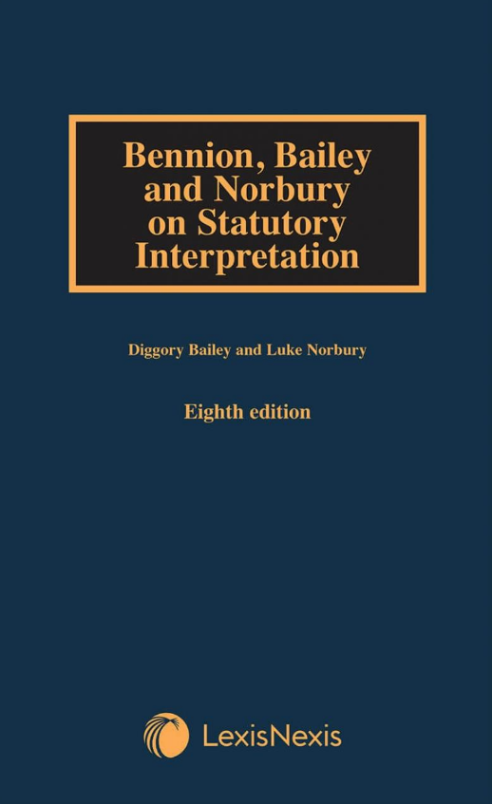

New CALC members

**New members since 14 September 2020**

The following have been recorded as members of CALC (a) since 14 September 2020 (the date when new members were last listed in the *CALC* *Newsletter* (September 2020 edition, as published on 15 September 2020), and (b) as at 16 December 2020.

| Name | Country | |
| --- | --- | --- |
| Craig, Paula | Canada |
| Green, Michael SC | Australia |
| Hj Md Salleh, Muhammad Alif | Brunei Darussalam |
| Lakim, Siti Aisyah | Brunei Darussalam |
| Nayan, Qhairul Azim | Brunei Darussalam |
| Serudin, Marrina | Brunei Darussalam |
| Grassie, Philip | Canada |
| Robertson, Mikaela | Canada |
| Szach, Natasha | Canada |
| Khadoo, Vishala | Trinidad and Tobago |
| Kohler, Manfred | Belgium |
| Boisvert, Andrée-Anne | Canada |
| Franklyn, Moureeze | Saint Vincent and The Grenadines |
| Mukunga, Marshall | Kenya |
| Zachar, Peter | Canada |
| Philip, John | Australia |
| Graham, Aveta | Canada |
| Jibril Madaki, Ibrahim | Nigeria |
| Tang, Oscar | United Kingdom |
| Masombuka, Elizabeth Lucy | South Africa |
| Guma, Jackie Bukaayi | Uganda |
| Kimaid, Luís | Brazil |
| Audet, Julie | Canada |
| Bruce, Adam CD | Canada |
| Shaumbwako, Saara Hanganeni | Namibia |
| Cucerzan, Megan | New Zealand |
| Ibrahim Yusuf, Abubakar | Nigeria |
| Bush, Gerard James | Australia |
| Cross, James | Australia |
| Miles, Andrew | Australia |
| Mills, Hikurangi | New Zealand |
| Munshi-Kurian, Akanksha | New Zealand |
| O'Hea, Jennnifer | United Kingdom |
| Pagano, Catherine | United States |
| Chaloner, Eve | Australia |
| Chua, Janna | Singapore |



## Secretary Contact Details

To contact CALC’s Secretary, Ross Carter, about membership or any other CALC matters (for example, to suggest or send items for this *CALC Newsletter*), email: [ross.carter@pco.govt.nz](mailto:ross.carter@pco.govt.nz)

 

(Old New Zealand newspaper headlines — courtesy of [Papers Past](https://paperspast.natlib.govt.nz/newspapers/))