|  |
| --- |
| Newsletter |

Published in Canberra, Australia, by the Commonwealth Association of Legislative Counsel

**Online** at [calc.ngo/publications/newsletters](http://www.calc.ngo/publications/newsletters)

Editor: Ross Carter, c/- Parliamentary Counsel Office, Level 13 Reserve Bank Building, No 2 The Terrace, Wellington, New Zealand.

In this issue―

CALC President’s Report—February 2022 2

Australian Capital Territory (ACT), Australia: Mary Toohey, PSM, Parliamentary Counsel (2016–2021) 4

British Columbia, Canada: New Chief Legislative Counsel, Kevin Kohan 5

Victoria, Australia: New Chief Parliamentary Counsel, Jayne Atkins 5

United Kingdom: New *Guide to Making Legislation* 6

Helen Xanthaki’s Book on *Drafting Legislation* Published in Chinese 7

Revised edition of Singapore’s Statute Book 8

UKSC decision on vires and interpretation informed by context 9

Webinar on 16 February 2022: use of defined terms 13

New CALC members 14

Secretary’s contact details 15

## 

## Flags of Australian Capital Territory, British Columbia, State of Victoria (Australia), UK, Singapore, Western Australia

## If you would like to join CALC, use our [online registration form](http://www.calc.ngo/user/register).

## CALC President’s Report—February 2022

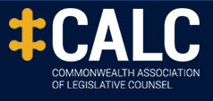

Dear CALC members

**Greetings and update**

Greetings once again to you all, and a belated Happy New Year for 2022.

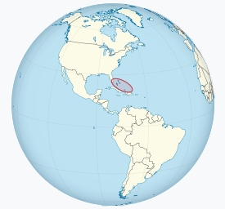



At its last meeting on 22 October 2021, the Council discussed the timing of the next conference and agreed that, since the last conference was held in 2019, and because the CALC Constitution requires a general meeting at least every 5 years, planning should begin for a conference in 2022 in The Bahamas.

As I reported in the previous *Newsletter*, the Council agreed that consideration would be given to a hybrid conference, with the conference being held in-person but with the option of virtual attendance (live streaming) for some or all of the conference. The option of a wholly virtual conference would also be investigated, in case an in-person conference was unable to proceed. If only a virtual conference could be held, the election of a new CALC Council would be conducted electronically.

It became clear at the beginning of this year that the rapid spread of the Omicron variant of the COVID-19 virus means that, regrettably, it would not be possible to hold an in-person conference in The Bahamas in 2022. Your Council has therefore decided that the 2022 conference will be virtual only, with an election of a new Council to be conducted electronically.

Your Council is beginning the planning for the format, content, and timing of the virtual conference, and details will be announced in due course. We appreciate that a virtual conference is not a true substitute for a physical conference, given that the attractions and great benefits of CALC conferences is the opportunity to meet in person. Nevertheless, we aim to provide a virtual conference that, to the greatest extent possible within the constraints of that format, provides members with relevant, useful and stimulating content.

The CALC Council Governance Working Group, chaired by Ross Carter, has been investigating options for using electronic voting for CALC Council elections. A trial of the proposed electronic system will be undertaken shortly, ahead of its use at the Council election later this year.

**Best wishes**

Best wishes to all CALC members and their families, friends and colleagues.

Please feel free to contact me or any CALC Council member about any matter relating to CALC.

I can be contacted on [geoff.lawn@pco.wa.gov.au](mailto:geoff.lawn@pco.wa.gov.au). Contact details for other CALC Council members are in the Members’ Area on the CALC website. See <https://www.calc.ngo/contact-details-calc-council>.

Stay safe.

 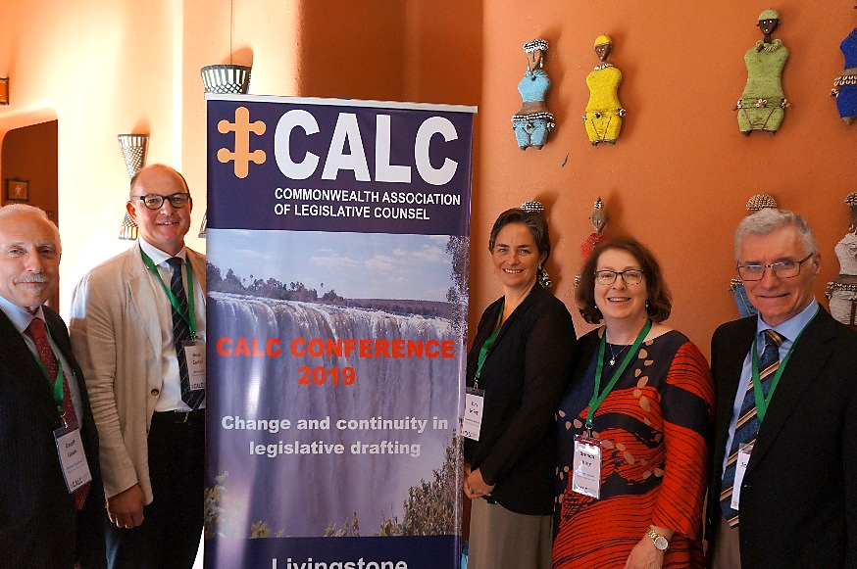

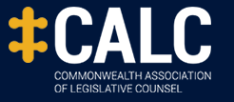

Geoff Lawn

CALC President, February 2022



**Australian Capital Territory (ACT), Australia:**

**Mary Toohey, PSM, Parliamentary Counsel (2016–2021)**



Mary Toohey, the former head of the [Australian Capital Territory Parliamentary Counsel’s Office](https://www.pco.act.gov.au/pages/contact.htm) (headed since 2021 by Parliamentary Counsel Bianca Kimber), has been awarded a Public Service Medal for “outstanding public service to law reform in the Australian Capital Territory and supporting the response to the COVID-19 pandemic”. The [citation](https://www.gg.gov.au/sites/default/files/2022-01/ad22_media_notes_-_meritorious.pdf) is as follows:

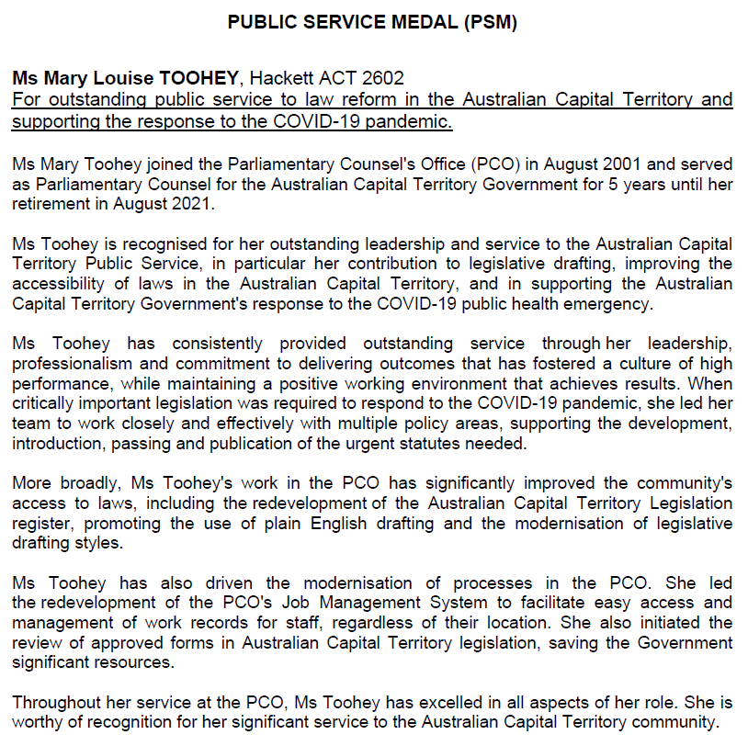

**British Columbia, Canada: New Chief Legislative Counsel, Kevin Kohan**

Congratulations to Kevin Kohan on his appointment as British Columbia’s new Chief Legislative Counsel, effective 17 January 2022.

Kevin grew up in Saskatchewan and was called to that province’s Bar in 1997. The following year he received his PhD in English, and was called to the B.C. Bar in 2003. Kevin has been with [the BC OLC](https://dir.gov.bc.ca/gtds.cgi?show=Branch&organizationCode=AG&organizationalUnitCode=LEG) since 2004, drafting in many different, and complex, areas including energy, environment, insurance, transportation, court rules and government re-organizations. Kevin was appointed senior counsel in 2019, and has acted as Chief Legislative Counsel on multiple occasions.

Kevin takes office on the retirement as Chief Legislative Counsel (2011–2022) of Corinne Swystun, QC (also Secretary and Former President of the Association of Legislative Counsel, Canada). Barbara Carmichael, QC, Assistant Deputy Attorney General, thanked Corinne for her leadership, expertise, and dedication as Chief Legislative Counsel. All the best to Corinne in retirement from that role.

**Victoria, Australia:**

**New Chief Parliamentary Counsel, Jayne Atkins**

Congratulations to Jayne Atkins on her appointment in 2022 as Chief Parliamentary Counsel, Victoria.

Jayne was Deputy Chief Parliamentary Counsel and Subordinate Legislation Manager since 2013, and formerly Subordinate Legislation Advisor and a Principal Parliamentary Counsel from 2006. She joined the Office of Chief Parliamentary Counsel in March 1991 after 4 years at State Trustees as a solicitor. In 2016, Jayne was a steward of the Victorian OCPC for 5 months after the retirement as Chief Parliamentary Counsel for Victoria (2008–2016) of Mrs Gemma Varley, PSM.

Jayne is supported in her role by Jim Soundias (Deputy Chief Parliamentary Counsel), and Catherine Schipano (Assistant Chief Parliamentary Counsel).

Marina Farnan retired as Chief Parliamentary Counsel, Victoria, on 17 January 2022.

All the best to Marina in her retirement from that role (2017–2022). Marina commenced her career in  the Australian Public Service in 1986 as a graduate, before moving to the Department of the Prime Minister and Cabinet. Marina worked in various legal and policy roles before joining the Commonwealth Office of Parliamentary Counsel in 1993. Marina was appointed Second Parliamentary Counsel in that office in 2005, and was in her second term in that role before taking up appointment in Victoria in 2017.

**United Kingdom: New *Guide to Making Legislation***

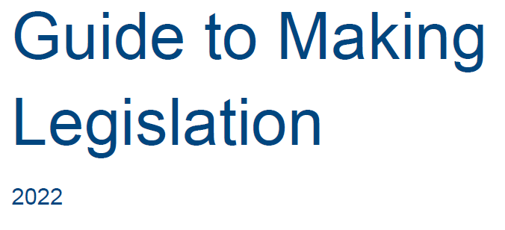

The UK Government Cabinet Office has recently issued a new [*Guide to Making Legislation* (2022)](https://assets.publishing.service.gov.uk/government/uploads/system/uploads/attachment_data/file/1048567/guide-to-making-legislation-2022.pdf).

The *Guide* was prepared by the Secretariat to the Parliamentary Business and Legislation (PBL) Cabinet Committee, a part of the Cabinet Secretariat at the Cabinet Office. It was produced together with the advice of Parliamentary Counsel and the Offices of the Commons Chief Whip, Lords Chief Whip, Leader of the House of Commons, Leader of the House of Lords, the Public Bill Offices of both Houses and officials in other government departments.

It covers the procedures to be followed in preparing primary legislation and taking it through

Parliament, setting out what is required of bill teams at each stage of the process. It should

answer the most commonly asked questions but should not be regarded as an authoritative

statement of parliamentary practice. Parliamentary Counsel (who may in turn consult the House authorities), the Whips Offices or the Public Bill Offices should always be consulted

on matters of procedure.

The *Guide* is written with the needs of departmental teams in mind, to help them manage

their work effectively throughout the process of preparing legislation and taking it through

Parliament. It describes the main features of the normal legislative process but cannot cover

every possible circumstance: every bill is different.

The different stages are dealt with in chronological order. A summary of key points is provided at the start of each chapter.

Checklists for each stage are included in Appendix D.

A link to the *Guide* is also on [the Drafting Manuals and Other Resources page](http://www.calc.ngo/drafting-manuals-and-other-resources) at [www.calc.ngo](http://www.calc.ngo/).

**Helen Xanthaki’s Book on *Drafting Legislation* Published in Chinese**

On 31 January 2022, the [International Association of Legislation (IAL)](https://ial-online.org/helen-xanthakis-book-on-legislative-drafting-published-in-chinese/) noted [Professor Helen Xanthaki’s Book on Drafting](https://www.bloomsbury.com/uk/drafting-legislation-9781849464284/) Legislation has been published in Chinese:

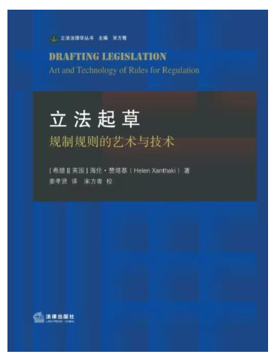

[**Drafting Legislation: The Art and Technology of Rules for Regulation**](https://www.bloomsbury.com/uk/drafting-legislation-9781849464284/), Prof. Helen Xanthaki’s representative opus, now is published in Chinese by Law Press China. The Chinese edition is translated by Dr. Xiaoxian Jiang, who is an assistant professor at Xiamen University and also the first Chinese member of IAL. Xiaoxian has worked closely with Prof. Xanthaki over a period of two years.  
  
Law Press China and many Chinese lawyers believe that this book would lead and prompt legislative drafting as a displine in China.

We wish there will be more academic communications between IAL and Chinese environment of legislation and legisprudence.

Revised edition of Singapore’s Statute Book

[The first universal revision of Singapore's laws since 1985 was launched on 31 December 2021.](https://www.channelnewsasia.com/singapore/singapore-statute-book-laws-simpler-language-universal-revision-2388911) [The 2020 revised edition of Acts](https://sso.agc.gov.sg/What's-New/Announcements/Article/28/New-2020-Revised-Edition-of-Acts) simplifies over 500 Singapore laws and makes them more readable to the public.

Congratulations to Jeanne Lee, Chief Legislative Counsel, and the Legislation Division of the Attorney-General’s Chambers (AGC), Singapore, on this very significant achievement.

The Division did the revisions as part of the Plain Laws Understandable by Singaporeans (Plus) initiative, which seeks to ensure Singapore's laws are understandable and accessible to the public.The AGC also aimed to ensure consistency in house styles and expressions, as well as accuracy in cross-references, across all Acts in force as far as possible. The language revisions do not change the meaning of the Acts.

While the revision project was formally started in August 2017, preparatory work began 2 years earlier, Jeanne Lee explained in [another news item, published 20 December 2021 in *The Straits Times*](https://www.straitstimes.com/singapore/courts-crime/over-500-singapore-laws-to-be-made-easier-to-read#:~:text=SINGAPORE%20%2D%20Over%20500%20of%20Singapore%27s,2020%20Revised%20Edition%20of%20Acts.):

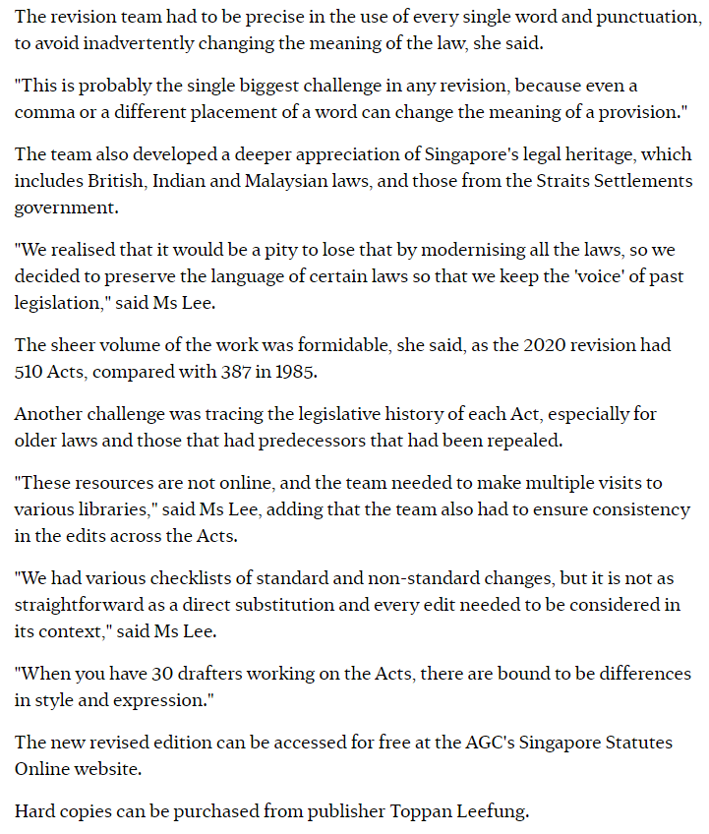

**UKSC decision on vires and interpretation informed by context**

In a 2 February 2022 decision, the UKSC held subordinate legislation authorised even though it set the fee for the exercise by a child or young person of the right to be registered as a British citizen at a level (eg, £973) which many young applicants have found to be unaffordable.

The decision includes interesting discussion of statutory interpretation informed by context.

“External aids to interpretation”, says Lord Hodge, Deputy President of the Supreme Court, at [30] and [31] (with whom Lord Briggs, Lord Stephens and Lady Rose agree), “ . . . must play a secondary role. Explanatory notes, prepared under the authority of Parliament, may cast light on the meaning of particular statutory provisions. Other sources, such as Law Commission reports, reports of Royal Commissions and advisory committees, and Government White Papers may disclose the background to a statute and assist the court to identify not only the mischief which it addresses but also the purpose of the legislation, thereby assisting a purposive interpretation of a particular statutory provision. The context disclosed by such materials is relevant to assist the court to ascertain the meaning of the statute, whether or not there is ambiguity and uncertainty, and indeed may reveal ambiguity or uncertainty: [*Bennion, Bailey and Norbury on Statutory Interpretation*, 8th ed (2020)](https://www.lexisnexis.co.uk/store/products/bennion-bailey-and-norbury-on-statutory-interpretation-eighth-edition-skuuksku9781474316729BSI884859/details), para 11.2. But none of these external aids displace the meanings conveyed by the words of a statute that, after consideration of that context, are clear and unambiguous and which do not produce absurdity. . . Statutory interpretation involves an objective assessment of the meaning which a reasonable legislature as a body would be seeking to convey in using the statutory words which are being considered.”

Lady Arden, at [58]–[77], says:

“I agree with Lord Hodge, and take this opportunity to address one point, namely the wide role in statutory interpretation for pre-legislative material, that is relevant material created before a Bill is passed (other than the Bill itself). Lord Hodge refers to this in paras 30 and 31 of his judgment. . . . I entirely agree with Lord Hodge that the task of the court when interpreting legislation is to find the meaning of the words that Parliament has used. . .

Lord Hodge prefaces paras 30 and 31 of his judgment by recalling in para 29 the observations of Lord Nicholls in *Spath Holme* at p 397 about what I will call ‘the legal certainty issue’. One of the problems in the court using pre-legislative material, Lord Nicholls explained, is that it makes it more difficult for a citizen to know what a statute means if the court has been influenced by external material and it is not readily available. This reason no longer applies to explanatory notes accompanying Acts of Parliament or explanatory notes appended to statutory instruments. These are often published by commercial publishers alongside the Act or statutory instrument. They are in any event available online without charge at <https://www.legislation.gov.uk> which is the official, web-accessible database of UK statute law. . . .

The concern of Lord Nicholls was also, as I read his judgment, on account of the constitutional implications, to which I refer further below.

The legal certainty issue leads Lord Hodge to the view that explanatory material must play a secondary role in interpretation. He puts explanatory notes prepared under the authority of an Act of Parliament into a different category from Law Commission reports, reports of Royal Commissions and advisory committees and Government White Papers. He states that the former may cast light on the meaning of a particular statutory provision whereas the latter disclose the background and help the court to identify both the mischief which the legislation addresses and its purpose, thereby assisting a purposive interpretation of a particular statutory provision.

I agree with Lord Hodge that such material is relevant to assist the court to ascertain the meaning of the statute, whether there is or is not ambiguity or uncertainty, and indeed may reveal ambiguity or uncertainty.

The next sentence in para 30 of Lord Hodge’s judgment reads:

‘But none of these external aids displace the meanings conveyed by the words of a statute that, after consideration of that context, are clear and unambiguous and which do not produce absurdity.’

I would put it this way. There are occasions when pre-legislative material may, depending on the circumstances, go further than simply provide the background or context for the statutory provision in question. It may influence its meaning. This is borne out by Spath Holme, where Lord Nicholls held:

‘Nowadays the courts look at external aids for more than merely identifying the mischief the statute is intended to cure. In adopting a purposive approach to the interpretation of statutory language, courts seek to identify and give effect to the purpose of the legislation. To the extent that extraneous material assists in identifying the purpose of the legislation, it is a useful tool.’ (p 397)

While external material is likely to contribute to the court’s knowledge of the context of and background to the statute to be interpreted and its appreciation of its purpose, matters do not always stop there. In some but not all cases, its use may go further. This is exemplified by contrasting two situations, first, the situation where the external material deals with proposals which did not find their way into the statute. This material may provide information of value about the context of and background to the legislation but is not likely to be of further use. The second example I have in mind is where perusal of the external material reveals that the language of the statute - perhaps initially thought to be clear on its face so as not to need any further inquiry - is in fact ambiguous. Here the external material has a use which goes beyond the provision of background and context.

Lord Nicholls immediately entered a caveat about the constitutional implications of statutory interpretation. He held that in view of the constitutional implications of statutory interpretation the courts should be slow to allow external aids to be used for meanings which were otherwise clear and unambiguous and not productive of uncertainty. But Lord Nicholls did not say that the pre-legislative material could never displace the apparent meaning of a provision. While I do not doubt the presence of constitutional implications - statutory interpretation is bound to engage the courts’ relationship with Parliament - it is difficult to see that there are adverse implications from the courts aiming to find a better-informed interpretation of a provision by reference to pre-legislative material which Parliament is more likely than not to have acted on. The process is quite different from finding a meaning which is not justified by the words that Parliament has used, or which is selected for some reason other than the presumed intention of Parliament. Neither of those approaches is in accordance with the principles of statutory interpretation.

That pre-legislative material may also influence the meaning which the court determines is the true meaning of the provision in question is also borne out by the judgment of Lord Diplock in *Fothergill v Monarch Airlines Ltd* [1981] AC 251. Lord Diplock held:

‘Where the Act has been preceded by a report of some official commission or committee that has been laid before Parliament and the legislation is introduced in consequence of that report, the report itself may be looked at by the court for the limited purpose of identifying the ‘mischief’ that the Act was intended to remedy, and *for such assistance as is derivable from this knowledge in giving the right purposive construction to the Act.*’ (Emphasis added, p 281)

Indeed, the legal certainty issue would not give rise to concern unless the external material could influence the result.

Like Lord Hodge, I would emphasise that in statutory interpretation the function of the court is to obtain the meaning of the words in the statute that it is required to interpret. The ultimate purpose of interpretation is always to find the meaning of those words. I consider that recourse to pre-legislative material can in appropriate circumstances considerably help the judge better to perform his or her role of finding the intention of Parliament in any particular enactment. (I explained this in my recent Lord Renton lecture to the Statute Law Society “What makes good statute law: a judge’s view?” ([*Statute Law Review*](https://academic.oup.com/slr), Volume 43, Issue 2, June 2022)). It follows that I would bear in mind the model of “the informed judge” which Viscount Simonds describes as applying to himself in *Attorney General v Prince Ernest Augustus of Hanover* [1957] AC 436, 460-461:

‘My Lords, the contention of the Attorney General was, in the first place, met by the bald general proposition that where the enacting part of a statute is clear and unambiguous, it cannot be cut down by the preamble, and a large part of the time which the hearing of this case occupied was spent in discussing authorities which were said to support that proposition. I wish at the outset to express my dissent from it, if it means that I cannot obtain assistance from the preamble in ascertaining the meaning of the relevant enacting part. For words, and particularly general words, cannot be read in isolation: their colour and content are derived from their context. So it is that I conceive it to be my right and duty to examine every word of a statute in its context, and I use ‘context’ in its widest sense, which I have already indicated as including not only other enacting provisions of the same statute, but its preamble, the existing state of the law, other statutes in pari materia, and the mischief which I can, by those and other legitimate means, discern the statute was intended to remedy.’

. . .

[*Craies on Legislation*, 12th ed (2020)](https://legal.thomsonreuters.com.au/craies-on-legislation-12th-edition/productdetail/128882), chapter 27 states that courts are increasingly prepared to look at any material that is likely to be genuinely helpful in illuminating the context in which legislation is to be construed but that they still start from the assumption that it is important that background material should not be allowed to take precedence over the clear meaning of the words used (para 27.1.1.2).

In my judgment it is realistic also to recognise that pre-legislative material, where available, may inform the court about an ambiguity which was not apparent simply on the face of the words, the mischief to which the legislation was directed and the purpose of the provision, and may in an appropriate case influence the meaning of the statutory provision. The use of pre-legislative material in an appropriate case in one of these ways, mindful always that statutory interpretation must be consistent with the courts’ relationship with Parliament, is an integral part of modern statutory interpretation. Moreover, the use of pre-legislative material in the ways I have described supports and strengthens the task of giving the correct meaning to the words that Parliament has used.

With these observations, I agree with Lord Hodge.”

Related website link: [*R (on the application of O (a minor, by her litigation friend AO)) (Appellant) v Secretary of State for the Home Department (Respondent)* [2022] UKSC 3](https://www.supremecourt.uk/cases/docs/uksc-2021-0062-judgment.pdf).

The Right Hon Lady Arden of Heswall DBE retired as a Supreme Court Justice on 23 January 2022. Lady Arden was appointed to the Supreme Court in October 2018. Watch Lady Arden's [valedictory ceremony](https://www.supremecourt.uk/watch/valedictory/lady-arden.html).

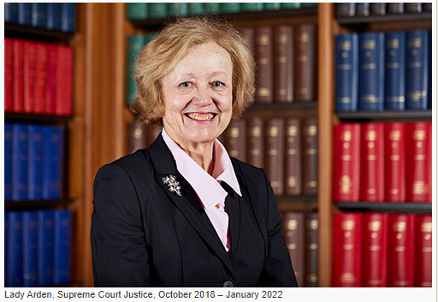

Webinar on 16 February 2022: use of defined terms

[Jacinta Dharmananda (Senior Lecturer, UWA Law School)](https://research-repository.uwa.edu.au/en/persons/jacinta-dharmananda) is presenting a webinar on this topic on Wednesday 16 February 2022 at 1pm AWST (Australian Western Standard Time, or UTC+8).

Related website link: <https://www.eventbrite.com.au/e/the-meaning-of-meanings-use-of-defined-terms-in-statutory-interpretation-tickets-168060626859>



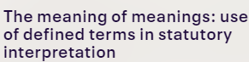

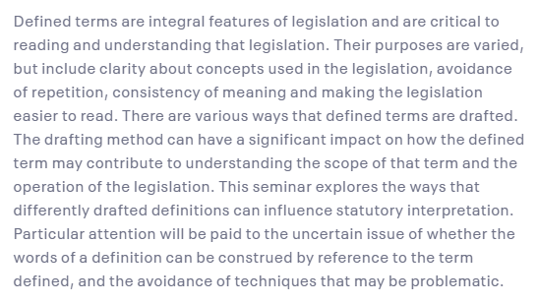

New CALC members

**New members since 25 November 2021**

The following have been recorded as members of CALC (a) since 25 November 2021 (the date when new members were last listed in the *CALC* *Newsletter* (November 2021 edition, as published on 10 December 2021), and (b) as at 6 February 2022.

| Name | Country | |
| --- | --- | --- |
| Mercer, Robert | Isle of Man |
| Poutu, Jacqui | New Zealand |
| Wayte, Pip | Australia |
| Symonds, Lorendae | Bermuda |
| Flanagan, Stephen | Canada |
| Sharpe, J P | Canada |
| Mensah, Jessica Adjeley | Ghana |
| Khiba, Motselisi Grace | Lesotho |
| Melville, Katrina | New Zealand |
| Upperton, Tess | New Zealand |
| Asanya, Boluwatife Ndidi | Nigeria |
| Cheng, Angelyn | Singapore |
| Poon, Shana | Singapore |
| Beckwith, Paula | United Kingdom |
| Kaye, Victoria | United Kingdom |
| Silwamba, Ian | Zambia |
| Farish, Kelly | BC, Canada |
| Armstrong, Jaime | BC, Canada |
| Borthwick, Sandra | BC, Canada |
| Champion, Jennifer | BC, Canada |
| Hancharyk, Andrew | BC, Canada |
| Kohan, Kevin | BC, Canada |
| Reid, Madeline | BC, Canada |
| Ward, Douglas | Canada |
| Katoole, Magano Sophia | Namibia |



## Secretary Contact Details

To contact CALC’s Secretary, Ross Carter, about membership or any other CALC matters (for example, to suggest or send items for this *CALC Newsletter*), email: [ross.carter@pco.govt.nz](mailto:ross.carter@pco.govt.nz)

 

(Old New Zealand newspaper headlines — courtesy of [Papers Past](https://paperspast.natlib.govt.nz/newspapers/))