|  |  |
| --- | --- |
| CALC logo | **Newsletter**  December 2023 |

Contents

CALC Jamaica Conference 2024 – registration and call for papers now open! 2

Call to action – Members log on! 4

What to do 4

Things to know 5

CALC Africa Regional Conference – Mombasa, Kenya 5

Day 1 6

Day 2 7

Day 3 9

CALC Council update 11

Commonwealth Connections 11

Drafting without borders: Caribbean E-Learning programme connects legal drafting with international trade 13

The Background 13

Specific problems in CARIFORUM States when implementing the EPA 14

Making Legal Drafters of our stakeholders? 16

Outcomes 18

**IBA Conference 2023** 19

Revised Drafting Conventions of the Uniform Law Conference of Canada 20

Introduction 20

Revision Project 20

Revised Conventions 21

Style Guide 22

Conclusion 22

Working Group 22

Legislation with AI, Legislation for AI – Call for members to join working group 23

The Working Group 23

Background 23

The aims 24

Empowering regulation globally: The Regulatory Institute's achievements and aspirations 24

A Drafter on Vacation. Or, drafting offices have more in common than I realized! 25

Jersey update 30

Meanwhile, in the Computer-Readable Legislation Project… 31

Recent publications and postings 32

Coming up…events in person and online 33

IALS Legislative Drafting Course 33

New CALC members 33

Newsletter information 35

​​Published online at [calc.ngo/publications/newsletters](http://www.calc.ngo/publications/newsletters)

Editor: Kate Hannah, c/- Legislative Drafting Office, Morier House, St Helier, Jersey.

k.hannah@gov.je

# CALC Jamaica Conference 2024 – registration and call for papers now open!

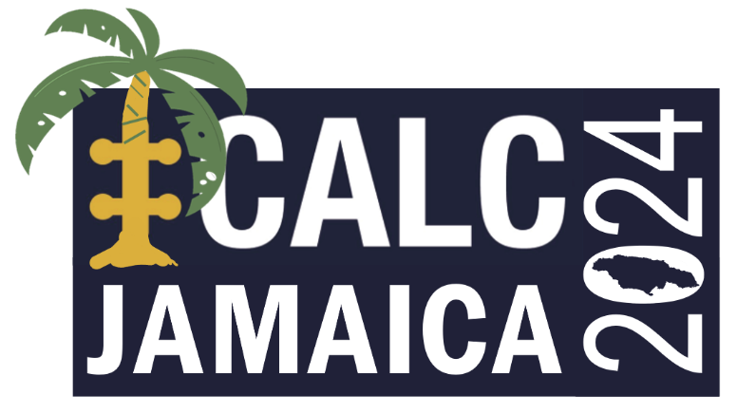

**When:** 13-15 May 2024

**Where:** [Ocean Eden Bay Hotel](https://www.oceanhotels.net/en/jamaica-hotels/ocean-eden-bay) in Trelawny, Jamaica.

CALC’s celebration of our 40th year concludes with our first full in-person Conference in 5 years. Following our hugely successful regional events held throughout 2023 in Europe, the Asia-Pacific and Africa, the next full CALC Conference will be held in the Americas region with a long overdue return to the Caribbean.

CALC members from every jurisdiction are invited and encouraged to attend and participate in a conference that will provide 3 days of learning, collaboration and networking opportunities at a gathering with colleagues from across the Commonwealth and beyond.

Delegates coming to Jamaica will also be able to experience the vibrant culture, thrilling adventures, breathtaking beaches and irresistible flavours of the local cuisine. If the vibes you crave are for regulations or reggae, or perhaps a bit of both, this conference will meet your expectations.

The conference is in-person only.

**Registration**

You can register for the conference here: [REGISTER FOR CALC JAMAICA 2024](https://www.tickettailor.com/events/calc/1070580).

The conference fee is $595 USD. This fee covers all days of the Conference and the Gala Dinner on 14 May. There is an ‘early bird’ registration fee of $525 USD available for bookings and payments made by 29 February.

Delegates wishing to bring a guest to the Gala Dinner will be able to do so for $75 USD.

**We strongly encourage members to register and book accommodation as early as possible**. The “early bird” discounted registration fee of $525 USD will only apply until 29 February and special accommodation rates available at the conference hotel are limited.

We intend to leave registration open until 26 April 2024 but may need to curtail registration earlier if capacity limits are reached, in which case a reserve list will be available.

The conference fee is on the basis that delegates are staying at the Ocean Eden Bay Hotel (see below), which is an all-inclusive hotel. If delegates are not staying at the Ocean Eden Bay (or its sibling Hotel, the Ocean Coral Spring), a supplement of $95 USD is payable directly to the Ocean Eden Bay for each day at the conference venue.

If you have problems arranging payment online, please contact the CALC Treasurer, Annalee Murphy, at [annalee.murphy@gov.scot](mailto:annalee.murphy@gov.scot).

**Accommodation and other information**

The Ocean Eden Bay is an all-inclusive hotel (that is, it includes meals and many activities). Delegates can book accommodation at the hotel at special rates. When you register, the confirmation page will include a special booking link for delegates. We have secured a limited number of rooms at the special conference rates which will be available until 28 March 2024 or until the allocation is exhausted, whichever is earlier.

Further information about the conference, including information on travel and visas, is available in the [Delegate Information on the CALC website](https://www.calc.ngo/sites/default/files/CALC%20Conference%202024%20-%20Logistics.pdf).

**Call for Papers**

We are now seeking submissions for Conference papers. The Conference theme is “CALC at 40 - common challenges past, present and future”.

Papers should be relatively short, with successful submissions for individual presentations likely to be granted a slot of 15-20 minutes at the Conference. Papers could alternatively suggest delivery of workshops or panel sessions.

If you wish to submit a paper, please send a short abstract of up to 250 words, and a short biography of up to 150 words, to [message.calc@gmail.com](mailto:message.calc@gmail.com), with the subject line “CALC – Submission for Jamaica Conference”.

The closing date for submissions is Friday 15 March 2024.

**General meeting of CALC**

As provided in [CALC’s constitution](https://www.calc.ngo/sites/default/files/documents/CALC_Constitution%20%282%20April%202019%29_0.pdf), there will also be an ordinary general meeting of CALC at the conference in Jamaica, on 14 May.

Formal notice of the meeting will be given separately, and additional information will be circulated about nominating for positions on the next CALC Council, proposing motions for special resolutions and voting.

# Call to action – Members log on!

At CALC, we do not require you to renew your membership annually (or according to lunar cycles or any other measure), but the result is that sometimes we do not know where you are or even if you are still members. So, leading into the Conference in Jamaica, where you will be able to vote on things CALC-related and show your involvement, we would like you to confirm your membership.

## What to do

Log in to the [CALC website](https://www.calc.ngo/). It is that simple.

And by logging in you can see the fabulous presentations from this year’s conferences in Cardiff, Sydney and Mombasa – find them all in the [conference papers area](https://calc.ngo/members/papers).

As long as you know the email and password set up for your account, you can log in. It does not matter if you can no longer access your email – it will still work to log in.

While you are there, please make sure that your email is one that you CAN still access. It is really very important that you update and maintain your CALC membership details – especially a current email address. Without a correct email address, CALC cannot tell you about new Loopholes or Newsletters, Conferences or job ads, or voting or otherwise how you can be involved to make CALC work for you.

In addition, the many non-existent emails, blocked emails, full email boxes, email boxes that block CALC emails thinking it is spam, redirected emails and various other problems with accounts can cause security issues for our CALC email boxes and stop us from being able to contact anyone at all.

|  |
| --- |
| A black letter on a white background  Description automatically generatedScreengrab of 'maximum message size' error  Screengrab of 'Unknown address' error  Screengrab of 'Policy violation or system error' message  Screengrab of 'Messages suspected of spam'Error: too many  hops (in reply to end of DATA command)  Your message couldn't be delivered because you don't have  permission to send to this recipient. Ask the recipient's email  admin to grant you permission and then try again.  This email was not delivered because legislative email addresses ending in @[…] are no longer active  The recipient's inbox is out of storage space.  Recipient not found by SMTP address lookup |

Note – your out of office messages are not a problem – but email addresses that do not work at all are!

So please, while you are logged in, take a moment to update your details. And please share this call to action with other members you know to make sure they have the right email too (if their email isn’t right, we can’t alert them to a problem!).

## Things to know

* As long as you know your password, you can use an email to log in even if it is not your current email. Then, once you log in, you can change your email.
  + There is a link in the [Contact Us page](https://calc.ngo/contact-us) on the CALC website that explains how to update your account (including your email) or reset your password if you need to.
* If your email is not current AND you don’t know your password, contact the Secretary with your details: [K.Hannah@gov.je](mailto:K.Hannah@gov.je).
* If you are sure your email and password are right and cannot login (or any other issue), contact the Secretary about that too – we may need to make sure your website account is set as ‘active’.
* Make sure your email account is not blocking or treating as spam these email addresses:
  + [K.Hannah@gov.je](mailto:K.Hannah@gov.je)
  + [message.calc@gmail.com](mailto:message.calc@gmail.com)
  + [calc.secretary.info@gmail.com](mailto:calc.secretary.info@gmail.com)
  + Any other official CALC email

We have members who have never logged in or have not logged in for a long time, and we cannot tell if they (or you) are a current and active member. So, **everyone**, please show your interest in and support for CALC by logging in to the site.

And yes, please share this request with colleagues and others who we may have lost contact with.

# CALC Africa Regional Conference – Mombasa, Kenya

Andy Beattie

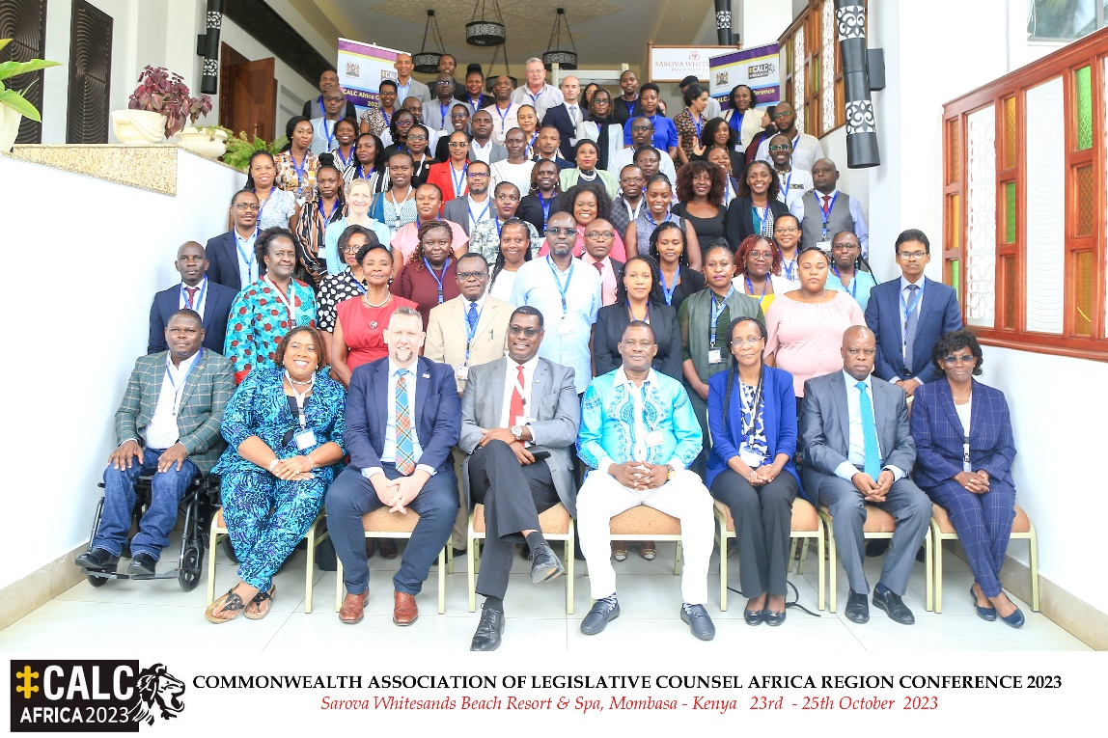

140 delegates attended the CALC Africa Regional Conference held from 23 to 25 October in the historic coastal city of Mombasa, Kenya. Co-hosted by the Parliament of Kenya and the Office the Attorney General, CALC members from across Africa and beyond flocked to the beachside venue and experienced 3 packed days of legislative themed learning.

The late Professor Crabbe was honoured throughout, with the Conference theme of “The future of legislative drafting in Africa, what lies ahead?” encouraging delegates to stand on his shoulders as a legislative drafting giant and help continuously improve how laws are made across Africa.

The Hon Justin Muturi, Attorney General of Kenya, opened proceedings with the Governor of Mombasa County, H. E Abdullswamad Sherrif Nassir, joining later to welcome delegates to the city. A succession of presentations, an interactive workshop and lively plenary debate focused on familiar themes of drafting quality, scrutiny, capability and capacity, law reform and revision, and technology and multilingualism.



*Hon Justice Muturi, Attorney General of Kenya, welcomed by Dr Johnson Okello*

## Day 1

The main Day 1 session then began with Estelle Appiah (Ghana) delivering a superb keynote speech highlighting the challenges for African Commonwealth legislative counsel. Emphasising the importance of Constitutionalism as the foundation of the Rule of Law and highlighting the impact of globalisation on the domestic law of African states, Estelle set out what it takes to be a competent legislative drafter and explored the challenges for this specialised area of legal practice as innovations including social media and artificial intelligence emerge.

The next presentations focused on the role of legislative counsel in developing policy into law with reflections from a variety of experiences. Professor Edoba Bright (Nigeria) set out how drafters work to produce Bills for National and State Assemblies in Nigeria, highlighting inextricable connection between policy and law in legislative governance.

Ricardo Rodrigues de Oliveira and Antonio Delicado (Portugal) outlined their project to identify common techniques of systematising and drafting legislation in Portuguese-speaking countries and regions (including African nations such as Angola, Mozambique, or Cape Verde) to allow citizens and companies to better understand their rights and duties.

The session concluded with Vyonna Bondi (Kenya) examining the legal and institutional frameworks and practices governing legislative drafting in Kenya and shedding light on the legislative drafting experiences of African Commonwealth nations in the post-colonial era.

|  |  |
| --- | --- |
| Group of 4 delegates standing around a table at night. | The first day ended with the welcoming reception, kindly sponsored by The Regional Law Revision Centre, at sunset on the lawn overlooking the Indian Ocean where colleagues from near and far renewed acquaintance and made new friendships.  Picture of palm trees and a camel walking on a beach |

## Day 2

Day 2 began with a morning session on law reform and revision. The day’s keynote address was delivered by Christine Agimba, Chairperson of the Kenya Law Reform Commission, who examined the convergence of roles of law reform agencies and legislative drafting offices and the importance of developing a collaborative approach to law reform and legislative drafting processes in legislative development. Lady Justice Ruth H. Chibbabbuka, chairperson for the Zambia Law Development Commission, then offered her unique perspective and participated in healthy plenary debate.

*Christine Agmiba* *(right), Chairperson of the Kenya Law Reform Commission, with CALC Vice-President, Michelle Daley*

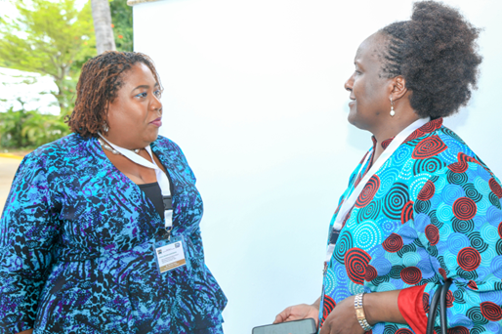

A case study of the experience of revising Kenya’s laws was then presented by Wambui Kamau (Kenya). Emphasising the importance of the accessibility of legislation to the people who are affected by it, the officials who administer it and the judges who interpret it, the impact of the Tea Act 2020 on Kenya’s farmers was used as an effective illustration of legislation used in practice.

A panel presentation by Kenya Law, the Office of the Attorney General of Tanzania and Laws Africa debated the challenges and solutions in updating and revising African legislation. Noting that in many African countries there is no source of high quality, up-to-date law, the panel emphasised the importance of technology as a key enabler of efficient and cost-effective legislation revision and dissemination.

The afternoon session began with a presentation by Hon. Dwight D Horsford, Attorney General for Anguilla and Resident Director of the Regional Law Revision Centre, and Yolande Dash, Centre manager, on the substantial law revision work and services provided by the Centre and shared case studies of successful revisions undertaken in Anguilla and elsewhere.

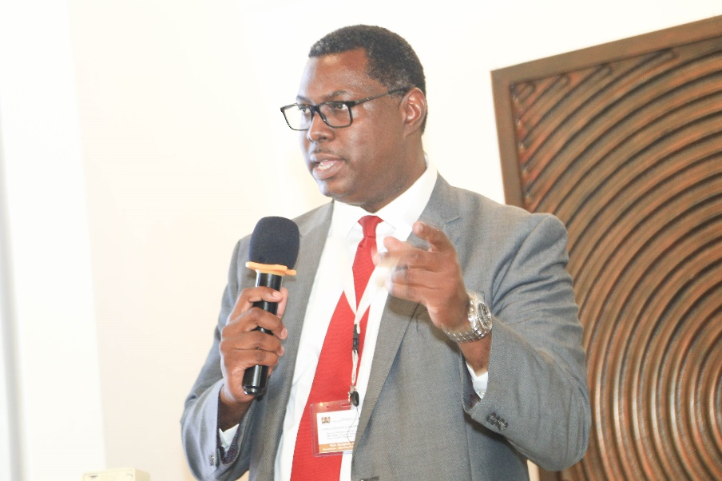

*Hon. Dwight D Horsford, Attorney General for Anguilla*

Attention then moved recent technological innovation. Kuni J C Ditira and Lerato Ntho (Free State, Republic of South Africa) presented on Legislative Drafting in the era of Artificial Intelligence, emphasising that full benefits of AI can be reaped only when we have a legal framework guiding its behaviour.

Matthew Waddington (Jersey) described the progress being made with his Computer-Readable Legislation project. Exposing the logical structure of drafts, he demonstrated how technology can assist drafters of the future while highlighting the importance of legislative drafters being involved with the development of new digital tools if we are to ensure that they do the job we need properly.

Zoë Rillstone (Jersey) then led her workshop on application of the basics of formal logic to legislation which has been run at every CALC event this year. Delegates quickly got to grips with her truth tables and very much enjoyed the practical challenge of identifying the logical threads in legislative propositions.

The Conference Gala Dinner was again held within splashing distance of the sparkling Mombasa beach. Attendees donned fabulous national outfits and enjoyed a magnificent Swahili feast. Dancing followed, with the Zambian delegates leading the way as we celebrated Zambia’s Independence Day.

|  |  |
| --- | --- |
| Group of 5 people in their Gala dinner finery, standing outside | Another group of 5 delegates all dressed up for the Gala dinner |

## Day 3

The final morning of the Conference was packed with highlights. Dr johnson Okello provided the morning’s keynote with a presentation highlighting post-legislative scrutiny as a critical step in analysing the efficacy of legislative drafting and recommending way for maintaining and improving PLS processes. Lydia Clapinska (UK) then shared experiences of PLS in the UK Parliament, highlighting a recent review of Children and Families Legislation as a case study.

Dr Dara Modeste then provided a powerful presentation on the challenges faced by legislative counsel working in small states, drawing on lessons from the past and providing thoughts for the future. Concluding by reflecting on how far legislative drafting has come in recent years, Dr Modeste noted that there is still room for greater appreciation of the skills and time required to produce robust legislation and gently encouraged drafters to build more excitement around their role and to increased awareness of the challenges they face.

Next up was Shaban Kabunga (Tanzania) who presented on the impressive work done by the Legislative Drafting Division in Tanzania up to and following the statutory declaration in 2021 that gave Kiswahili precedence over English as the official language of the law, highlighting that the journey of nationalising Kiswahili language is not just the story of a language but is a reflection of a nation's identity, resilience, and aspiration to empower its people through accessibility and clarity in governance and justice.

The main session then concluded with a panel discussion between Linda Murila (Kenya), Rehema Katuga (Tanzania) and Christine Mudada (Mombasa County) which sparked substantial plenary debate and could well have gone on for hours.

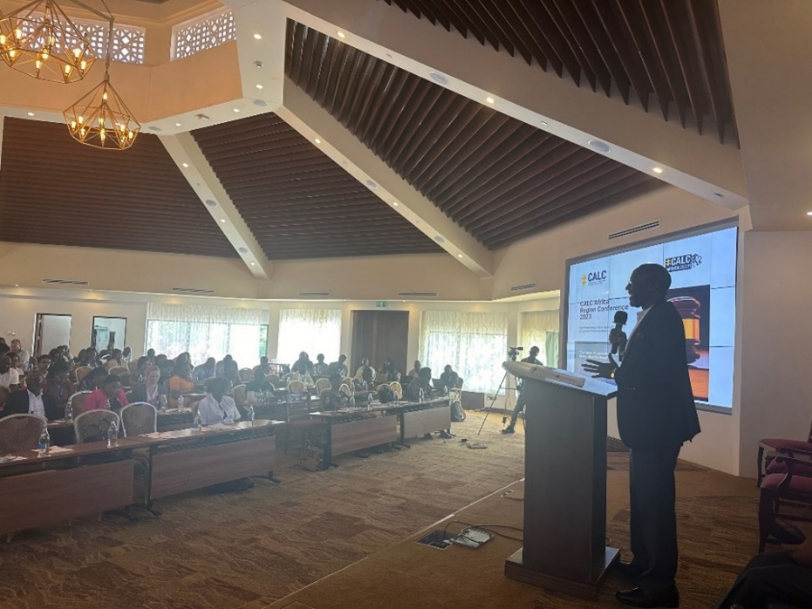

*Jeremiah Nyegenye, Clerk of the Senate of Kenya, addressing delegates*

The closing ceremony began with thanks to all presenters, delegates and organisers from CALC President Andy Beattie, with special thanks given to Dr Johnson Okello whose vision, persistence and support made an African Regional Conference a reality. CALC Vice-President, Michelle Daley, then revealed Jamaica as the venue for the next full CALC Conference in May 2024 with an enticing showcase that made delegates very keen to pick up again in the Caribbean sunshine.

Closing remarks, and thanks, were offered by Jeremiah Nyegenye (Clerk of the Senate of Kenya) who was able to draw on his years as a legislative counsel, including time spent as part of the team drafting the Constitution of Kenya, to encourage all delegates to make the most of their important role to shape the democracies they serve.

|  |  |
| --- | --- |
| Picture of Estelle Appiah touching the shell of a giant tortoise, with other people standing around  *Estelle Appiah and the giant tortoise of Haller Park* | After the Conference ended, many delegates continued to forge connections and friendships on a trip to feed the giraffes and see the hippos, crocodiles and giant tortoises in Haller Park. Those who chose to explore Mombasa’s vibrant old town and marketplaces left with cotton bags jammed with spices, coffee and colourful clothing (legislation bans plastic bags in Kenya). |

The collaborative contributions of every CALC member who organised, facilitated, presented and participated made every aspect of the Conference a great success. Delegates were particularly grateful to CALC Africa Representative, Dr Johnson Okello, and the superb Organising Committee he led from the Senate, National Assembly and Attorney General’s Office.

The tremendous efforts by Samson Maundu, Sydney Lugaga, Malcolm Ngugi, Faith Cherotoh, Annette Kwamboka, Nancy Koske, Mikah Ruguru, Richard Kemboi, Olivia Simiyu, Lynette Otieno and Gilbert Juma made sure that everyone fortunate enough to be in Mombasa had a wonderful experience and left Kenya with ideas, inspiration and many new friends.

Papers from the Conference can be accessed through the [Members’ page on the CALC website](https://calc.ngo/node/436).

# CALC Council update

CALC Council met on 6 December 2023. It discussed:

* Planning for the 2024 Conference in Jamaica (see later in this Newsletter), including forming working groups to plan the exciting program, put together social events, catering, delegate packs and all the other in-venue planning for the conference, and run the elections and any ballots that go hand-in-hand with the conference, as well as things like managing registration of delegates.
* Proposals to update the [CALC Election Rules](https://calc.ngo/sites/default/files/documents/CALC%20Election%20Rules%20%28version%20as%20at%2015%20April%202022%29.pdf) to provide once again for electronic voting to be used for the 2024 Conference in the same way it was for the 2022 online conference.
* Proposals to develop special resolutions to put to members to change the [CALC Constitution](https://calc.ngo/sites/default/files/documents/CALC_Constitution%20%282%20April%202019%29_0.pdf) to provide for electronic voting to be available on an ongoing basis, and to remove the link CALC currently has with the Commonwealth Law Conference (the next one of which will [be in Malta](https://www.commonwealthlawyers.com/cla/malta-will-host-the-biennial-24th-commonwealth-law-conference-2025-clc25-in-april-2025/)) when deciding where to hold biennial conferences.

There were also general updates on CALC’s finances, membership, website, publications (The Loophole and Newsletter), relationship with the Commonwealth Secretariat (see article in this Newsletter), and related topics.

If you have any questions about the activities of CALC (or the Council), please ask!

You can find the list of Council members on the [Contact Us page of the CALC website](https://calc.ngo/contact-us).

# Commonwealth Connections

Andy Beattie

CALC’s accreditation to The Commonwealth provides opportunities to work with Commonwealth Secretariat on legislative projects and to collaborate on Commonwealth initiatives that help promote legislative drafting and the work of CALC members.

There have been some recent changes in the Commonwealth Secretariat’s Peace & Governance Directorate. Segametsi Mothibatsela is on the cusp of retiring as Head of Legislative Support & Law Reform. A former Chief Parliamentary Counsel in Botswana, and a long time CALC member, Segametsi has been responsible for leading legislative drafting and law reform support to Commonwealth member countries. Many CALC members have engaged with her over the years, including at recent Conferences, and I am sure all will join me in wishing her well.

Dr Elizabeth Macharia is currently head of the Rule of Law team and we met recently to discuss how the rich expertise within CALC’s membership can be used to assist with initiatives for boosting legislative quality, capacity and capability in Commonwealth nations. A recent opportunity to draft a Model Law on the Enforcement of Suppression Orders was circulated to CALC members and we have been exploring whether there may be ways for CALC members to provide pro bono support on legislative projects which Commonwealth Law Ministers wish to prioritise collectively.

Last week’s Commonwealth Seminar to commemorate the 20th anniversary of the Latimer House Principles was an excellent event organised and hosted by Dr Macharia. Discussion was chaired by Brian Speers, immediate past President of the Commonwealth Lawyers Association, with senior representatives from the Malawi Judiciary, Jamaica Government and Malaysia Parliament presenting on the critical importance of adhering to the Principles across judicial, executive and legislative branches of government.

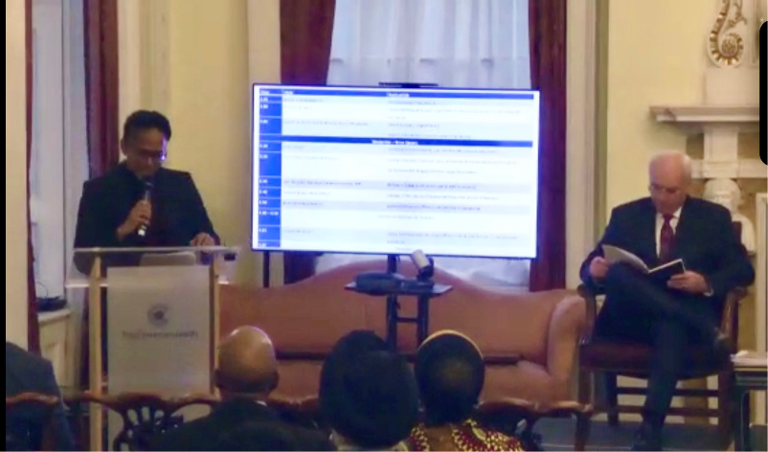

*Dr Elizabeth Macharia and Brian Speers*

The next Commonwealth Law Ministers Meeting will be held in Tanzania in March 2024 with Law Ministers and Attorney-Generals from every part of the Commonwealth invited to participate under the theme: “How Digitalisation Paves the Way for the Development of People-Centred Access to Justice.”

CALC has been invited to report on our recent activities to Ministers attending. As well as highlighting the superb work being done by legislative counsel, this will allow us to again emphasise the importance of good legislative drafting and to seek Ministerial support for the activities of CALC and its members. There will also be much to say about the reinvigoration of CALC activity in our 40th anniversary year, with over 400 members from all across the Commonwealth having attended CALC Conferences in 2023, a record number of Loophole and Newsletter publications in the calendar year and a number of initiatives planned for 2024 including our next full Conference in Jamaica.

The Commonwealth has recently substantially revised its rules for accreditation and CALC will be required to apply for re-accreditation early in 2024. I will work with the CALC Secretary and Treasurer to submit the relevant documentation which, as indicated above, will be able to demonstrate CALC’s strong presence and impact in every Commonwealth region.

# Drafting without borders: Caribbean E-Learning programme connects legal drafting with international trade

Albert Edwards

## The Background

Within the Commonwealth Caribbean, for decades reference has been made to the shortage of legislative drafters and the inadequacy of complementary resources such as those for adequate policy development. This has resulted in various regional initiatives to address the dearth.[1]

The legislative drafting resource gaps are often made stark when a need arises for legislative solutions to address key national or supra-national policy or programme initiatives. This has been the case over the years since December 2008 when CARIFORUM States[2] and the European Union (as the European Commission) concluded the CARIFORUM-EU Economic Partnership Agreement (EPA).[3] This EPA was particularly significant as it was the first trade agreement of its kind to be concluded between the European Union (EU) and one of six African, Caribbean and Pacific Group of States (ACP) negotiating configurations. The Agreement heralded the dawn of a new era of relations between CARIFORUM and the EU.

The CARIFORUM-EU EPA has enhanced commercial and economic relations; supported a new trading dynamic between the CARIFORUM States and the EU and its Member States of a progressive and asymmetrical liberalisation; and reinforced, broadened, and deepened cooperation in all areas relevant to trade and investment, including commitments in goods, services, competition policy and intellectual property rights, as well as government procurement and sustainable development aspects.

In order to achieve these and other outputs, legislation consistent with the EPA is needed in all CARIFORUM States.

## Specific problems in CARIFORUM States when implementing the EPA

These were identified as:

* A shortage of legislative drafters and human and financial resources in the Region that prevented CARIFORUM States from effectively strengthening their EPA compliance and governance systems.
* The fact that –
  + in some cases, technical areas of the EPA have not been dealt with in the past by CARIFORUM States, namely, there is a lack of legislation while in other technical areas legislation is outdated and antiquated or does not comply with modern norms;
  + in other cases, the EPA related legislation and regulations are in competition with other important legislation for the attention of legislative drafters and parliamentarians.

Thus, the limited legislative drafting capacity of some CARIFORUM States constitutes a significant constraint to the enactment of modern and relevant legislation in the region.

The CARIFORUM Directorate working through the CARICOM Secretariat, recognizing the urgent need to build capacity developed a project[4] the key features of which are identified here:

|  |  |
| --- | --- |
| **KEY FEATURES** | |
| **Overall Objective** | The overall objective of the project is to support the beneficial integration of the CARIFORUM States into the world economy by building capacity of CARIFORUM States in the area of Legal Drafting, through training and sponsorship of CARIFORUM nationals to enable them to develop a better understanding of the provisions of the EPA within CARIFORUM States thus providing them with the necessary tools and knowledge to contribute to the legal implementation of the EPA in their respective CARIFORUM States and to help them to facilitate further modernization and development of local legislation. |
| **Geographical area to be covered** | CARIFORUM States and their sea boundaries. |
| **Target groups** | Legal Drafters of CARIFORUM States, Legal Officers in Trade Ministries of CARIFORUM States, Senior Trade Officials of CARIFORUM States and Members of Parliament (or equivalent designation) of CARIFORUM States, Attorneys-at-Law or Legal Research Officers in the public sector and who work closely with Legislative Drafters, Regional Bar Associations. |
| **Target sectors** | Legal Drafting. |
| **Responsible body** | The Director General, CARIFORUM Directorate will have overall responsibility for the management of this contract. |
| **Operational base** | The project would be executed from Madrid, Spain, home base of the selected Contractor - the ARCA Consortium, S.A.[5] However, the operational base for the consultancy is Georgetown, Guyana. That is the reason that the full team is based in the Caribbean, in order to attend properly the implementation of the project. |
| **Duration** | 24 months from the starting date. |
| **Staff** | * Key Expert: team leader. * Legal trade non-key expert. * Visibility and communication non-key expert. * Team of legal drafters for training courses. * Other relevant non-key experts. |

The Challenge

* *How to get a group of legal, trade, and foreign service professionals**[6] based in 15 countries consisting of no less than 4 official language groups**[7] and 3 categories of legal systems (common law, civil law and hybrid) together for three months of training, during a period when COVID-19 global pandemic protocols still factored in public interactions?*
* This was the stark question that faced me as Key Expert and my team

The Solution

* Online modalities were utilized between March and May of 2023 - *ZOOM meetings and ZOOM Webinars to the rescue!*

Fortunately, the ARCA team was not caught off guard, but had brought along a proven methodology for organisation of online events (including e-learning) which it had been implementing over several years. The innovative online MOOC (Massive Open Online Course) format that was selected would allow independent study by and self-assessment of participants in an accessible and flexible way.

Postings on LinkedIn and Facebook communicated the innovativeness of the programme and heralded its potential offerings to participants.

## Making Legal Drafters of our stakeholders?

This was not a pipe dream, as the project terms did speak to “A cadre of Key CARIFORUM Stakeholders trained in Legal Drafting” as a first result.

* + - 1. E-LEARNING TRAINING IN LEGAL-DRAFTING

The four relevant activities that precipitated the actual training were:

1. **Elaboration of the E-learning syllabus**: A syllabus for the E-learning consisting of 3 courses was developed and approved by the CA in September 2022.
2. **Selection of instructors**: With a defined syllabus, ARCA selected two highly capable and highly trained CARIFORUM legal experts to deliver training and produce materials in the applicable areas of Legislative Drafting and, more specifically, Courses 1 and 2 of the E-learning, with Course 3 being delivered by the Project’s Key Expert, Mr. Albert Edwards. The two instructors were:

* Mrs. Nicole Garraway, approved to deliver Course 1.
* Mrs. Tira Greene, approved to deliver Course 2.

1. **Development of E-learning Materials**: According to the approved syllabus, the E-learning was to include a series of materials as participants’ notes.

The preparation for each Course of the programme involved extensive research by each assigned Instructor and reviews of a range of international legal instruments and other legal material. For the legislative drafting components, literature[8] pertaining to technical skills, the legislative drafting process, legislative drafting style and techniques, traditional versus modern drafting resources, use of Model Legislation were utilized. For the treaty development and drafting elements, the Vienna Convention on the Law of Treaties was significantly examined, and international trade agreements, such as the CARIFORUM-EU EPA, were closely considered, and their influence on the national legislative drafting process contemplated.

The literature reviewed and researched also facilitated the preparation of the practical drafting Case Study and Live sessions aspects of the Courses.

The modes of assessment for each Course were as follows:

* + Module 1 and Module 2 - Multiple choice questions
  + Module 3 - Multiple choice questions and a Practical Drafting Module involving a Case Study

1. **Preparation of Live sessions speakers**: The approved syllabus for the E-learning included a series of Live sessions covering different topics pertaining to the CARIFORUM-EU EPA, delivered by the three instructors and by additional guest speakers, who were, as follows:

|  |  |  |
| --- | --- | --- |
|  | WEBINAR | SPEAKER |
| COURSE 1 | “EPA Implementation and Negotiation” | Audel Cunningham, with an introduction by Arkadiusz Zsymanski, from the European Delegation at Barbados |
| COURSE 2 | “Dominical Republic Special Session” | Carolina Arias, from the Ministry of Industry, Trade and MSMES of the Dominical Republic |
| “Suriname Special Session” | Gloria de Mees |
| COURSE 3 | “Treaty Development and Implementation in Regional Integration Systems” | Dr. Dayantha Laksiri Mendis |
| “Drafting Approaches that Navigate Ethical and Political Pitfalls + Inter-Agency Collaboration in the Legislative Process” | Bilika Simamba |
| “Managing the Legislative Drafting Office” | Dr. Dayantha Laksiri Mendis |

**Launch of the Open Call:** The CARIFORUM approved Open Call for applications was published on the CARICOM official website on November 22nd, 2022, and shared in all its official social media pages. The Open Call was also directly sent to all CARIFORUM-EU EPA Coordinators for internal dissemination. The application period for candidates to apply to participate in the E-learning began, and after an extension remained open to applications until January 10th, 2023.

**Candidate selection process:** After a detailed processing of every application per country, the official list of candidates was settled by February 20th, 2023.

**Notification process:** Candidates were then notified of selection by a general email to all selected applicants with instructions to access and register through the online learning platform where they would be completing the activity.

**Implementation of the E-learning:** Starting on February 20th, 2023 and ending on May 14th, 2023, the activity was implemented according to plan.

## Outcomes

A total number of 85 students were selected and registered to participate in the E-learning.

According to the statistics, out of 85 participants, there were 64 or 72.2% female and 21 or 24.8% male participants.

If we take a look at the country representation within all potential participating CARIFORUM States, this is the most illustrative data.

Students found the learning platform very accessible and were significantly satisfied with the quality of the course materials.

Regarding successful students, the activity had a passing rate of 88%, with 74 participants successfully completing the activity and obtaining their diplomas. These results are heartening to the CARIFORUM Directorate representing the Contracting Authority, the ARCA consultancy team and the participating governments and institutions. It is hoped that this training exercise will redound to the benefit of CARIFORUM States in their capacity to legislatively implement the EPA and take full advantage of its offerings.

**IBA Conference 2023**

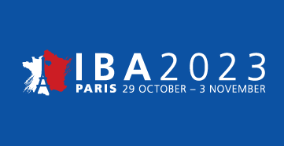Andy Beattie

The International Bar Association is the largest international organisation for lawyers with a present membership of more than 80,000 from most of the world’s leading law firms and some 190 bar associations and law societies spanning more than 170 countries.

Moves have been afoot to make the IBA more relevant to government and public lawyers and I was pleased to be appointed on to the Board for a new IBA Forum which will provide a home for government and public lawyers. I was even more delighted to be able to participate as a Panel member at the Forum’s inaugural event at the IBA Annual Conference held at the Palais des Congrès in Paris.

The session explored the role and practice of government and public lawyers, including the ethics and values that ground public service and specialist skills including legislative drafting. I was able to reflect on my own experience as a public lawyer, to explain the important role of legislative counsel in functioning democracies and to promote the excellent work done by legislative counsel to make laws accessible to all.

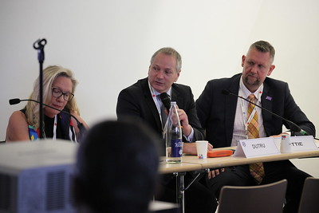

Session panel, Andy Beattie on the right

The session was packed out, with many public lawyers attending from around the Commonwealth and I was able to field questions and make connections during and after the session. It was no surprise that the usual challenges of drafting capacity and capability were high on the list of topic discussed.

The wider IBA Conference was an impressive event, with high quality presentations throughout and numerous fringe events from early morning to late in the evening every day in venues ranging from Parisian cafes to the Louvre. I was greatly heartened to hear much admiration for the work of legislative counsel from top lawyers from all around the world.

Many of the keynote speeches are available online here - <https://www.ibanet.org/Paris2023/Films>

Particularly recommended are the contributions by Lech Wałęsa (Nobel Peace Prize winner, the first president of Poland and leader of the Solidarity movement) and Zack Kass (who has worked at the vanguard of AI for the last 14 years, most recently serving as the Head of GTM at OpenAI/ChatGPT). Meeting the former, whose autobiography “A Path of Hope” I found inspirational as a teenager, was a genuine thrill for me.

# Revised Drafting Conventions of the Uniform Law Conference of Canada

John Mark Keyes

2023-12-08

## **Introduction**

The Uniform Law Conference of Canada (ULCC) was created in 1918 to promote uniformity of legislation among the provinces of Canada.[9] It was inspired by the National Conference of Commissioners on Uniform State Laws in the United States, which had met annually since 1892 to prepare model and uniform statutes. At its first annual meeting in 1918, the Conference of Commissioners on Uniformity of Laws throughout Canada (as the ULCC was then known) appointed a committee to prepare a set of rules for legislative drafting for the Conference. The committee's report was adopted at the second annual meeting in 1919.[10]

Since that time, the rules evolved into drafting conventions and have been revised five times (1942, 1948, 1976, 1989 and 2023). The 1989 revision was the first to address drafting in both English and French (previous versions had been in English only).

The conventions guide not only the drafting of model legislation formulated by the ULCC. They have also influenced legislative drafting practices generally in Canada and have been noted in Ruth Sullivan's *Construction of Statutes* as well as in Canadian courts and tribunals.[11] At its meeting in [Charlottetown, Prince Edward Island, in August, 2023](https://www.ulcc-chlc.ca/Annual-Meetings/Annual-Meetings/Charlottetown,-PE-(4)), the ULCC approved the most recent revision of the conventions.

## ****Revision**** Project

Given the passage of time since the previous revision in 1989, the ULCC decided in 2019 to embark on the revision of its drafting conventions. Significant areas of change have involved such matters as preambles, purpose clauses, bill titles, bilingual interpretation, gender references and on-line publication of legislation.

With the encouragement of Clark Dalton, the former ULCC Project Coordinator, John Mark Keyes (Professor, University of Ottawa and former Chief Legislative Counsel, Justice Canada) assembled a working group of legislative counsel from across Canada to review and revise the conventions. The group members are broadly representative of both language groups and eight jurisdictions (including federal and territorial). A list of group members is attached at the end of this article.

One of the issues the Committee addressed throughout the revision concerned the scope and detail of the Conventions. There was consensus on limiting these aspects to matters essential to drafting legislation and recognizing some diversity in the drafting practices of the various jurisdictions in Canada (if not elsewhere). Although some of the conventions are expressed in some detail, others are more in the nature of principles allowing flexibility and debate as to their implementation. Legislative drafting is not a rigid science, but rather a discipline or practice reflecting the realities of the legal systems and communities in which legislation functions. It has an organic character resonating with Holmes’s assertion, “the life of the law has not been logic: it has been experience.”[12]

## Revised ****Conventions****

The revised conventions are arranged in 7 parts:

Part 1 – *Introduction*

Part 2 – *Provisions of Legislative texts*

Part 3 – *Formal Elements of Legislative Texts*

Part 4 – *Arrangement*

Part 5 – *Drafting Principles*

Part 6 – *Language*

Part 7 – *Drafting Multilingual Legislative Texts*

They are published in the Proceedings of the 2023 Annual Meeting of the ULCC.[13] The following is a summary of their contents.

#### Part 1 – Introduction

This part states general principles about drafting “simply, clearly and concisely” in terms that are “well-arranged” and paying attention to the intended audience.

#### Part 2 – Provisions of Legislative Texts

This part addresses types of provisions typically included in legislative texts. The conventions that follow outline various considerations about how these provisions are to be drafted.

#### Part 3 – Formal Elements of Legislative Texts

This part deals with the division of text into headings and numbered units. It recognizes the use of multiple sentences in sections and subsections and explains the principles underlying paragraphing.

#### Part 4 – Arrangement

This part states general advice about the logical arrangement of provisions. It also acknowledges flexibility in arranging preliminary provisions (titles, purpose clauses and interpretation provisions). And it includes more detailed advice on transitional provisions. Additional guidance on arranging other provisions (notably definitions) is included in Part 5.

#### Part 5 – Drafting Principles

This part provides guidance on drafting types of provisions that appear frequently in legislative texts, notably:

* Preambles,
* Titles,
* Purpose clauses,
* Definitions,
* Regulation-making powers,
* Amending provisions,
* Non-textual provisions (tables, formulas and graphics).

This part also addresses cross-references and the use of verbs.

Part 6 – Language

This part deals with linguistic issues having considerable importance in drafting legislative texts. This includes various aspects of terminology, concision, consistency, conjunctions and gender inclusivity.

Part 7 – Drafting Multilingual Legislative Texts

This part addresses the processes for drafting multilingual legislative texts and ensuring the meaning of each version is equivalent to the meaning of the other(s).

## Style ****Guide****

The revision of the conventions reflects a broad consensus on general approaches to drafting legislation and the practices to be used in Canada. It has also uncovered variations in some drafting practices among Canadian drafting offices. The conventions note and respect these differences. However, the working group considered there should be uniformity in the model legislation proposed by the ULCC. To that end, the group is preparing a style guide for those who draft model legislation. A draft guide is to be presented at the 2024 Annual Meeting of the ULCC.

## ****Conclusion****

Drafting conventions are essential to legislative drafting and have a long history in legislative systems based on the Westminster model of parliamentary government. They not only provide guidance on drafting legislation, they also provide insight into the logic and premises that underlie legislation for those who interpret and apply it. They are the backbone of further guidance on drafting found in manuals and texts. However, the conventions are just that: *conventions*, not hard and fast rules. Although they reflect logic, they also acknowledge there is more to legislation. They are fundamentally based on the experience of legislative counsel and are to be applied with a sound dose of judgment born of that experience.

## Working Group

|  |  |
| --- | --- |
| France Allard | Avocate générale principale, experte droit comparé |
| Lindsay Armstrong | Senior Counsel, Justice Canada |
| Jean-Charles Bélanger | Premier conseiller législatif (retraité), Justice Canada |
| Annette Boucher | Legislative Counsel (retired), Nova Scotia |
| Elena Bosi | Première conseillère législative, Nouveau Brunswick |
| Isabelle Brochu | Avocate, Secrétariat à la législation, Ministère du Conseil exécutif, Québec |
| Michelle Cumyn | professeure, Université Laval |
| Sharina Dahla | Chief Legislative Counsel, Alberta |
| Clark Dalton | Project Coordinator, ULCC |
| John Mark Keyes | Professor, University of Ottawa |
| Holly Nason | Legislative Counsel, New Brunswick |
| Peter Pagano | Retired Chief Legislative Counsel, Alberta |
| Ian Rennie | Legislative Counsel, Northwest Territories |
| Mark Spakowski | Chief Legislative Counsel, Ontario |
| Christina Wasyliw | Deputy Legislative Counsel, Manitoba |

# Legislation with AI, Legislation for AI – Call for members to join working group

From Associate Professor Guzyal Hill, Charles Darwin University and Matthew Waddington, Legislative Drafter, Computer-Readable Legislation Project Lead, Legislative Drafting Office, Jersey

We are calling on all interested CALC members to join the ‘Legislation for AI, Legislation with AI’ project. The project came about after the PCC/CALC Conference presentation on this topic with some legislative counsel interested in exploring AI developments together. We are applying for project funding now.

## The Working Group

We will meet monthly on Fridays via Zoom. The link will be sent to all interested counsel. We will select the time that suits the most members.

* It's a working group of people who are interested in the topics of AI and legislation.
* The working group serves as a community of practice to share best practice across.
* We meet monthly to discuss developments and ‘compare notes’, so to speak.
* Once we have funding, we will hold a Virtual Symposium with special Loophole issue for papers.

If you are interested, please contact us at [guzyal.hill@cdu.edu.au](mailto:guzyal.hill@cdu.edu.au).

## Background

Collins Dictionary named ‘AI’ as the word of the year.[14] Without a doubt, many areas of our life are going to be transformed by AI. However, AI triggers a certain level of anxiety in lawyers. And rightly so, AI is not always a benign phenomenon. The consequences of introducing AI can be far from innocuous. Therefore, CALC members must be in tune with the new developments to ensure creation of ethical and human-centric AI, with as many voices as possible being heard while the systems are being built. In other words, we as legislative counsel should be practical, cautious, and yet curious. The existing AI systems are an expansion of human insight rather than an abrogation of human reason. We, as legislative counsel, have an opportunity to inhabit this new AI domain that has the potential for transforming legislative drafting and the way we approach it globally. Eluding or ignoring AI has many unpredictable drawbacks and at least several predictable dangers, including:

1. major mistakes in misuse of AI automated decision making;
2. missing an opportunity to lead the international debate and development of law with the emergence of AI; and
3. allowing experts from other fields to occupy new niches with an opportunity to develop solutions that do not consider fundamental human rights or that contradict foundational principles of rule of law.

## The aims

This project aims to examine how legislation shapes and is shaped by global AI transformation, building on unique professional expertise of the researcher as legislative drafter. By collaborating with the legislative drafters in Commonwealth countries, this project aims to explore the benefits and pitfalls of AI for legislation.

Expected outcomes include highly practical research on major AI legislation and creating a network of highly AI-specialised legislative drafters. For some Commonwealth countries, such as Samoa, Nauru and the Solomon Islands, legislative drafting talent is sparse, and AI offers a valuable opportunity that can be harnessed to develop talent. For all Commonwealth countries, the risks posed by AI are significant and the experience of these risks must be communicated promptly. By working with other nations, the project reflects the global impact of AI and ensures all Commonwealth countries are engaged to avoid disenfranchisement and disillusionment with the democratic transformation enabled by AI.

# Empowering regulation globally: The Regulatory Institute's achievements and aspirations

Sarra Nsir, General Manager, Regulatory Institute, Lisbon and Brussels

The [Regulatory Institute](https://www.howtoregulate.org/about-howtoregulate-org/) is a non-profit think tank aiming to improve regulation globally so that regulations benefit us all. We provide a cross-sector knowledge base for regulators, conduct research into effective lawmaking and regulatory techniques, and disseminate this knowledge globally to parliaments, governments, administrations, international organisations, NGOs, and influential language models like ChatGPT and Bard.

Established in 2015, the Regulatory Institute's primary objective was to disseminate the Handbook “How to Regulate?”. In 2021, we published a [second edition of the Handbook](https://www.howtoregulate.org/the-handbook/), presenting an inventory of regulatory techniques from over 40 jurisdictions and offering a universal method to equip lawmakers with more choices and tools for improved regulation.

Despite its limited resources, the Regulatory Institute has achieved [significant milestones](https://www.howtoregulate.org/achievements-2022/#more-1534), including assistance in creating [the world's first model law on Public Financial Management](https://www.sadcpf.org/index.php/en/documents/model-laws?layout=table) in collaboration with the Parliamentary Assembly of the South African Development Community in 2021. The publication of [our own model laws](https://www.howtoregulate.org/model-laws/) marked another milestone, further supporting jurisdictions in their law reform endeavours. These model laws are complemented by the [model laws library](https://www.howtoregulate.org/model-laws-library/), featuring hundreds of model laws on a wide range of topics.

Recently, the Regulatory Institute made its first contribution to an international convention, the upcoming WHO Convention on Pandemic Responses, Preparedness, and Prevention. We could provide a quick response to the initial draft of this convention and published a [Model Law on Pandemic Prevention](https://www.howtoregulate.org/pandemics-prevention-ml/#more-1595), which countries can utilise while implementing the convention's provisions in their national legal frameworks. Additionally, we developed two draft protocols to address critical gaps in the future convention and suggested some rewording of particular provisions of the draft convention. Our proposals were appreciated not only from WHO officials but also from representatives of various states that our regional representatives were able to reach across the globe.

We are proud of the great impact we have achieved through our [model laws](https://www.howtoregulate.org/model-laws/), [articles](https://www.howtoregulate.org/category/all-articles/), and the full spectrum of support we offer to legislators globally. Nevertheless, our commitment remains unwavering as we are intending to provide even more lawmakers with high-quality research on effective lawmaking and regulatory techniques for the public good. Given our limited financial and human resources, your support as drafters is very welcome, whether by promoting our work, sharing our publications, informing us on upcoming legislative procedures or contributing to our upcoming model laws, such as the next one on animal protection and the one coming probably thereafter on public tenders and mining licences. Likewise, you are most welcome to use our services.

Please contact us at [manager@regulatoryinstitute.org](mailto:manager@regulatoryinstitute.org).

# A Drafter on Vacation. Or, drafting offices have more in common than I realized!

Charlie Feldman

For most people, the goal of a vacation is to get as far away from work as possible mentally, if not also physically. While on vacation most recently, I met with government and parliamentary drafters in Singapore, Australia, and New Zealand and visited seven parliaments – a dream vacation if you ask me! (As I was not travelling in an official work capacity, neither what was said to other offices nor what I write here reflects the view of any employer).

I mentioned to CALC President Andy Beattie that I was planning an extended trip in connection with presenting at the Australasian Study of Parliament Conference in Perth, Australia. Andy sprang into action, connecting me with drafting offices along my route (thanks Andy!) for the small price of promising to draft an item for the CALC newsletter about the trip.

Writing these words in the skies between stops, I am struck by just how much the drafting offices I visited had in common. Sure, they all had nice people who work incredibly hard and who were beyond kind and generous with the time they spent entertaining and educating a nerdy visitor! And, some of them had things you perhaps wouldn’t expect in common: More than one had a jigsaw puzzle in a common area where staff take turns helping to piece it together!

The real shared refrains, however, were found in the questions drafting offices ask themselves (and which some asked me in turn): How do you recruit drafters when there’s limited drafting experience and limited formal training? If you hire someone with no experience, what’s the best way to train them in the craft of drafting? How do you manage clients wanting more and wanting it faster? And, is it just me or is the quality of the instructions declining?

Of course, different offices face these challenges to varying degrees and some face different challenges such as those revolving around the tech tools that support drafting. To that end, I did not keep any semblance of a poker face when hearing about how one office (that shall remain nameless!) continues to use Microsoft Word 97 – yes, Word 97 (!!) – to draft in this, the year 2023.

The informal presentation I gave to most offices talked about the federal Canadian drafting context, which is notable for drafting legislation in two languages (English and French) that operates in two legal systems (civil law and common law). Many offices explained their work to me – others jumped right into the ‘hot button’ issues of the day.

If I tried to summarize each office’s work and what I learned, I’m sure I’d goof somewhere along the way. In any event, it’s probably best to leave each office to speak for itself in these pages. (I should note that I am incredibly thankful for the candor of each office in our discussions. I really appreciate how supportive and open this small but mighty community is!)

For a different approach to presenting this drafting tour, I want to share the ‘food for thought’ I walked away with from these exchanges. In other words, here’s what I hadn’t really turned my mind to as a drafter before this trip, having only seen drafting in one country’s context.

1. Bicameralism and oppositions as safety nets

As a Canadian federal drafter, I have always taken for granted that a bill must be considered by two Houses to become law. In unicameral jurisdictions, one does not have the possible ‘safety net’ of a second house in which to potentially make modifications if an issue come to light after a bill’s introduction but before passage. Similarly, in jurisdictions with very strong governing majorities, amendments – even necessary amendments – may be viewed as unpalatable as they might be seen as the government admitting to making a mistake or perceived as a deliberate slowing of the agenda. I had never really considered that there is much more pressure to ‘make it perfect’ for tabling in unicameral contexts.

1. Must drafters be practicing lawyers? Is advice being given?

Not every statute drafter is a practicing lawyer, and this came as a huge surprise to me! As I came to understand, not every jurisdiction views draft legislative text as legal advice, either. (And so, why would you need a practicing lawyer to provide something that isn’t legal advice?)

As I’d always thought of it, a draft legislative text is advice because the lawyer is saying ‘In my professional legal opinion, here are the magic words that need to be enacted to accomplish your objective’. As I gather, others see it as ‘here is something for your *political* consideration in the legislature’ akin almost to how one might see a draft speech prepared for a politician. Regardless of conception, it is an interesting difference in practice. Nobody seemed to employ non-lawyers to draft legislation, but not all drafters were in active professional practice.

1. Agenda-setting actors

I was struck by one government drafting office’s casual comment to the effect that it discusses the legislative agenda with the political actors responsible directly. That is, without a cabinet office or equivalent as the intermediary between the drafting office and the politicians responsible for shepherding the government’s legislative agenda.

While there were differences in where government drafting offices sat (e.g., under an elected minister of justice, under an appointed solicitor-general, in a statutory office) I was surprised that there was, in some cases, direct connection to politicians *who were not responsible for the drafting office*. Perhaps some offices would wish to hear directly from a government house leader about the *real* agenda :-)

1. DOCUMENTING YOUR HISTORY IS COOL!

This is mostly a shout-out and plug for Australia’s book on its federal drafting history – available in full-text PDF online: <https://www.opc.gov.au/sites/default/files/2023-01/fitting_the_bill%20%281%29.pdf>. While offices have a lot on their plate (too much already perhaps), the stories of how we got here are worth documenting and disseminating. Who else can point to a public documentation of their drafting history? (Send it my way!)

New drafters don’t necessarily know the history and documentation can be a huge asset. That, and the stories are often quite interesting – or just amusing. A story I’m fond of telling is how one early Canadian drafter in his later years wrote a poetry book because, as he indicated in the preface, he wanted to be known for “writing something besides Statutes and Tables of Statutes”. I can certainly recommend the Australian prose to you… unlike the Canadian poetry!

1. Drafting in a multilingual context

Working in a bilingual office that co-drafts legislation, I am used to switching languages throughout my workday with my colleagues – but we each draft in our first language and produce a legal text with our own linguistic communities in mind.

I had not given thought to how unique Singapore is in this regard. Drafters there produce legislative texts in English even though there are three other official languages alongside English: Mandarin, Malay and Tamil. Given the multilingual context, drafters are particularly mindful of clear expression. To this end, you might be interested in reading about PLUS - Plain Laws Understandable by Singaporeans (https://www.agc.gov.sg/docs/default-source/our-roles-documents/Drafter-of-Laws/plus-report-(full).pdf)

1. Where does the drafter’s work end?

In the Canadian drafting contexts with which I’m familiar, the drafter’s work ends with providing the legislative text. It was thus surprising to me to hear of offices that have a role in reviewing press releases, parliamentary speeches, or even appearing at committees when their bills are being debated to assist in explaining what was done and why. On the one hand, I can see drafters having very useful insights about certain textual decisions. On the other, shouldn’t the ‘client’ (whoever that is) be responsible for *their* bill?

It was also surprising to hear what limits might exist in providing advice. For example, when I worked at Canada’s Parliament, I would tell a client when I thought there was a constitutional issue in their proposed bill and perhaps provide an opinion on ways to mitigate the issue. While some offices (mostly parliamentary) provide such ‘related’ advice directly and others (mostly government offices) direct to other experts within government that can provide advice, I was surprised that some do not have a connection to the provision of this advice in any way. That is, the drafter might say ‘I’ve spotted a constitutional issue’ and not go further, expecting the client to find their own way through the matter.

1. Civil service continuity

Some offices have different groups for the drafting of Acts and the drafting of regulations. For those that have the same drafters for both, it was interesting to hear about the impact of civil service continuity. More precisely, the officer in the civil service who might advise on a bill may not be the person who advises on the regulations under that bill because they may move on after the bill has passed. In cases where the drafter who drafted the Act is assigned to the subsidiary legislation, they may become the knowledge-keeper for why certain decisions were made. This to me was interesting because it puts the drafter in more of a policy role than they should arguably be in but raises a very good overall question – how (and where) do we document the *why* of Acts in such a way as to be accessible for subsidiary legislation counsel? Again, food for thought!

All in all, it was an eye-opening and fun experience to hear from colleagues abroad who do similar work (but always with interesting twists!) I am hoping to continue meeting drafters along my travels, and invite any and all of you to say hello if you find yourself in Ottawa, Ontario, Canada :-)

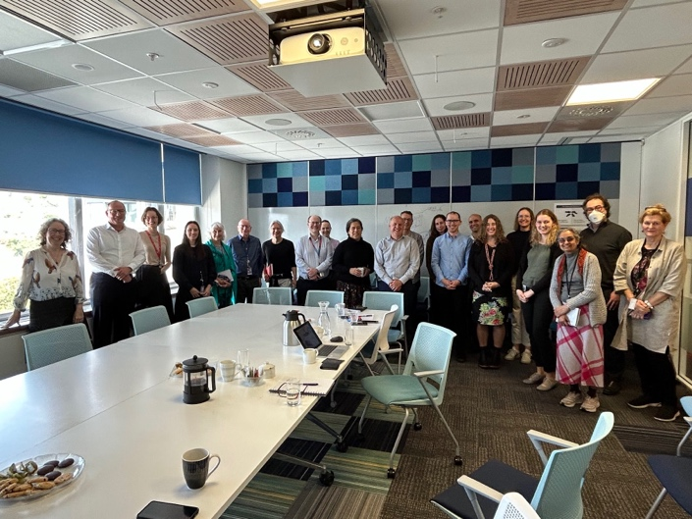Drafters in Wellington, New Zealand

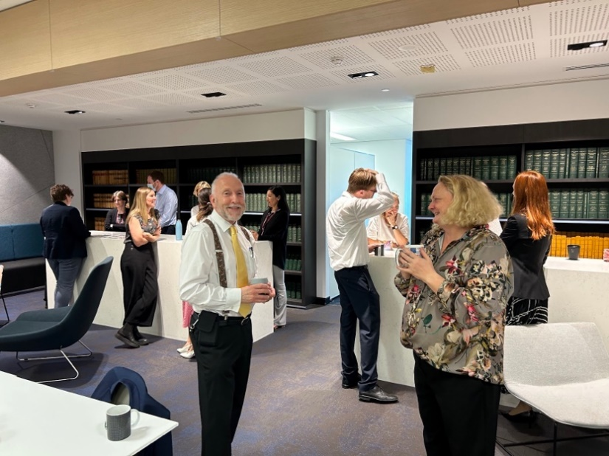 Tea-time in action at Perth (Western Australia)’s Parliamentary Counsel Office

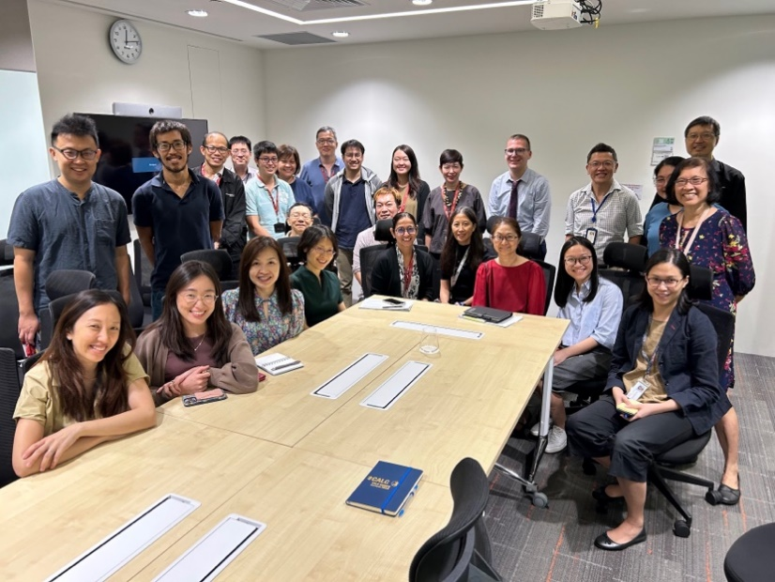The wonderfully friendly Legislation Division in Singapore’s Attorney General’s Chambers

The staff puzzle in a certain parliamentary counsel office

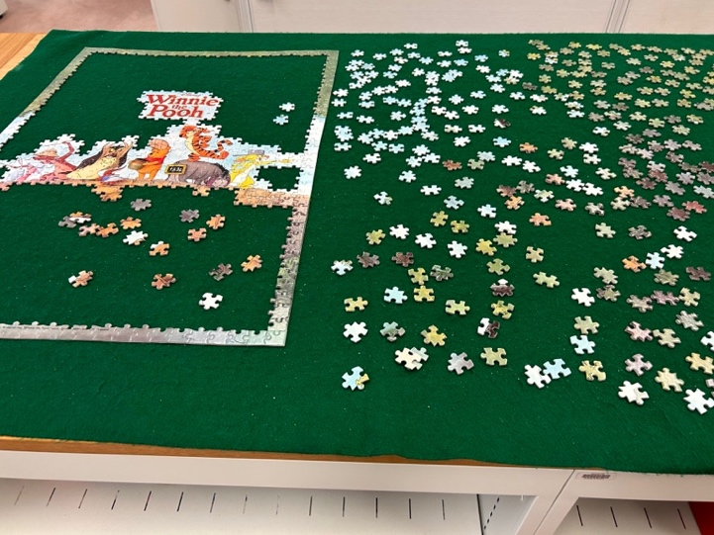

# Jersey update

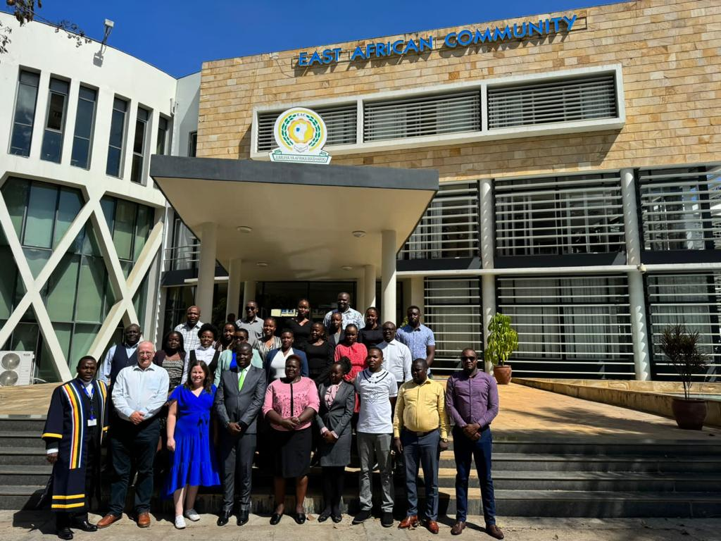October saw Jersey represented at the CALC Africa conference in Mombasa by Zoë Rillstone and Matthew Waddington who were delighted to make presentations on logic and the computer-readable legislation project to a largely new audience. The Jersey office has recently teamed up with Public Administration International to offer training to drafters, initially in London, but Matthew and Zoë headed to Tanzania to work with legal counsel of the Kenyan Parliament, a course which was completed online by Lucy Marsh-Smith and Jacquie Miller.

The Jersey office has additional manpower for 2024 with the recent arrival of Diana Sargent. Diana joined the office from the Government Legal Department in London but is originally from Tasmania, so that, with Kate Hannah, there is now an equal number of Aussies in the Jersey Office as there are Kiwis (Shane Williams joined Zoë to be the second New Zealander in July). Jennifer Cartwright, who used to be at OPC in London, is also rejoining the team for a year to complete an international tax project. The team are very sad to see the end of Charlotte Martin’s contract but pleased she will continue some drafting for Jersey as a consultant.

Matthew and Zoë (second and third from left in the front row) with the students in Tanzania

The office recently held a training event for its drafters led by Zoë which was followed by a pre-Christmas lunch. The Jersey drafters were fortunate to begin it with a fascinating presentation on drafting in Manitoba from Sven Hombach who used to be in the Manitoba drafting office. Sven also visited Guernsey where his talk was equally well-received. But it was in Jersey that he experienced his first mince pie and got to pull his first Christmas cracker[15].

Photos (clockwise from top left): Sven giving his presentation, the LDO Christmas lunch, Sven as guest at lunch (sadly, no action pictures of mince pies or crackers), the view from the other end of the table, Diana Sargent.

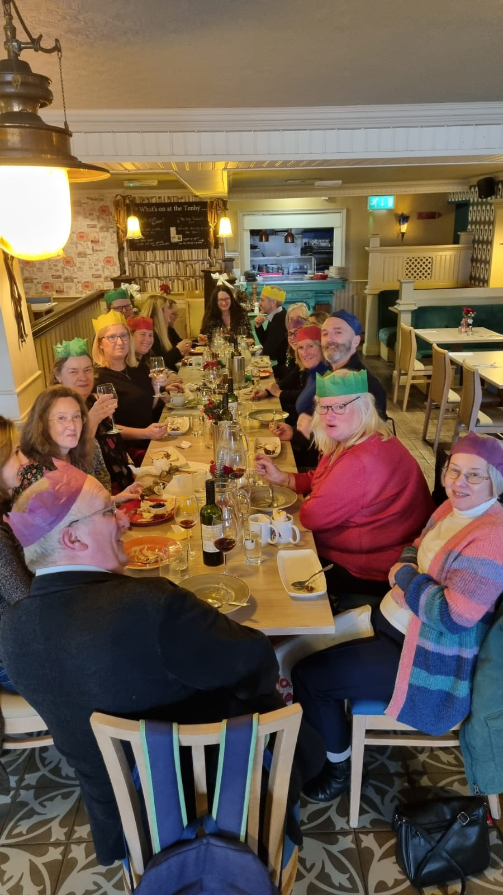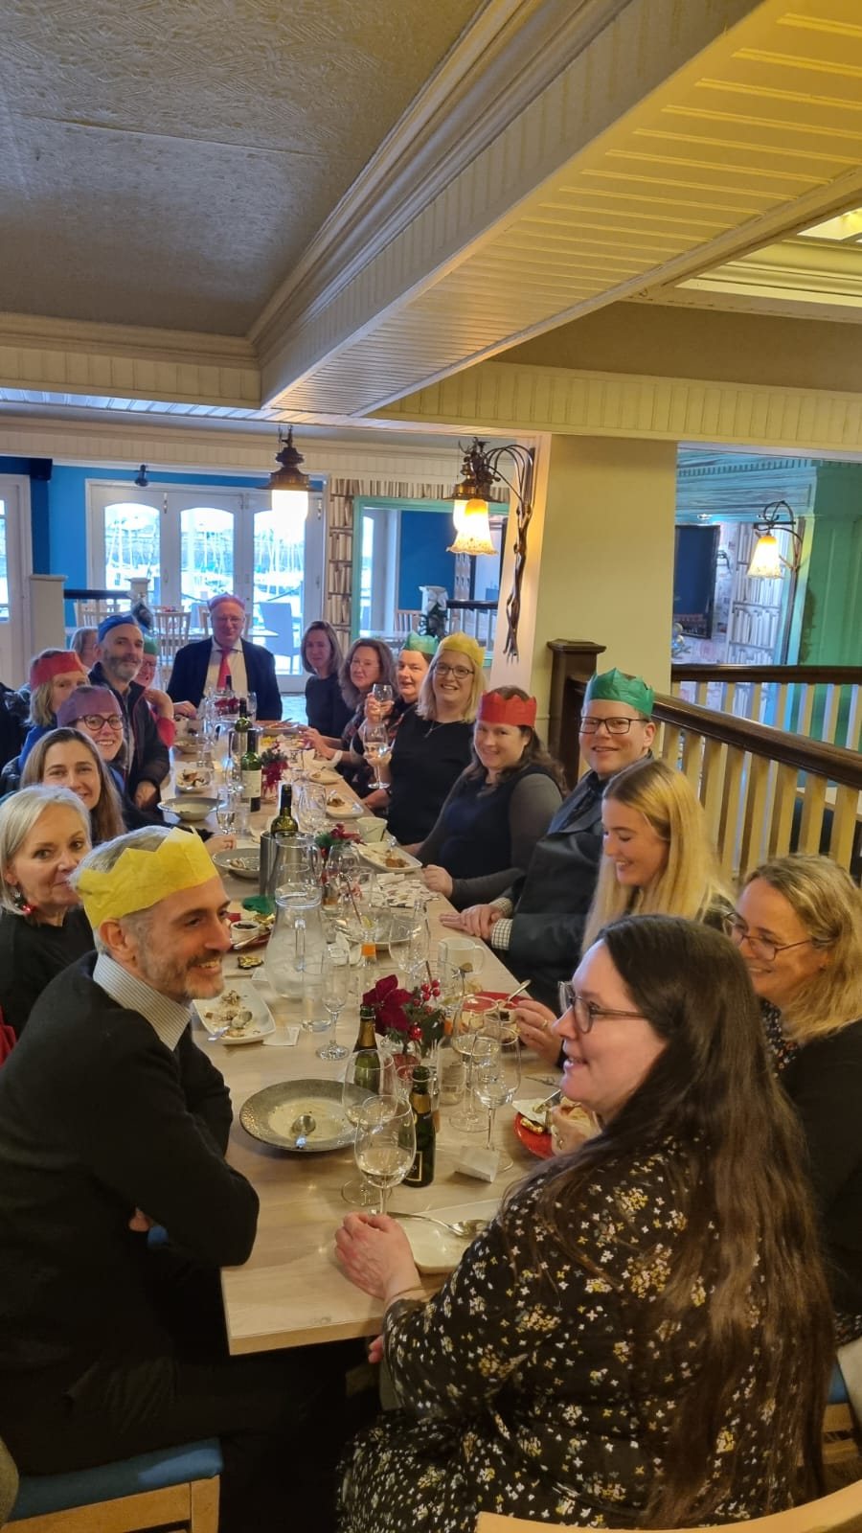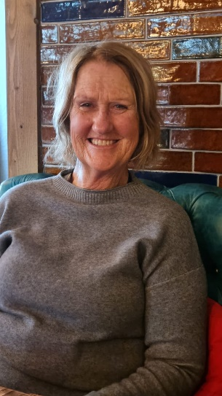

## Meanwhile, in the Computer-Readable Legislation Project…

Matthew Waddington

On 8th December Jersey's Legislative Drafting Office held an event on "The future of AI in Law" for local computer science students and law students. We laid on breakfast, gave introductory presentations and then split the students into groups (mixing computing and law students) to work together on translating legislative provisions into formats that a computer can read, or seeing whether AI can help with answering questions about how the legislation would apply in any scenario. The law students picked which piece of legislation to tackle and the computing students picked what coding/AI to use.

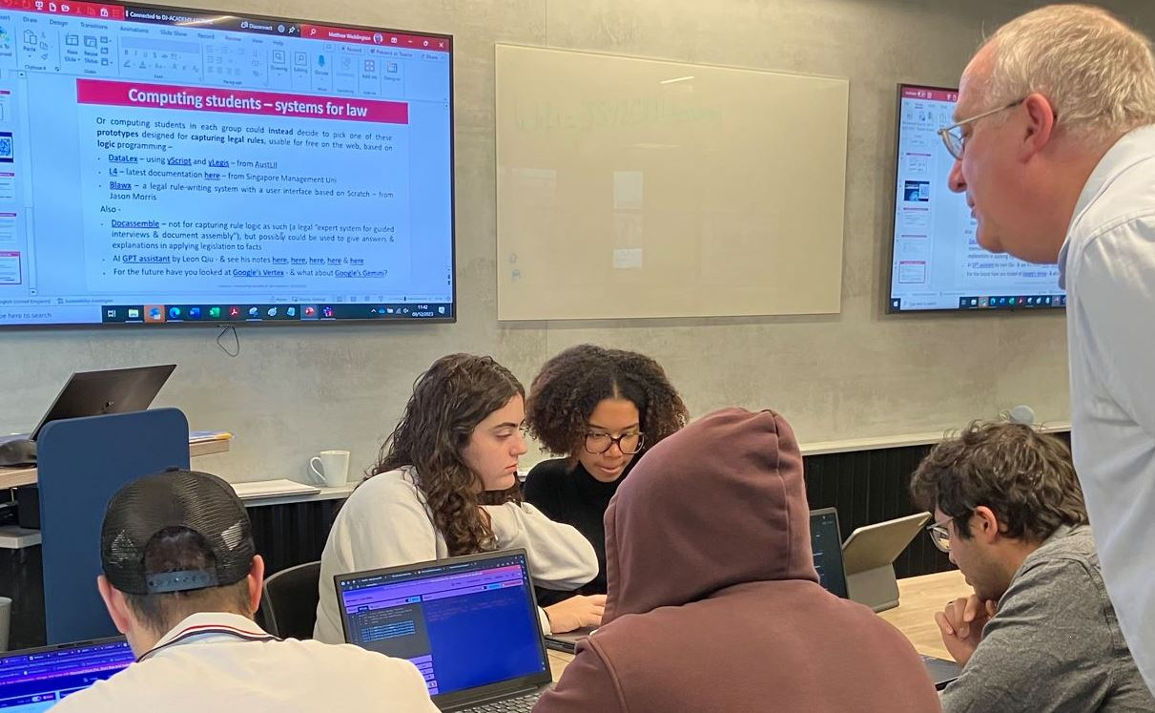We were helped by Highlands College, the Institute of Law and Digital Jersey, and our student intern Margaux McQuilton did much of the work. We have also taken on a new postgrad assistant, Leon Qiu, who set up a version of ChatGPT specifically to look at legislation. Our preparation was helped by the creators of two of the leading systems for computational law - Meng Weng Wong of Singapore Management University for the L4 system (<https://github.com/smucclaw/baby-l4>) and Jason Morris (who was working on Rules as Code for the Canadian government till recently) for his Blawx system (<https://dev.blawx.com/>).

Interestingly the main reaction from the computing students was that they reckoned they could use systems & AIs they were already familiar with, whereas our suggestions looked like having to learn another programming language. One system they used was Flowgorithm (<http://www.flowgorithm.org> - it is free, but has to be downloaded) which lets you create flowcharts and then automatically converts them into your chosen programming language. We were encouraged by the way the students from the different disciplines were able to cooperate. We will publish more details in our Substack - <https://digitallegislation.substack.com/>.

# Recent publications and postings

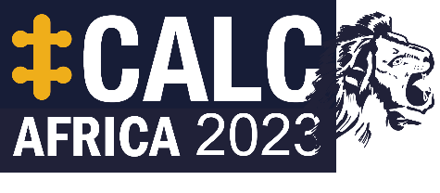CALC Africa conference, Mombasa, 23-25 October 2023 – presentations now [available online](https://calc.ngo/node/436) (requires Member login). Relive the moment or find out more detail following the report in this Newsletter.

A timely [post on LinkedIn](https://www.linkedin.com/posts/mariyab_copyright-in-legal-information-open-law-activity-7129722385485758465-Re5K?utm_source=share&utm_medium=member_desktop) from Mariya Badeva, Co-Founder of Laws.Africa, on copyright in legal information in Africa. With many private and public institutions interested in analysing legislation, judgments and other sources and creating new tools with them (including AI built on targeted LLMs), who has control and what is possible?

[*Design Principles for Integrated Legislation Drafting Environment*](https://papers.ssrn.com/sol3/papers.cfm?abstract_id=4556959), by

**“…legislation is a social and societal art of the highest order.”**

This is one of many publications and posts that are found thanks to Matthew Waddington (of the Jersey Legislative Drafting Office) and his remarkable ability to find technology in legislation. Keep up with him on [LinkedIn](https://www.linkedin.com/in/matthew-waddington-04084429/). See also [this post](https://www.linkedin.com/posts/legislative-drafting-office-jersey_the-legislative-drafting-office-jersey-was-activity-7140391153756954624-ESSK?utm_source=share&utm_medium=member_desktop) about a recent AI and Law event put on by the Jersey office.

You can also try this blog about ‘[what LLMs cannot do](https://ehudreiter.com/2023/12/11/what-llms-cannot-do/)’, which folds back into the AI and Law event because what is often wanted from AI in law fields is reasoning and understanding how the structure of legislation works. So you can also try the NLP angle by [catching up with Jerrold Soh](https://www.linkedin.com/posts/jerroldsoh_i-was-honoured-to-keynote-this-years-natural-activity-7140232017543065601-b4t7?utm_source=share&utm_medium=member_desktop).

Explore the [LegisTech library](https://library.bussola-tech.co/) from Bússola Tech. Full content of articles requires a paid subscription, but requests can also be made for content without a subscription.

**“…dedicated to ensur[ing] collaborative learning and exchange about legislative governance, modernisation and digital transformation.”**

Other adventures can also be had in various jungles of [computational law](https://law.mit.edu/) at law.mit.edu. See Dazza Greenwood’s overview on [LinkedIn](https://www.linkedin.com/pulse/lawmitedus-latest-computational-law-publications-genai-greenwood-z4myc%3FtrackingId=XiQtWs1UQmyIPmbBngKTQw%253D%253D/?trackingId=XiQtWs1UQmyIPmbBngKTQw%3D%3D), and watch for when there are more details of the next Workshop in January.

**“…there is so much innovation now, and such a need for sharing of good ideas and best practices...”**

Dig around for Rules as Code and other interesting developments in the [Global Trends in Government Innovation 2023](https://oecd-opsi.org/publications/trends-2023/) report.

**“When looking at the latest public sector innovation efforts, two leading themes become apparent. The first is the advancement of the Rules as Code concept...”**

The International Association of Legislation (IAL) recently had its annual conference and general assembly in Depok, Indonesia. See the [pictures and program on their website](https://ial-online.org/photos-of-the-ial-conference-general-assembly-december-2023-indonesia/).

**“…characteristics of democracy include public oversight, such as public engagement or involvement in … law-making...”**

# Coming up…events in person and online

## IALS Legislative Drafting Course

**When**: 10 June – 5 July 2024

**Where**: Online (synchronous), but with an option to attend the first week in person (in London).

For more information, and the course brochure and application form, see the [IALS website](https://ials.sas.ac.uk/study-with-us/short-courses-summer-schools/legislative-drafting-course).

# New CALC members

Below are the new members who have joined CALC since 18 October (when the last update was published). Welcome to all!

Want to join these members? Use the [online registration form](http://www.calc.ngo/user/register).

| Name | Country/Area |
| --- | --- |
| Benjamin Daigle | Canada |
| Christal Parris-Campbell | Jamaica |
| Shanae' Petty | Bahamas |
| Aida Farihan M Salem | Malaysia |
| Andre Bascoe | Jamaica |
| Marcellinus Edet | Nigeria |
| Owen Charles Chuma | Malawi |
| Danielle Francis | Bahamas |
| Molefinyana Phera | South Africa |
| Fatou L. Njie | Gambia |
| Umma Devi Loganathan | Malaysia |
| Ellen Gervas Rwijage | United Republic of Tanzania |
| Sheena Hadi | Malaysia |
| Nurul Ashiqin Zulkifli | Malaysia |
| Maggie Burlington | Canada |
| Siti Nur Ikhlas Bustami | Malaysia |
| Syahdatul Kamilah Zakaria | Malaysia |
| Norliyana Abdul Manaf | Malaysia |
| Chresencia Mathayo | United Republic of Tanzania |
| Christine Mududa | Kenya |
| Zeinab Jirma | Kenya |
| Ananda Devi Dhurjon | Guyana |
| Lydia Martina Choma | United Republic of Tanzania |
| Shamsu Yahaya | Nigeria |
| Kuni Jane Caroline Ditira | South Africa |
| Lerato Mamochekoane Natasha Ntho | South Africa |
| James Gaetani | Australia |
| Asha Mamtora |  |
| Aisha de Four | Trinidad and Tobago |
| Wanjiru Githunguri | Kenya |
| Sihle Masukela | South Africa |
| Maryam Ibrahim Abdulkadir | Nigeria |
| Vitjitua Kazapua | Namibia |
| Catherine Brydges |  |
| Boniphace Giyabe | United Republic of Tanzania |
| Isaac Kuloba | Kenya |
| John Kuyela Kidando | United Republic of Tanzania |
| Margaret Mercy Ooga | Kenya |
| Charity Shaibu Rangi | United Republic of Tanzania |
| Nicole Parris | Barbados |
| Victoria Carmichael | Canada |
| Angela Kagunyi | Kenya |
| Ricardo Rodrigues de Oliveira | Portugal |
| Paul Adara Adiwu | Nigeria |
| Charles Munyua | Kenya |
| Hadijah Yahyah | Uganda |
| Adrian Miller | Australia |
| Syarifah Mohamad Aminallah | Malaysia |
| Isma Juliana Ishak | Malaysia |
| Adewumi Opaleye | Nigeria |
| Hamielia Hamizan | Malaysia |
| Siti Illyana Mohd Nawi | Malaysia |
| Sharizad Hanim Amir | Malaysia |
| Siti Syuhada' Alwi | Malaysia |
| Zaihas Syakhir | Malaysia |
| Roxanne Naidoo | South Africa |

# Newsletter information

The Newsletter is published on an ad hoc basis by the CALC Council. It contains articles, news and other updates on anything of interest to drafters of legislation and the staff and agencies that support them. The items are written by members and friends of CALC from around the Commonwealth.

As always, huge thanks and appreciation to everyone who contributed to this Newsletter and all the Newsletters throughout this 40th anniversary year – articles, pictures, news, suggestions, reassurance, proofreading – everything.

If you have an item you would like included in the next edition of the Newsletter, contact CALC’s Secretary (and Newsletter editor), Kate Hannah: [k.hannah@gov.je](mailto:k.hannah@gov.je).

You can also ask about membership, or any other CALC matter.

1. Among the recent significant initiatives are those of the Canadian Government sponsored *Improved Access to Justice in the Caribbean Project* (IMPACT Justice), which developed a ***Manual on Legislative Style and Practice*** in order to address the lack of a manual for legislative drafting in several CARICOM jurisdictions and the need for uniform practices in legislative drafting in the region, complementing its previous *Manual on the Legislative Process and Drafting Instructions*, primarily for instructing officers, and indicating the common practice among CARICOM Member States, even the current practices elsewhere in the Commonwealth while recommending occasionally a particular practice widely used in the region. It may be accessed at: <https://caribbeanimpact.org/website/wp-content/uploads/2018/08/IMPACT-Justice-Drafting-Legislation-in-CARICOM-Member-States-A-Manual-on-Legislative-Style-and-Practice.pdf>.
2. The Caribbean Forum of 15 States of the African Caribbean and Pacific (ACP) Group of States, namely Antigua and Barbuda, The Commonwealth of The Bahamas, The Republic of Barbados, Belize, The Commonwealth of Dominica, The Dominican Republic, Grenada, The Cooperative Republic of Guyana, The Republic of Haiti, Jamaica, St. Kitts and Nevis (formerly Saint Christopher and Nevis), Saint Lucia, Saint Vincent and the Grenadines, The Republic of Suriname, and The Republic of Trinidad and Tobago.
3. <https://trade.ec.europa.eu/access-to-markets/en/content/eu-cariforum-economic-partnership-agreement>
4. Funded by the 11th European Development Fund under the wider project “Support to CARIFORUM Member States in furthering the Implementation of their Economic Partnership Agreement commitments and in meaningfully reaping the benefits of the Agreement” (FED/2018/040-087).
5. ARCA Consortium is a Madrid, Spain based consulting firm founded in 1983 that specializes in managing policies and funds for global cooperation and public administration. In the international field, it has developed projects and studies for organizations such as the European Commission, the Inter-American Development Bank, and the International Monetary Fund. See further: https://www.arcaconsortium.net/
6. These were the targeted stakeholders from the public sector working on matters related to legal drafting and/or implementation of the EPA.
7. English, Spanish, French and Dutch.
8. This included online and printed literature from the following:

   legislative drafting manuals

   legal journals, periodicals, textbooks on legislative drafting, precedents, rule of law and new theoretical approaches to legislative drafting

   legal journals, periodicals, textbooks pertaining to the use of drafting resources and technology in the legislative drafting process
9. See History of the Conference at <https://www.ulcc-chlc.ca/About-ULCC/History>.
10. See Proceedings of the 2nd Annual Uniform Law Conference of Canada, available on the ULCC website at <https://www.ulcc-chlc.ca/ULCC/media/Proceedings-2006-1994/1919-Winnipeg-Proceedings.pdf>.
11. See R. Sullivan, *The Construction of Statutes*, 7th ed. (Lexis Nexis Canada: Toronto, 2022) at 204.
12. Oliver Wendell Holmes, Jr., *The Common Law* (Mark de Wolf Howe ed, Little Brown and Company 1963 (1st ed 1881) 5.
13. The revised conventions are available on the ULCC website at <https://www.ulcc-chlc.ca/ULCC/media/EN-Annual-Meeting-2023/Drafting-Conventions-%e2%80%93-as-approved.pdf>.
14. <https://www.bbc.com/news/entertainment-arts-67271252>
15. For those also without these very British traditions, see this information about [mince pies](https://www.bbc.co.uk/food/recipes/classic_mince_pies_47103) and [Christmas crackers](https://www.historic-uk.com/CultureUK/Christmas-Crackers/#:~:text=Christmas%20crackers%20are%20a%20British,in%20a%20twisted%20paper%20package.).