|  |  |
| --- | --- |
| CALC logo | **Newsletter**  April 2024 |

Contents

President’s report 2

CALC Conference 2

Proposals for constitutional change 2

Commonwealth Law Ministers Meeting 3

CALC Presidency 4

CALC Jamaica Conference 2024 – coming very soon! 5

CALC Council – meeting 25 March 2024 6

Are you lost to us? 7

**Jessica DeMounteney – new First Parliamentary Counsel UK** 8

What’s happening in Belize 8

Western Australia – staff updates 9

Our new office space, empowering new ways to work 11

Jersey trees 14

Update from Jersey’s Computer-Readable Legislation Project 14

Legislation for AI – Legislation with AI 16

Sex-specific language in UK legislation 17

Recent publications and postings 18

Coming up…events in person and online 22

CIAJ – Legislative Drafting Conference 22

iLegis – International Conference on Legislation and Law Reform 22

International Legislative Drafting Institute 22

IALS Legislative Drafting Course 23

New CALC members 23

Newsletter information 25

​​Published online at [calc.ngo/publications/newsletters](http://www.calc.ngo/publications/newsletters)

Editor: Kate Hannah, c/- Legislative Drafting Office, Morier House, St Helier, Jersey.

k.hannah@gov.je

# President’s report

## CALC Conference

The CALC Council are in the midst of finalising arrangements for next month’s Conference in Jamaica. Delegates have registered from all across the Commonwealth and we will have papers from members in every region on a wide range of legislative drafting related topics.

It is shaping up to be a marvellous event and I am very appreciative of the enthusiasm and effort of the Council in supporting delivery of our flagship event, with Vice-President Michelle Daley in particular using her local connections to make sure that CALC will return to the Caribbean in fabulous style.

The Conference follows on from last year’s excellent regional Conferences in Wales, Australia and Kenya. Holding events across the regions has helped make CALC more accessible to a wider range of members and by the time we meet in Jamaica well over 500 members will have attended a CALC Conference within a single calendar year.

It has been particularly pleasing to see many newer drafters attending their first ever CALC events and hopefully making connections and friendships that will endure throughout long careers in legislative drafting. Having the opportunity to participate in CALC events not only provides great learning opportunities, it also provides a great morale boost among drafters attending and I strongly encourage every head of a drafting office to facilitate participation in future CALC events by drafters at every stage in their career.

More information is provided below for those still keen to join us in the Caribbean. Note that the closing date for registrations is 26 April.

## Proposals for constitutional change

This newsletter is accompanied by notice of proposals for various amendments to CALC’s constitution which the Council agreed at our meeting on 25 March.

Some of the changes will help facilitate a more permanent move to one member, one vote electronic voting for CALC general meetings and will provide future Councils with the opportunity to use electronic voting to ensure that any regional representatives appointed in regional elections are the favoured candidates in those regions.

Another amendment will break the requirement to host CALC general meetings (and full CALC Conferences) in conjunction with Commonwealth Law Conferences, giving the Council discretion to choose future locations subject to guidance to seek to secure rotation around the Commonwealth regions.

The final changes adjust administrative processes for attaining membership and for contacting, or terminating the membership of, lost or defunct members. These have become necessary as the effect of spam and email controls on our ability to send mass mailshots and the need to comply with data protection requirements have made compliance with current constitutional requirements unworkable.

I offer special thanks to CALC Council member Neil Martin who has led the development and drafting of these changes and extend my appreciation to the many Council members who have engaged with the process of developing the special resolutions. All of the proposals have the support of the Council and I encourage you support them all when called on to vote electronically in the week beginning 23 April.

## Commonwealth Law Ministers Meeting

I was pleased to be invited to represent CALC at the recent CLMM hosted in Zanzibar by the United Republic of Tanzania. Attorney Generals and Law Ministers from every part of the Commonwealth participated in the meeting which was held under the theme: “Technology and innovation: how digitalization paves the way for people centred access to justice”.

Secretary General of the Commonwealth, Baroness Patricia Scotland, opened the Meeting by urging Commonwealth nations to harness technology and encourage innovation in order to better meet the justice needs of every Commonwealth citizen.

As at recent CALC Conferences, the emergence of artificial intelligence was a key theme with Professor Richard Susskind presenting on the tremendous opportunities and somewhat terrifying risks that AI presents, observing that AI will become an enabler of the rule of law with potential to create legal rules, including legislation, in the form of code.

I addressed the meeting on the final day to update Ministers on CALC’s recent activities and to invite them to formally recognise the importance of well-drafted legislation to the rule of law, to support the participation of legislative counsel in CALC activities and to encourage continued collaboration between the Commonwealth Secretariat and CALC.

I was able to engage with senior Law Ministers from all across the Commonwealth over the course of the meetings. All were full of praise for the work done by legislative counsel in their respective jurisdictions, albeit with many emphasising the difficulty they have in obtaining the specialist expertise they need and keen to discuss how best to advance legislative capacity and capability across the Commonwealth.

I also enjoyed meeting a number of CALC members who were supporting their national delegations and with Presidents and representatives from other accredited Commonwealth legal organisations all of whom expressed enthusiasm for developing bonds with CALC.

At CLMM Tanzania 2024 – Malcolm McMillan (CALRAS Secretary-General) Felicity !Owoses (CALC Council Africa representative), Andy Beattie (CALC President) and Liz Macharia (acting Head of Rule of Law, Commonwealth Secretariat)

## CALC Presidency

The Jamaica Conference will mark the end of my term of President. I have very much enjoyed the past couple of years, and particularly having the opportunity to engage with so many wonderful CALC colleagues all around the world.

I will reflect more fully on my own time as President in my report to the Conference but offer a few words to you now.

At our first Council meeting following the virtual Conference held in 2022 we agreed to make CALC’s 40th anniversary year a fulcrum to reinvigorate connections between CALC members after the disruption of the pandemic. I am pleased and proud at how much we have achieved—

* over 500 delegates attending 4 Conferences across every region
* Loopholes and Newsletters issued at our most prodigious rate
* the new CALC Group on AI and Legislation is a first step towards using new technologies to bring members together more regularly online
* CALC’s finances remain in a healthy state
* CALC’s membership continues to increase as we head towards 3000 members

Personally, I have been delighted to be able to attend events and meet with legislative counsel in drafting offices all across the world, learning lots and encouraging engagement with CALC at every opportunity.

It has also been a privilege to have been able to promote CALC among Commonwealth Law Ministers and to forge stronger connections with Commonwealth Secretariat, the Commonwealth Lawyers Association, Commonwealth Association of Law Reform Agencies and numerous other partner organisations and associations.

I have made the most of every opportunity to connect with senior lawyers, judges, politicians, academics and royalty to promote the invaluable work done by legislative counsel, to emphasise the importance of good legislative drafting and to secure support for the activities of CALC and its members.

CALC is built entirely on the discretionary effort of its members and, in particular, of its Council. It has been a pleasure to collaborate with my Council colleagues and I am extremely grateful for every contribution made. Particular thanks are of course due to Secretary Kate Hannah and Treasurer Annalee Murphy, both of whom will also stand down from Council, and to Michelle Daley who I am delighted will be re-appointed as Vice-President for another term.

I also offer a special thanks to John Mark Keyes for his remarkable contribution as long standing editor-in-chief of the Loophole, a role from which he will step down on imminent publication of the next edition.

Finally, I was honoured to nominate and support my colleague and friend Dr Johnson Okello to succeed me. With the initial nomination period now closed, it is now confirmed that Johnson will be CALC’s first ever President from Africa. I am also pleased to be able to congratulate Annette O’Callaghan from New South Wales PCO and Adrian Hogarth from OPC UK on becoming the new Secretary and Treasurer. All 3 will take up office at the general meeting to be held during the Jamaica Conference and are sure to bring fresh ideas and new energy to CALC. Working together with Michelle and regional representatives, I am sure that the new Council will move CALC onwards and upwards and their willingness to dedicate their own time for the good of as all should be warmly appreciated by every member.

Vacancies remain for a Council regional representative from each of the Asia and Australasia/Pacific regions, and I encourage colleagues in those regions enthusiastic about being more involved in CALC’s future direction to seek a position on the next Council. Details of how to nominate are [on the website](https://calc.ngo/) (see the information about the CALC general meeting).

CALC is very well placed to go forward from strength to strength and I will be offering my wholehearted support to the next CALC Council as an ex officio member. I look forward to being actively involved with CALC matters, and connected with the extended CALC community, for many years to come.

Best wishes,

Andy Beattie

CALC President

# CALC Jamaica Conference 2024 – coming very soon!

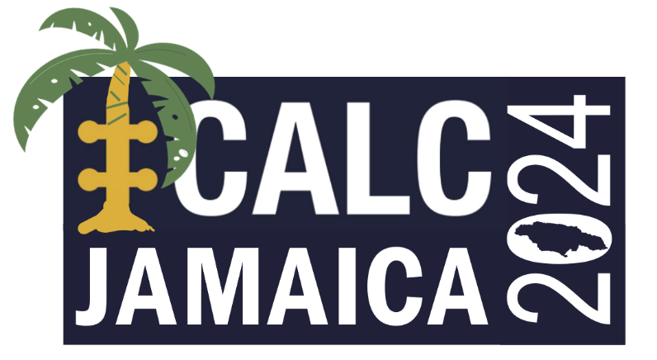

**When:** 13-15 May 2024

**Where:** [Ocean Eden Bay Hotel](https://www.oceanhotels.net/en/jamaica-hotels/ocean-eden-bay) in Trelawny, Jamaica.

CALC’s celebration of our 40th year concludes with our first full in-person Conference in 5 years. Following our hugely successful regional events held throughout 2023 in Europe, the Asia-Pacific and Africa, the next full CALC Conference will be held in the Americas region with a long overdue return to the Caribbean.

**Yes, you can still register!**

Register for the conference here: [REGISTER FOR CALC JAMAICA 2024](https://www.tickettailor.com/events/calc/1070580).

The conference fee is $595 USD. This fee covers all days of the Conference and the Gala Dinner on 14 May.

Delegates wishing to bring a guest to the Gala Dinner can do so for $75 USD.

We intend to leave registration open until 26 April 2024 but may need to close registration earlier if capacity limits are reached, in which case a reserve list will be available.

**We strongly encourage members to register and book accommodation as early as possible**. The special accommodation rates available at the conference hotel are limited (see below).

The conference fee is on the basis that delegates are staying at the Ocean Eden Bay Hotel (see below), which is an all-inclusive hotel. If delegates are not staying at the Ocean Eden Bay (or its sibling Hotel, the Ocean Coral Spring), a supplement of $95 USD is payable directly to the Ocean Eden Bay for each day at the conference venue.

If you have problems arranging payment online, please contact the CALC Treasurer, Annalee Murphy, at [annalee.murphy@gov.scot](mailto:annalee.murphy@gov.scot).

**Accommodation and other information**

We secured a limited number of rooms at the at the Ocean Eden Bay at special rates which were available until 28 March 2024, but we expect delegates should still be able to book at the special rates unless the room type is sold out. The registration confirmation page contains a link to book accommodation, and also an airport transfer link.

Further information about the conference, including information on travel and visas, is available in the [Delegate Information on the CALC website](https://www.calc.ngo/sites/default/files/CALC%20Conference%202024%20-%20Logistics.pdf).

**Call for papers**

The call for papers is now closed – thank you to everyone who submitted ideas and papers. A draft programme is being prepared!

**General meeting of CALC**

As provided in [CALC’s constitution](https://www.calc.ngo/sites/default/files/documents/CALC_Constitution%20%282%20April%202019%29_0.pdf), there will also be an ordinary general meeting of CALC at the conference in Jamaica, on 14 May. Formal notice of the meeting has been given and a special resolutions proposed by the Council. The initial nomination period for Council members has closed (a further period is now open for the remaining positions). See the [general meeting information](https://calc.ngo/sites/default/files/CALC%20general%20meeting%202024.pdf) for the various deadlines. Voting on the special resolutions and for any regional representatives will open on 23 April.

# CALC Council – meeting 25 March 2024

The Council met online on 25 March to discuss proposals for special resolutions to amend the CALC Constitution to update provisions about electronic voting and managing member accounts (see below about updating yours!), among other things. The special resolutions are now available on the [2024 Conference webpage](https://calc.ngo/CALC-Jamaica-2024) (requires Member login), along with a marked up copy of the Constitution showing the effect of the proposed changes. Members will be able to vote on the resolutions ahead of the general meeting at the Conference in May.

The Council will meet again on 15 April to finalise planning for any elections or ballots, the requirements for the general meeting and Conference details.

# Are you lost to us?

 We have lots of members whose emails no longer work, and lots of members who have not logged into their account for a long time. Are you one of them?



Are you here? (picture: molotovcoketail on iStockphoto.com)

Let us know you are still an active member by logging on to [calc.ngo](https://calc.ngo/) and making sure your contact details are up to date. There is some [information](https://calc.ngo/sites/default/files/CALC%20-%20how%20to%20update%20details%20and%20reset%20password.pdf) on the [Contact Us](https://calc.ngo/contact-us) page about how to update things. If you haven’t received any emails from us this year, we cannot find you!

Leading up to the ordinary general meeting of CALC held as part of the Conference in Jamaica, if you want to be involved in elections for your new Council and vote on changes to CALC’s constitution (and we would love you to be) we need to know who you are and you have to be able to access information by logging in. So, why not do it now?



Or here? (picture: molotovcoketail on iStockphoto.com)

And while you are logged in, why not check out the presentations from the [3 Conferences](https://calc.ngo/members/papers) last year or [who is running for Council](https://calc.ngo/CALC-Jamaica-2024)?

**Jessica DeMounteney – new First Parliamentary Counsel UK**

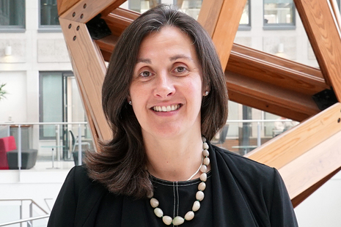Congratulations to Jessica DeMounteney on her appointment as the new First Parliamentary Counsel, Office of Parliamentary Counsel, UK Government - [https://www.gov.uk/government/news/](https://www.gov.uk/government/news/new-first-parliamentary-counsel-appointed)

Jessica was called to the Bar in 1994 and joined OPC in 1997. She has been responsible for the drafting of legislation for Ministry of Justice, Home Office, Ministry of Defence, Cabinet Office, and the Scotland, Wales and Northern Ireland Offices. She has also worked twice for the Law Commission of England and Wales, first from 2003 to 2006 and again from 2015 to 2018 as the Senior Drafter there.

Jessica has attended and presented at numerous CALC events and colleagues will look forward to seeing her again in the future.

Jessica will replace Dame Elizabeth Gardiner who steps down following a 9 year stint as First Parliamentary Counsel, and a remarkable career of more than 32 years in OPC.

# What’s happening in Belize

Randall Sheppard, Assistant Solicitor General (Legislative Drafting)

In February, the Judiciary of Belize, in collaboration with the United Nations Development Programme (UNDP) and other Government Ministries, launched the Partnership of the Caribbean and the European Union on Justice (PACE Justice) Project. The principal objective of the Project is to enhance the institutional capacities of police forces, prosecutors, attorneys, courts, and prisons in the Caribbean to effectively manage criminal cases given the major backlog of criminal cases caused by delays within several stages of the criminal justice process. The objective of this Project also coincides with the Needham’s Point Declaration adopted in October of 2023, which embodies experiences, best practices and recommended actions to improve criminal justice.

As a primary implementing partner for the Project, the Attorney General’s Ministry has been playing an active role by having Counsel from the Legislative Drafting Unit sit as members of the Board. To further the Needham’s Point Declaration, the Legislative Drafting Unit has also been instrumental in enacting laws that provide for the diversion of juvenile offenders and the rehabilitation and reintegration into society of offenders. Recently, the Legislative Drafting Unit completed the drafting of the Alternative Sentencing Act, the Criminal Records (Rehabilitation of Offenders) Act, and the Criminal Procedure (Plea Discussion and Plea Agreement) Act. Together, these laws form part and parcel of the strategy to tackle the issues plaguing the criminal justice system in Belize.

The Attorney General’s Ministry is also currently in the process of consolidating the subsidiary laws of Belize to 2020. In Belize, law revision is done periodically, but the last time this exercise was done for the subsidiary laws was in 2003. Law revision was initially outsourced; however, with the Attorney General’s Ministry aiming to have law revision done annually or more frequently, the establishment of the Law Revision Unit was deemed necessary to meet such goal. The establishment of a Unit dedicated to law revision will allow the public to have access to more up-to-date edition of the laws as often as necessary.

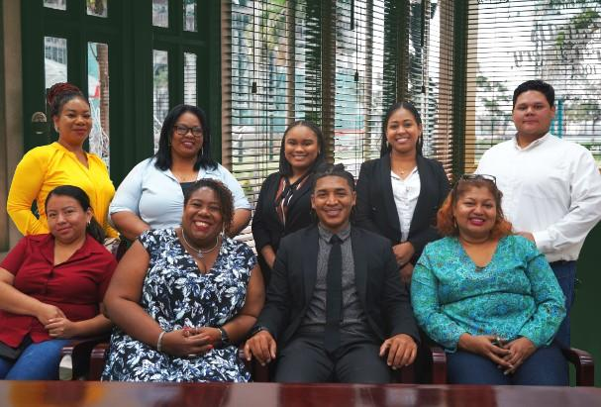CALC Vice President Michelle Daley (a former Commonwealth Secretariat/CFTC Expert to Belize) recently visited our office and spent time talking to staff about the benefits of CALC membership. Several drafters took the opportunity to apply for membership and are looking forward to interacting with other CALC members in the future.

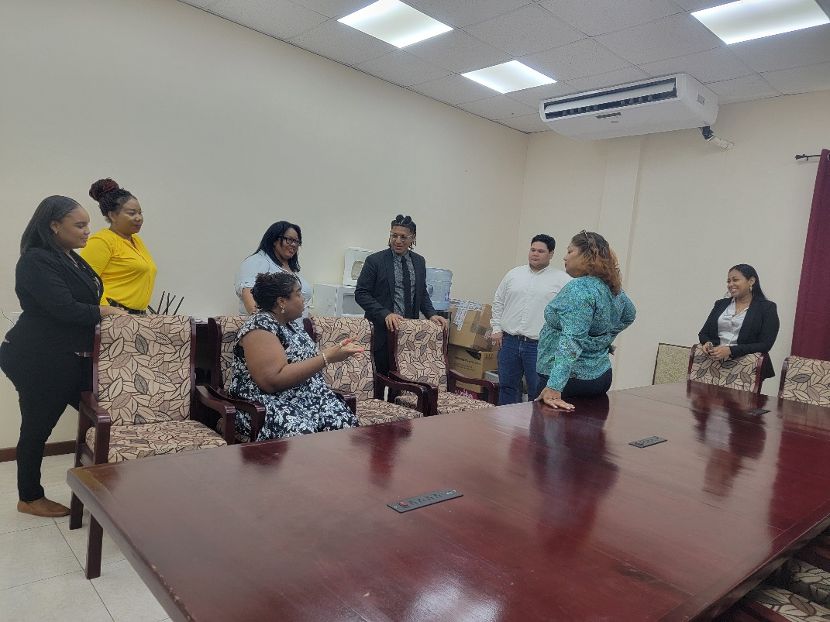

# Western Australia – staff updates

**Michael Andrews** joined us on 4 September 2023 as a Senior Assistant Parliamentary Counsel. Michael comes to us from the NSW PCO, where he has been a drafter since 2013. His most recent position was as a Senior Assistant Parliamentary Counsel (senior executive band 1). Michael holds a Bachelor of Laws (Hons 1)/Bachelor of Creative Arts (with distinction) from the University of Wollongong. Michael also holds a Joint Master of Parliamentary Procedures and Legislative Drafting from LUISS Guido Carli in Rome (Italy), Universidad Complutense de Madrid (Spain) and the Institute of Advanced Legal Studies at the University of London (UK).

**Richard Marlin** and **Roger Jacobs** have been appointed as Deputy Parliamentary Counsel, effective 18 December 2023.

Both Roger and Richard are very experienced legislative drafters, who previously held office as Senior Parliamentary Counsel in PCO.

These appointments fill the vacant Deputy Parliamentary Counsel position formerly held by Una Couper, who retired earlier this year, and an additional Deputy Parliamentary Counsel position created recently.

***Retirement of Dan Djurdjevic***

On 30 November 2023, the Leader of the House in the Legislative Assembly, the Hon. David Templeman, made a Brief Ministerial Statement on behalf of the Attorney General to acknowledge the retirement of Dan Djurdjevic from PCO.

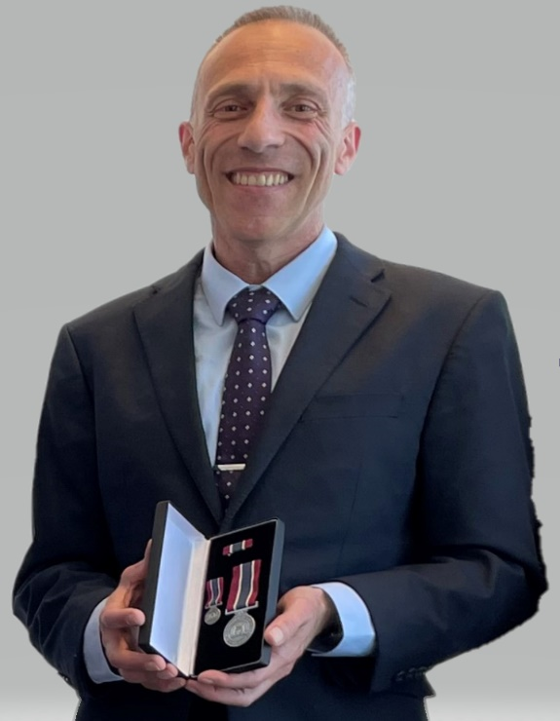

Dan Djurdjevic and his Public Service medal in 2021

Dan retired from PCO in early 2024. He began working in PCO in November 1995 as an Assistant Parliamentary Counsel, was promoted to a Senior Parliamentary Counsel level 1 position in 2019 and a Senior Parliamentary Counsel level 2 position in December 2022. He acted as Deputy Parliamentary Counsel for several months in 2023.

In October 2021, Dan was presented with a long service award recognising 30 years’ service in the WA Public Service. And in the course of that public service career, Dan made a huge contribution to the Western Australian Statute Book through the legislation he drafted.

Dan has made an outstanding contribution to PCO and the State of Western Australia, and PCO wishes him well for his retirement.

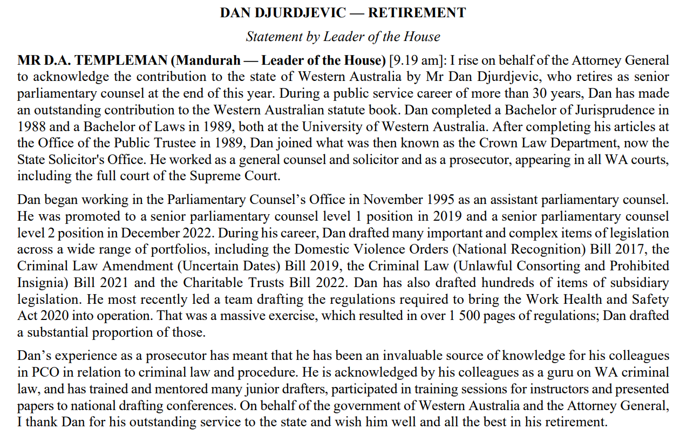

***New drafters appointed***

**Jessica Chanin** and **Luke Geurtsen** have been appointed as Senior Parliamentary Counsel. Both work remotely, Jess from New South Wales and Luke from Queensland.

Jess has worked as a legislative drafter in the NSW Parliamentary Counsel’s Office since 2010, most recently as a Principal Assistant Parliamentary Counsel. Before joining the NSW PCO, Jess was an Assistant Parliamentary Counsel in the Tasmanian Office of Parliamentary Counsel between 2004 and 2010. Jess has a Bachelor of Laws from the University of Tasmania.

Luke has worked as a legislative drafter in the Office of the Queensland Parliamentary Counsel since 2006, most recently as a Senior Assistant Parliamentary Counsel. Luke has a Juris Doctor and a Bachelor of Arts from the University of Queensland.

**Alison Ryan** has been appointed as a Senior Assistant Parliamentary Counsel. Alison works remotely from Queensland but will relocate to Perth in the first half of 2024. Alison has worked as a legislative drafter in the Office of the Queensland Parliamentary Counsel since 2014 as an Assistant Parliamentary Counsel. Before that, she has worked as a policy officer and instructor in the Queensland Public Service and as a lawyer drafting subordinate legislation in the Government Legal Service in the UK. Alison has a Bachelor of Laws (Honours) from the University of Queensland.

**Rebecca Alcock** has been appointed as a Senior Assistant Parliamentary Counsel. Rebecca works remotely from Queensland. Rebecca has worked as a legislative drafter in the Office of the Queensland Parliamentary Counsel since 2010 as an Assistant Parliamentary Counsel. Before that, she worked for several private law firms in Brisbane. Rebecca has a Bachelor of Laws (Second Class Honours) from Bond University and a Master of Laws from the University of Queensland.

**Jessica Braithwaite** has been appointed as an Assistant Parliamentary Counsel. Jess has worked in the New Zealand Parliamentary Counsel Office since May 2018 as a Parliamentary Counsel. Before that, she worked as a lawyer in a number of private law firms in New Zealand and as a Judge’s Clerk for a Judge of the New Zealand High Court (equivalent to the WA Supreme Court). Jess has a BA/LLB (First Class Honours) from Victoria University of Wellington, New Zealand.

**April Eisner** has been appointed as a Senior Assistant Parliamentary Counsel. April will work remotely from New South Wales. April has worked as a legislative drafter in the NSW Parliamentary Counsel’s Office since 2008, most recently as a Senior Assistant Parliamentary Counsel. From January 2019 to September 2020, April worked as a legislative drafter in the Jersey Legislative Drafting Office, Channel Islands. April has a Bachelor of Laws and a Bachelor of Arts (Hons) from the University of Sydney.

# Our new office space, empowering new ways to work

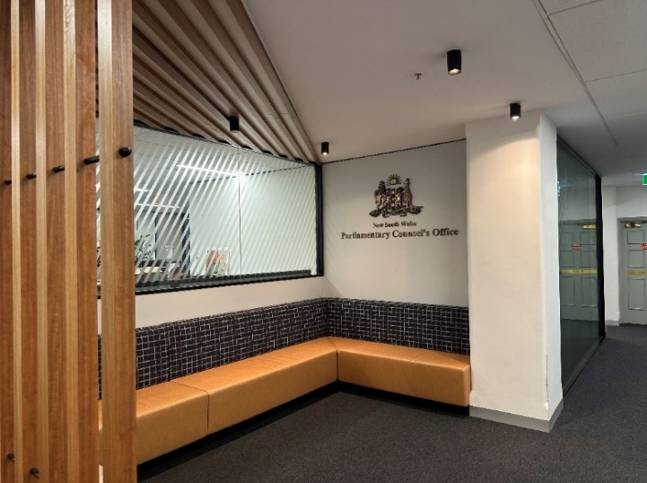

Photo 1 NSW Parliamentary Counsel's Office entry foyer pre-refurbishment in December 2023

PCO, New South Wales, Australia

The team at the NSW Parliamentary Counsel’s Office recognised that fulfilling the Office’s commitment to supporting flexible ways of working, as well as evolving requirements to optimise space, changed what we need from our work space. Feedback indicated that collaboration was often hindered by private offices and that we were lacking places for the exchange of ideas and productive conversations. After a consultative, considered and rigorous office redesign process, we tidied and packed up our office in the lead up to the Christmas and New Year’s break.

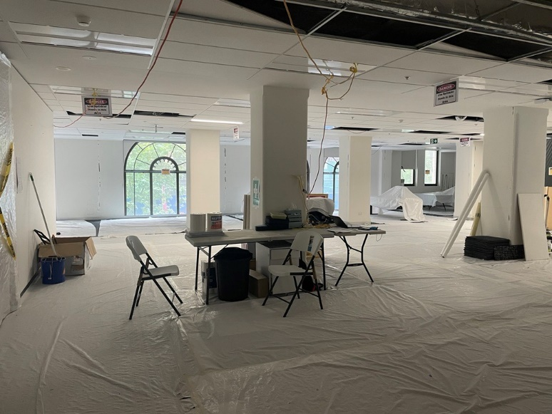

Photo 2 Mid-construction, looking from our (now open-plan) entry foyer towards Martin Place

As construction commenced in the new year, we vacated our office for eight weeks. Most team members worked remotely on a full-time basis, while a smaller proportion of the team worked from a temporary office space at WeWork. This transition period presented its fair share of challenges. Our temporary office space was very small, with 17 staff and desks squeezed into a 25m² space. We quickly had to learn to plan more effectively and book the available shared spaces such as meeting rooms, phone call booths and the kitchen. We started to build skills necessary to function in a more open plan setting, becoming more aware of the needs of others and learning how to participate in online meetings more effectively. Though many of us didn’t realise it at the time, it was a great learning experience ahead of our return to our newly refurbished office. And it provided a great opportunity to get to know each other better in an informal setting.

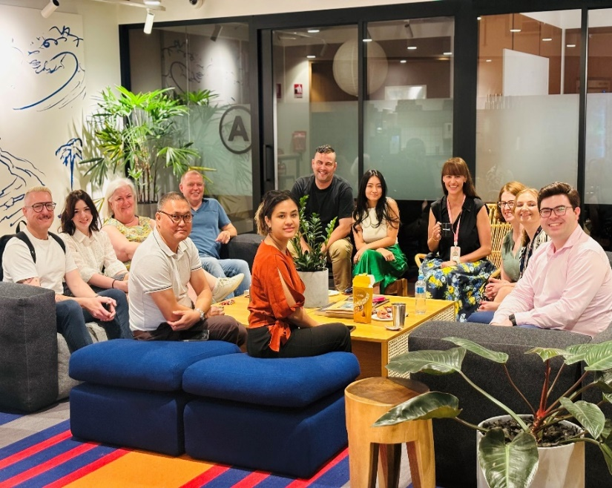

Photo 3 Colleagues gathered in a common space at our short-term office

While the substance of what we do and who we serve hasn’t change, our new work space empowers us to have more choice on the how. The office doesn’t just look different – it enables new ways of working with a focus on being adaptable and collaborative.

Our new open-plan and hot desk arrangements create opportunities for more diverse conversations. The new collaboration spaces around the office supports us to work with others in more dynamic and interesting ways. And there are still plenty of quiet places to escape to, with the equipment we need, for those moments when we really need to focus.

Exploring these new options for how we work may mean there are tricky moments. But positive change rarely comes easily. The new work space is an exciting opportunity for us to unlock new levels of service because we’re considerate, committed and bring out the best in each other. We’ll continue to be open-minded and curious about what’s possible.

Are you exploring new and different ways of working? We would love to hear your experiences. Please feel free to share with us at [pcocommunications@pco.nsw.gov.au](mailto:pcocommunications@pco.nsw.gov.au)

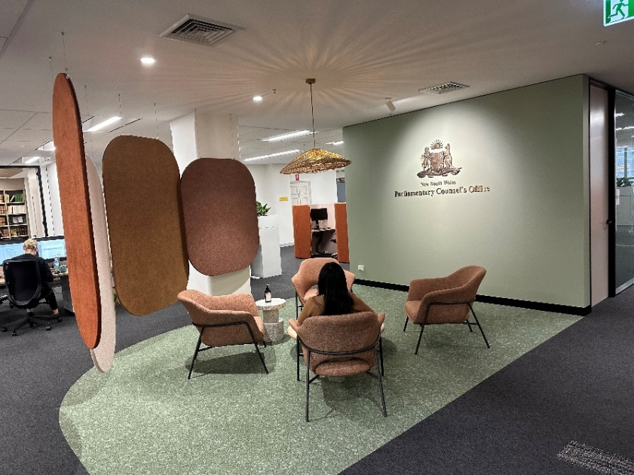

Photo 4 Our new entrance foyer

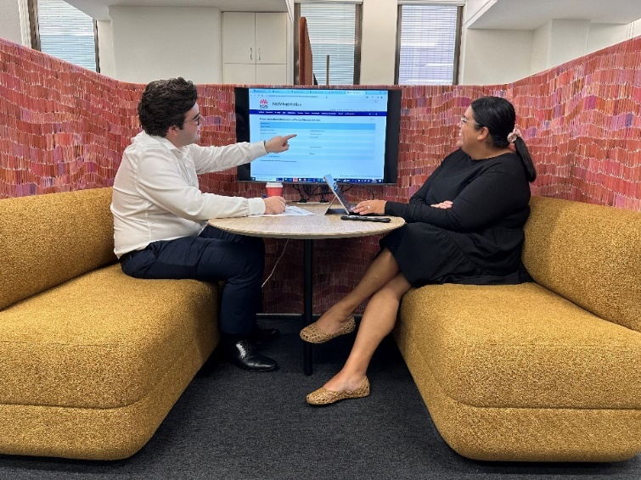

Photo 5 Collaboration hub



Photo 6 Working from our new hot-desks

# Jersey trees

Heather Mason, Legislative Drafting Office, Jersey

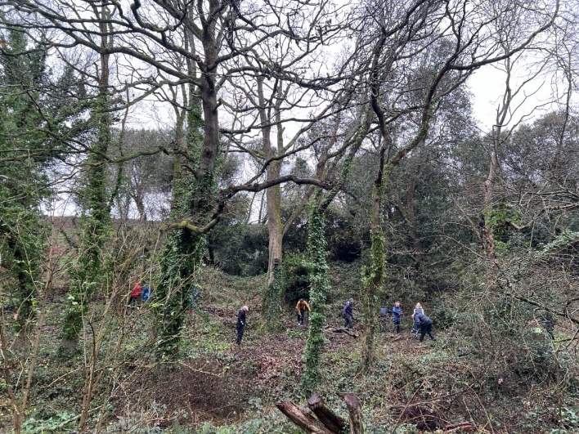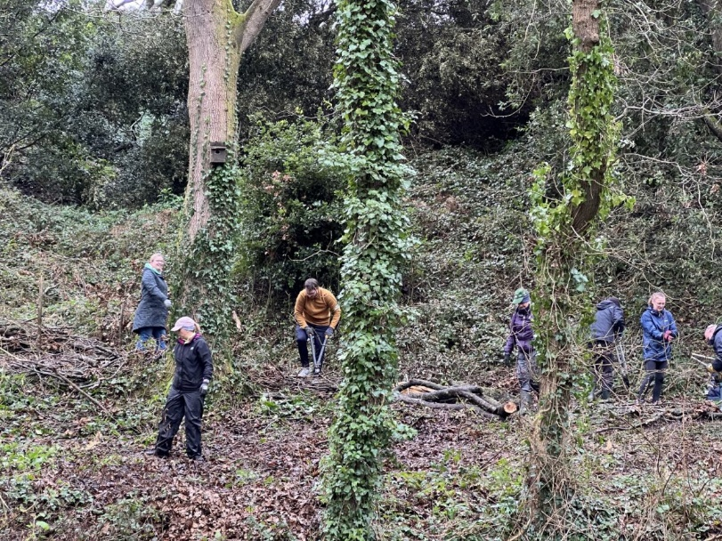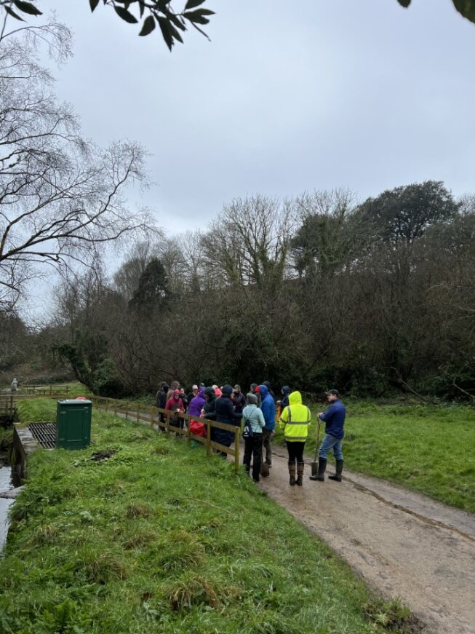Several members of the Jersey Legislative Drafting Office spent a wet and muddy February morning volunteering with Jersey Trees for Life at Val de la Mare reservoir. In October last year, Storm Ciarán caused extensive damage in Jersey, with an estimated >20,000 trees felled by the storm, and the clear-up is ongoing. Some of us were cutting back ivy from the base of tree trunks to prevent it from weakening the remaining trees. Another group was tasked with clearing and widening some of the walking paths and steps. Fallen branches were given a new purpose as ‘dead hedges’, which will become a habitat for biodiversity and help prevent soil erosion. Despite the weather, it was great to get out from behind our keyboards for a while and help to repair the damage done to our island.

# Update from Jersey’s Computer-Readable Legislation Project

We have just set up a website for the project at [https://crlp-jerseyldo.github.io/](https://link.sbstck.com/redirect/33f971cf-3295-421f-a60c-855af658d570?j=eyJ1IjoiMjR2azY1In0.01WEixLVifkNTkPK-V12DYsGXnP6T7k47bCZ3Pc59JQ) and put our latest news on [Substack](https://digitallegislation.substack.com/p/more-news-from-jerseys-computer-readable). We have also set up a site for the project on the Open Science Foundation at [https://osf.io/yzf6x/](https://link.sbstck.com/redirect/6d278dd6-7092-47f1-a0e9-a914013fbb34?j=eyJ1IjoiMjR2azY1In0.01WEixLVifkNTkPK-V12DYsGXnP6T7k47bCZ3Pc59JQ), to act as a permanent store for plans, experiments, reports and other documents that we generate. The sites feature the four current main strands of our work –

* [Artificial Intelligence and legislation](https://link.sbstck.com/redirect/c3610765-b8be-4461-80b7-3365e963bff4?j=eyJ1IjoiMjR2azY1In0.01WEixLVifkNTkPK-V12DYsGXnP6T7k47bCZ3Pc59JQ) – see below
* [Non-tech guidance & training for drafters](https://link.sbstck.com/redirect/06968330-c8c5-48fb-a972-2f937d47c280?j=eyJ1IjoiMjR2azY1In0.01WEixLVifkNTkPK-V12DYsGXnP6T7k47bCZ3Pc59JQ) – lessons from computing on improving logical rigour of drafts
* [“Common Legislative Solutions” – parsing & digitising model provisions](https://link.sbstck.com/redirect/4de5634a-9051-4980-be35-bef8601abfc8?j=eyJ1IjoiMjR2azY1In0.01WEixLVifkNTkPK-V12DYsGXnP6T7k47bCZ3Pc59JQ) for a Jersey version
* [Parsing exercises](https://link.sbstck.com/redirect/8cbbf979-4ce0-49c9-9f90-4564c7c3db58?j=eyJ1IjoiMjR2azY1In0.01WEixLVifkNTkPK-V12DYsGXnP6T7k47bCZ3Pc59JQ) – the imaginary and real examples we have been working on – we will post versions with different forms of mark-up, and in Mermaid, QnA & Excel, and possibly in DataLex, L4 and Blawx

Nobody can ignore AI now, and we have started work with Digital Jersey on applying Google’s AI systems to our legislation –

* So far it is picking out definitions (and their component parts), and we are now working on picking out if-then structures.
* We see AI as helping the human drafters to parse the logical structure of their drafts as they write them. That could be as part of a drafting tool like an “IDE” that helps coder to write code – see [Schwartz “Design Principles for Integrated Legislation Drafting Environment”](https://link.sbstck.com/redirect/389e1b61-5d09-4cff-9c1b-b4bd61242a95?j=eyJ1IjoiMjR2azY1In0.01WEixLVifkNTkPK-V12DYsGXnP6T7k47bCZ3Pc59JQ).
* 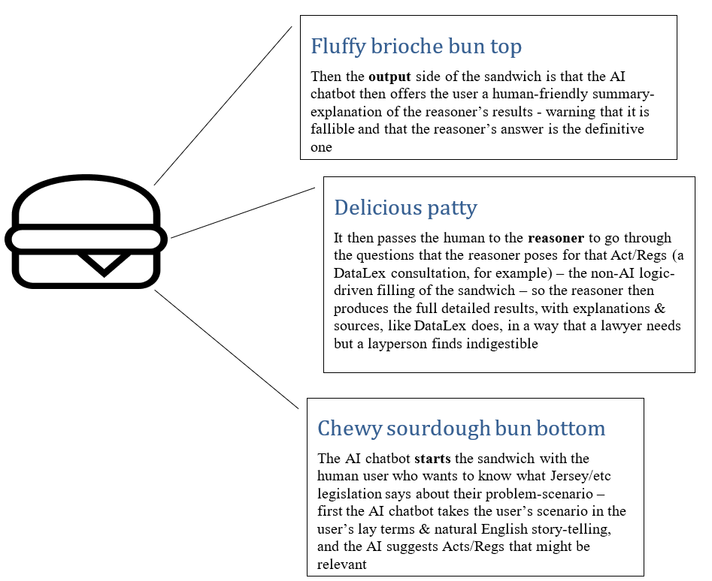Generative AI has inherent problems of “hallucinations”. But “[Using generative AI for computer-readable legislation](https://link.sbstck.com/redirect/9faa8580-37ea-4845-ba78-024479a67130?j=eyJ1IjoiMjR2azY1In0.01WEixLVifkNTkPK-V12DYsGXnP6T7k47bCZ3Pc59JQ)” sets out our current take on how AI might contribute to parsing drafts and helping users engage with systems like [DataLex](https://datalex.org/) that do not use AI. For CALC’s new AI working group, that Guzyal Hill has set up, we presented “[An AI sandwich](https://link.sbstck.com/redirect/d0820050-7af6-43d9-87dd-1a2e7fffee15?j=eyJ1IjoiMjR2azY1In0.01WEixLVifkNTkPK-V12DYsGXnP6T7k47bCZ3Pc59JQ)” to show what this could look like (thanks to Kate Hannah for the illustration) –

To ensure our legislation can be freely used by AI and other software developers, we have also worked with other Jersey bodies to produce an [open licence](https://link.sbstck.com/redirect/46050499-c33a-4c1d-946a-7f699a356b6b?j=eyJ1IjoiMjR2azY1In0.01WEixLVifkNTkPK-V12DYsGXnP6T7k47bCZ3Pc59JQ) for the [copyright in our legislation](https://link.sbstck.com/redirect/330c8489-8d58-413f-a318-1096d2ec4725?j=eyJ1IjoiMjR2azY1In0.01WEixLVifkNTkPK-V12DYsGXnP6T7k47bCZ3Pc59JQ). We are now working on a guide for AI developers who might want to produce chatbots to answer questions about Jersey legislation, pointing out the challenges of taking legislation seriously.

Meanwhile, away from AI, we are working on training material and a drafting manual chapter on lessons that we have learned as drafters from logic and computing. CALC has led the ongoing process of improving the rigour of legislative drafts, such as in moving from “shall” to “must”, or at least in recognising that “shall” was being overused where “must” is not a substitute (as when “shall mean” was used in definitions). Our guidance for drafters will similarly help in becoming more systematic about the various uses of “may”.

Also on a broader front than AI, we have published “[Digitising legislation: progress and prospects](https://link.sbstck.com/redirect/6f92d633-f9a0-477e-947f-9eabe6422a3a?j=eyJ1IjoiMjR2azY1In0.01WEixLVifkNTkPK-V12DYsGXnP6T7k47bCZ3Pc59JQ)” (a chapter for a proposed book – Black, Moloney & Graffham “Legislating for risk and precaution - Bridging the divide between science and law for biosecurity”, CRC Press 2024/2025).

There have been comings and goings in our team –

* Margaux McQuilton recently left after working as an intern for us while studying a for a law degree. Recently she organised an ELSA essay competition on AI and law, and she has made the shortlist for the Jersey TechAwards.
* Leon Qiu is staying with us and switching to one day a week for the rest of the project. He was recently first author on a prize-winning paper “Formalisation Memories: Towards a Pattern Approach to Legal Design”, which looks at legislative patterns and “Common Legislative Solutions”
* Laurence Diver has just joined us, also for one day a week to the end of the project. He is the author of the book “Digisprudence: Code as Law Rebooted”, and has been working at [COHUBICOL](https://link.sbstck.com/redirect/3ddb4392-aa5b-4845-b362-67839da56719?j=eyJ1IjoiMjR2azY1In0.01WEixLVifkNTkPK-V12DYsGXnP6T7k47bCZ3Pc59JQ).

[](https://substackcdn.com/image/fetch/f_auto,q_auto:good,fl_progressive:steep/https%3A%2F%2Fsubstack-post-media.s3.amazonaws.com%2Fpublic%2Fimages%2F6d8bbb91-7af2-4ef5-a01a-5dc1d6769e03_882x335.jpeg)

Left to Right: Margeaux, Leon and Laurence

We are planning to report further progress at the Jamaica conference in May. Zoë and Matthew also hope to repeat their interactive “logic roadshow” there, which has already toured the CALC regional conferences in Cardiff, Sydney and Mombasa.

# Legislation for AI/Legislation with AI logoLegislation for AI – Legislation with AI

**Join our group if you want to stay up to date with AI developments across the Commonwealth**

From A Professor Guzyal Hill, PhD, Law, Charles Darwin University, Australia

We have created a trusted space for collaborating and sharing ideas, expertise, and experience on the use of AI in drafting practice in a collegial and safe environment. We talk about legislation and all other accompanying materials, such as explanatory notes, for example.

We have representatives from Australia, Canada, Scotland, Jersey, UK, Singapore, Guernsey, Bangladesh, New Zealand, Kenya, and other countries.

Our common understanding is that AI is used to extend capabilities, not to replace the drafting expertise. We think some AI can be used safely for automating boring tasks, speeding up drafting, bouncing ideas, improving the quality of work, working with complexity and volume.

Here is the photo from our recent meeting.

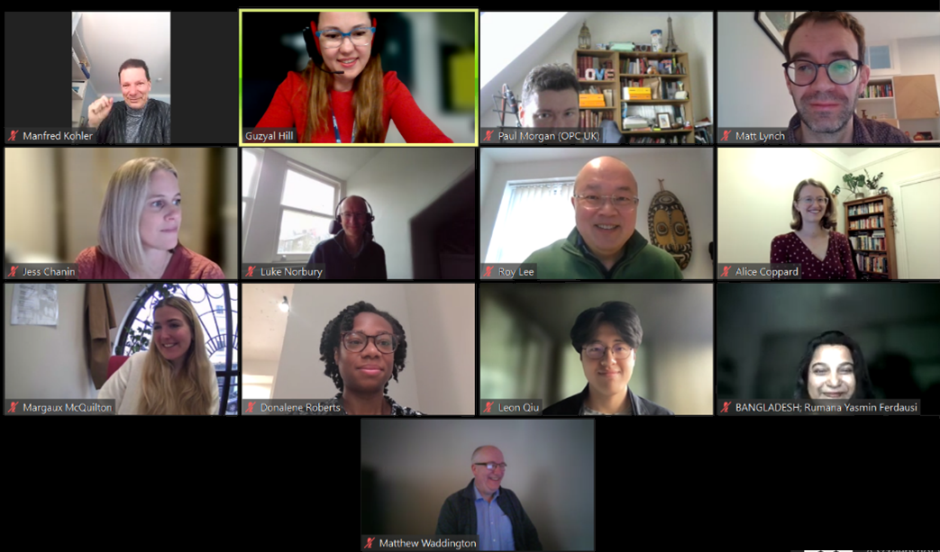

By working together across the Commonwealth, we can quickly exchange information on benefits and threats of AI, recent developments and research. For example, our recent update from New Zealand included the release of [guidelines on use of AI by judges and lawyers](https://www.courtsofnz.govt.nz/going-to-court/practice-directions/practice-guidelines/all-benches/guidelines-for-use-of-generative-artificial-intelligence-in-courts-and-tribunals/). Would you like to share innovative practices of your office or stay up to date with the latest innovation?

We are meeting monthly and now starting to create subgroups on topics of special interest.

If you would like to join, please email [guzyal.hill@cdu.edu.au](mailto:guzyal.hill@cdu.edu.au).

# Sex-specific language in UK legislation

Diggory Bailey, Office of the Parliamentary Counsel, London

The Office of the Parliamentary Counsel (UK) recently updated its published drafting guidance, which now includes material to reflect the UK Government’s policy that there are some circumstances in which it is appropriate to draft legislation using sex-specific language. See Part 2 of the guidance published here: <https://www.gov.uk/government/publications/drafting-bills-for-parliament>.

**Background**

During the passage of the Ministerial and Other Maternity Allowances Act 2021, concern was expressed by members of the UK Parliament about the Bill’s use of gender-neutral language in the context of pregnancy and childbirth. As a result, drafting changes were made to the Bill during its passage.

The UK Government also undertook to carry out a review to explore the various approaches to drafting legislation on subjects that prompt these sorts of questions around language.

On 23 May 2022, following the review, the UK Government made a statement to Parliament setting out their position <https://questions-statements.parliament.uk/written-statements/detail/2022-05-23/hcws47>.

**Avoiding gender stereotypes**

The 2022 statement reiterated the UK Government’s commitment to drafting legislation in a way that avoids reinforcing gender stereotypes, for example by—

* avoiding pronouns such as “he” where a reference to men and women is intended;
* avoiding nouns that might appear to assume that only a man, or only a woman, will do a particular job or perform a particular role (eg “chairman”).

But that does not mean avoiding sex-specific language in all legislative contexts.

**Sex-specific language**

The 2022 statement set out the UK Government’s policy that it is appropriate to use sex-specific language in contexts where legislation is concerned only or mainly with people of one sex. Examples include legislation relating to pregnancy, childbirth or breastfeeding or in contexts in which the policy is to distinguish between people on the basis of sex (for example in relation to old statement pension entitlement).

One of the factors that drafters in the UK need to consider when implementing this policy is the effect of the Gender Recognition Act 2004, which allows a person to change their legal sex by obtaining a gender recognition certificate. Interpretive provisions in that Act produce the effect that references in other legislation to a “woman” (without more) will generally be construed as including a person who is a woman by virtue of a gender recognition certificate but not a person who is a man by virtue of a gender recognition certificate.

The new drafting guidance is designed to help drafters give effect to the UK Government’s policy on sex-specific language, outlining potential issues that they need to consider and giving examples of different drafting approaches that can be adopted depending on the underlying policy.

# A white background with black text Description automatically generatedRecent publications and postings

UK New Year’s OBE for David Sprackling, recently retired from OPC London.

|  |  |  |
| --- | --- | --- |
| 8 March was **International Women’s Day**. See the series of LinkedIn posts put together by the New Zealand Parliamentary Counsel Office to mark the day. Click on the pictures to see the posts. | [Picture of Rebecca O'Connell](https://www.linkedin.com/posts/parliamentary-counsel-office_internationalwomensday-iwd2024-greatplacetowork-activity-7171231089632501760-v8K0?utm_source=share&utm_medium=member_desktop) | [Picture of Kerry O'Rourke](https://www.linkedin.com/posts/parliamentary-counsel-office_internationalwomensday-iwd2024-greatplacetowork-activity-7170923909846880256-vXUz?utm_source=share&utm_medium=member_desktop) |
| [Picture of Sare Bryan and a colleague](https://www.linkedin.com/posts/parliamentary-counsel-office_internationalwomensday-iwd2024-greatplacetowork-activity-7170524284430352385-ynCA?utm_source=share&utm_medium=member_desktop) | [Picture of Leigh Talamaivao](https://www.linkedin.com/posts/parliamentary-counsel-office_iwd2024-parliamentarycounseloffice-greatplacetowork-activity-7170190208787836928-_U64?utm_source=share&utm_medium=member_desktop) | [Picture of Cassie Nicholson](https://www.linkedin.com/posts/parliamentary-counsel-office_internationalwomensday2024-activity-7171646776255479808-1ctI?utm_source=share&utm_medium=member_desktop) |

**“…[Gender Equality Laws] should make it clear that both “direct discrimination” and “indirect discrimination” are prohibited and a clear definition of these terms should be provided.”**

An informal theme running through this Newsletter is gender and the legislation landscape. See [Maria Mousmouti’s update](https://www.linkedin.com/posts/maria-mousmouti-0308266_genderequality-oscegenderequality-eugenderequality-activity-7167995048909783040-p9PN?utm_source=share&utm_medium=member_desktop) on the comparative note on gender equality laws on LinkedIn, and also [read the full note](https://legislationline.org/sites/default/files/2024-02/2024-02-26%20FINAL%20ODIHR%20Note%20on%20Gender%20Equality%20Laws%20Across%20OSCE%20Region.pdf).

The European Institute for Gender Equality has a [Toolkit on gender-sensitive communication](https://eige.europa.eu/publications-resources/toolkits-guides/gender-sensitive-communication). Why not have a look at the tests or practical tips, including tackling the gendered nouns.

You can also catch up with the recent [Legistics update](https://www.justice.gc.ca/eng/rp-pr/csj-sjc/legis-redact/legistics/p1p15.html) (Department of Justice, Canada) on gender-inclusive language, including ‘they’, ‘ombuds’ and other challenges as well as techniques to use. There is also an equivalent covering French texts, [Rédaction législative inclusive](https://www.justice.gc.ca/eng/rp-pr/csj-sjc/legis-redact/juril/no143.html).

**“That statute provided that in any Act “every word importing the masculine gender only, shall extend and be applied to a female as well as to a male”.”**

**….**

**“Scholars have noted that, through much of the 19th and 20th centuries, judges sometimes ignored general interpretive provisions to deny women rights, privileges or benefits under legislation written using the default masculine rule while applying those same interpretive provisions to impose duties or penalties on women”**

CALC Council representative for Africa Felicity Owoses [recently published](https://www.linkedin.com/posts/felicity-owoses-bb8595131_law-versus-policy-activity-7160596913061347328-Ysa6?utm_source=share&utm_medium=member_desktop) a glossary of some key differences between policy and law, including their circular nature as “Law can influence policy and policy can influence Law”.

Nigerian universities [have a new drafting textbook](https://guardian.ng/features/law/fed-govt-approves-legislative-drafting-textbook-for-universities/): “A Workbook on Legislative Drafting in Nigeria” by Dr Tonye Clinton Jaja. There is no link or extract available, but you can see a list of other works by the same author on [Google scholar](https://scholar.google.com/citations?user=vxrl5LkAAAAJ&hl=en).

The Judicial Institute for Africa now has a bi-weekly newsletter. See the [latest issue and the whole archive](https://africanlii.org/articles/) at AfricanLII. You can also [subscribe](https://uct.us18.list-manage.com/subscribe?u=8a6c98d39105d04fc0371321d&id=f0d6f342db).

The Parliament of South Africa hosted a [summit about post-legislation scrutiny](https://www.parliament.gov.za/news/oversight-summit-reflects-importance-evaluating-impact-legislation-passed-parliament). There was also a [declaration](https://www.parliament.gov.za/press-releases/2024-south-african-legislative-sector-oversight-summit-declaration) outlining a commitment to the process. Maria Mousmouti summarised the event [on LinkedIn](https://www.linkedin.com/posts/maria-mousmouti-0308266_oversight-summit-reflects-on-importance-of-activity-7159130888901910529-Gwud?utm_source=share&utm_medium=member_desktop).

**“We commit to…[e]xercising law-making mandate by properly scrutinising legislation from the perspective of implementation timelines, budgetary implications, and executive capacity”**

**“…it is not necessary and maybe not desirable to develop digital silo systems, that is systems that solely operate within a single organization such as the Parliament. On the contrary, suggested solutions should span across the entire central government system and utilize a secure and safe authentication system.”**

The Statute Law Review recently published “[Better Regulation and its Evolution in the Hellenic Legislative and Parliamentary System](https://academic.oup.com/slr/article/45/1/hmae003/7578665?login=false#446116124)”, by Fotios Fitsilis and Georgios Theodorakopoulos.

The National Archives in the UK is working on improving its XML data, and has been awarded a grant to help it along. This [LinkedIn post](https://www.linkedin.com/posts/activity-7160202937078607872-7EfY/?utm_source=share&utm_medium=member_desktop) outlines what they are working on and trying to achieve.

**“…the project will…enable members of the public to construct standardised prompts to access the LLMs fine-tuned on the enriched NA datasets”**

Find out about which laws are under consideration for the next round of statute law revision in New Zealand: [“Making sure New Zealand laws are up-to-date and accessible”](https://www.parliament.nz/en/get-involved/features/making-sure-new-zealand-laws-are-up-to-date-and-accessible/), and the NZ PCO [page on the consultation](https://www.pco.govt.nz/revision-consultation-2024/).

**Very familiar reasons for review include “age”, “outdated language”, “improve clarity” and “number of repealed provisions and schedules”**

Meanwhile, the revision of Halifax’s laws became [newsworthy](https://www.cbc.ca/news/canada/nova-scotia/law-amendments-statutes-revisions-nova-scotia-legislature-1.7099585#:~:text=Tuesday%2C%20for%20only%20the%2011th,tiding%20up%20of%20provincial%20statutes), then that it was newsworthy was [post worthy](https://www.linkedin.com/posts/sven-hombach-0b00792a_new-page-of-history-quietly-turns-in-halifax-activity-7158607252122136577-YhTR?utm_source=share&utm_medium=member_desktop)!

**“…the Stanley Cup of law revisions…”**

**“…just over 11 minutes…to approve…[t]he six-and-a-half year effort by lawyers in the legislative counsel's office… in 18 volumes”**

The Australian Office of Parliamentary Counsel ventured into always brave waters with the launch of their new register (legislation website). See the First PC’s [LinkedIn post](https://www.linkedin.com/posts/meredith-leigh-a11300197_primary-content-activity-7147378268499812352-7Svl?utm_source=share&utm_medium=member_desktop), and, of course, [try the website](https://www.legislation.gov.au/) for yourself (don’t miss the special [Norfolk Island section](https://www.legislation.gov.au/norfolk-island-legislation), or, if you are an enthusiast for legislation revision powers, the [unique names reports](https://www.legislation.gov.au/help-and-resources/understanding-legislation/unique-names-reports)!).

The team at the NSW Parliamentary Counsel’s Office have been visiting one of the instructing Departments to work on better understanding. See the [post on LinkedIn](https://www.linkedin.com/posts/new-south-wales-government-parliamentary-counsel%27s-office_nswgovernment-nswlegislation-nswpco-activity-7178830850367664128-ic-v?utm_source=share&utm_medium=member_desktop).

**“…the value of building trust by communicating intentions clearly and inviting collaboration.”**

What about a Law as Code hackathon? See [Stefan Eder’s post on LinkedIn](https://www.linkedin.com/posts/stefan-eder_iris24-hackathon-education-activity-7167441799458766849-lGO2?utm_source=share&utm_medium=member_desktop) and get in touch if you want to be involved.

More from [Stefan Eder](https://www.linkedin.com/posts/stefan-eder_artificialintelligence-law-riskmanagement-activity-7151818879537668096-AxtW?utm_source=share&utm_medium=member_desktop), drawing our attention to a paper about use of LLMs in a legal context. He quotes the authors: “Responsible integration of AI in legal practice will require more iteration, supervision, and human understanding of AI capabilities and limitations”. Read the [associated article](https://hai.stanford.edu/news/hallucinating-law-legal-mistakes-large-language-models-are-pervasive?fbclid=IwAR3OINcdoxptTBKLI85p9iyls_YFkDdQ_NcM7FggUdy9M7Wm3B6tuB2zA2o) (which also includes a link to the preprint paper).

In what is a big and growing area of interest, there is also [the article](https://joinup.ec.europa.eu/collection/better-legislation-smoother-implementation/news/new-article) from the Better Legislation for Smoother Implementation group at the European Commission outlining a report from Australia: [A cost/benefit analysis of a Rules as Code-enabled transformation](https://www.themandarin.com.au/234650-a-cost-benefit-analysis-of-a-rules-as-code-enabled-transformation/) by Tim de Sousa.

**“The findings reveal a compelling business case...”**

And catch up with the [2024 MIT Computational Law Workshop](https://law.mit.edu/pub/2024-iap-workshop/release/3) – a great enlivening and enlightening listen.

**“…A thousand flowers blooming…” (Dazza Greenwood)**

You can also catch the [latest video](https://www.youtube.com/watch?v=sElzpf7eKOw) from [Singapore Statutes Online](https://sso.agc.gov.sg/), this one is on the design of subsidiary legislation.

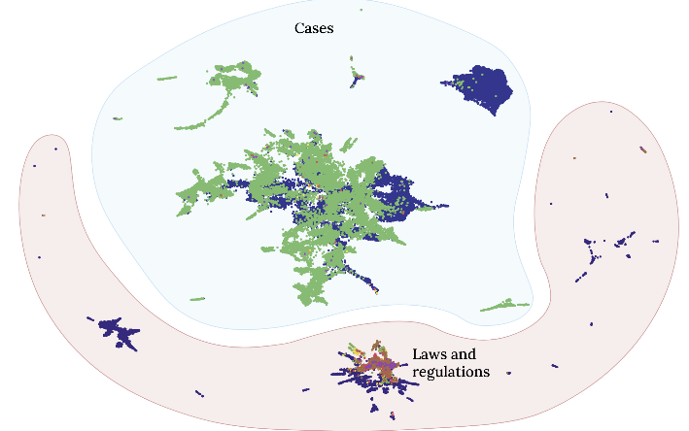Umar Butler has tried mapping (almost) every law in Australia – see the [post (and comments) on LinkedIn](https://www.linkedin.com/posts/umarbutler_mapping-almost-every-law-regulation-and-activity-7176538449108226048-OYe_?utm_source=share&utm_medium=member_desktop), or jump straight into the [detailed blog](https://umarbutler.com/mapping-almost-every-law-regulation-and-case-in-australia/) about how it was done and what it showed.

**View the poles, islands and other**

**features that emerge,**

**and see the impact of**

**copyright restrictions**

**on this kind of analysis…**

# Coming up…events in person and online

## CIAJ – Legislative Drafting Conference

The Canadian Institute for the Administration of Justice biennial Legislative Drafting Conference is coming later this year.

**When**: 16-18 September 2024

**Where**: Ottawa and Online.

Information about registration fees, a preliminary program and other details are available on the [conference webpage](https://ciaj-icaj.ca/en/upcoming-programs/2024-legislative-drafting-conference/).

## iLegis conference logoiLegis – International Conference on Legislation and Law Reform

The 8th Conference is being held later this year. Check the [iLegis website](https://www.ilegis.org/) for details as they become available (and get a feel for the flavour of the conference by having a look at the [2022 program](https://static1.squarespace.com/static/63fb2f4cf5d48807c66d0fdf/t/63fdc4e56bc6f13f0fbf1c5b/1677575535502/Final+Agenda+2022.pdf)).

**When**: 24 and 25 October 2024

**Where**: Washington DC

## International Legislative Drafting Institute

**When**: 10–21 June 2024

**Where**: New Orleans, Louisiana, USA (Tulane University)

****For all the details and how to register, see the [Institute website](https://law.tulane.edu/international-legislative-drafting-institute).

## IALS Legislative Drafting Course

**When**: 10 June – 5 July 2024

**Where**: Online (synchronous), but with an option to attend the first week in person (in London).

For more information, and the course brochure and application form, see the [IALS website](https://ials.sas.ac.uk/study-with-us/short-courses-summer-schools/legislative-drafting-course).

# New CALC members

Below are the new members who have joined CALC since 15 December (when the last update was published). Welcome to all!

Want to join these members? Use the [online registration form](http://www.calc.ngo/user/register).

| Name | Country/Area |
| --- | --- |
| Anna Ross | United Kingdom |
| Byron Clugston | Australia |
| Chris Micheli | United States |
| June Wang | Australia |
| Leandra Bodden March | Belize |
| Tori Lord Thompson | Belize |
| Miguel Reyes | Belize |
| Rassie Malherbe | South Africa |
| Japhet Murora | Kenya |
| Sharada Humes-Ferguson | Bahamas |
| Barbara Malotsha | South Africa |
| Muhammad Fauzi Mdyusof | Malaysia |
| Azira Wan |  |
| Ashyraf Ashy'Ari Kamaruzaman | Malaysia |
| Zuraidah Muhammad Rais | Malaysia |
| Muhammad Farith Muhammad Faizal | Malaysia |
| Muhammad Firdaus Yaacub | Malaysia |
| Siti Noor Hafizan Zakaria | Malaysia |
| Faith Rotich | Kenya |
| Kaiyisah Shukri |  |
| Amirah Binti Mohamed Yusoff | Malaysia |
| Nurain Md Yusoff | Malaysia |
| Nurul Ain Abdul Rahim | Malaysia |
| Aimi Zahiah Abdul Rahim | Malaysia |
| Fauziah Said Khan | Malaysia |
| Nor Fazreen Othman | Malaysia |
| Shahirah Shaharuddin | Malaysia |
| Royalina Faudzi Joshua | Malaysia |
| Wan Zuraida Wan Nawan | Malaysia |
| Farrah Izzlorna Binti Asri | Malaysia |
| Asfahani Hamzah | Malaysia |
| Hasnurliza Mohd Radzi | Malaysia |
| Nurfarzana Rosli | Malaysia |
| Nuur Zul Izzati Zulkipli | Malaysia |
| Kurt Thomas | Saint Lucia |
| Theresa Boasiako-Korang | Ghana |
| Jordan Birenbaum | Canada |
| Devi St Luce | Dominica |
| Denise Eades | Canada |
| Mariathereza Kamugisha | Tanzania, United Republic of |
| Chuo Li Ho | Singapore |
| Peter Bevan | New Zealand |
| Laurence Diver | United Kingdom |
| Vanita Jehan | Australia |
| Cydney Keith | Canada |
| Lumbani Mwafulirwa | Malawi |
| Jennifer Arzu-Williams | Belize |
| David Desborough | United Kingdom |
| Neil Trenholm | Canada |
| Lillian Wambui Waweru | Kenya |
| Rebecca Scott | Australia |
| Julie Rylko | Australia |
| Sarah Markallo | United States |
| Austin Yim | United States |
| Rebecca Kimarcus | United States |
| Hallet Brazelton | United States |
| Michelle Vanek | United States |
| Navoya Mcintosh | Jamaica |
| Masanja Samson Gaganija | Tanzania, United Republic of |
| Mohd Norazlan Abd Rahaman | Malaysia |
| Veronica Katwale | Tanzania, United Republic of |
| Anne O'Driscoll | New Zealand |
| Tamsyn Badland | New Zealand |
| Kate Hutchinson | New Zealand |
| Cassandra Kenworthy | New Zealand |
| Regan Ashwell | Australia |
| Penelope Russell | United Kingdom |
| Amie Igoe-Josephs | Australia |
| Annamika Premsagar | South Africa |
| Madeline Holm | Australia |
| Alick Mponela | Zambia |
| Frances Katooko | Uganda |
| David Jonathan Allens | Bahamas |
| Austin Kaberia | Kenya |
| Loveness Nyumayo | Tanzania, United Republic of |
| Benedicta Annan | Ghana |
| Codie Chisholm | Canada |
| Annika Fritz-Browne | Trinidad and Tobago |
| Laurie Weir | Canada |
| Findlay Glynn | United Kingdom |
| Mekelaye Ndelipanda Kamati | Namibia |
| Priscilla Paquette | Turks and Caicos Islands |
| Fiona Koopman | Namibia |
| Wilmary Chantal Tsamareb | Namibia |
| Rebecca Broderick | Ireland |
| Perseverance Difele | Botswana |
| Olympia Maselos | Australia |
| Paris Ball | Australia |
| Ugomma Ewama | Nigeria |
| Oala Moi | Papua New Guinea |
| Raundjua Ritta Hengari | Namibia |
| Luluclara Mutungi | Tanzania, United Republic of |
| Pudensiana Mrema | Tanzania, United Republic of |

# Newsletter information

The Newsletter is published on an ad hoc basis by the CALC Council. It contains articles, news and other updates on anything of interest to drafters of legislation and the staff and agencies that support them. The items are written by members and friends of CALC from around the Commonwealth.

As always, huge thanks and appreciation to everyone who contributed to this Newsletter – articles, pictures, news, links, suggestions, reassurance, proofreading – everything.

If you have an item you would like included in the next edition of the Newsletter, contact CALC’s Secretary (and Newsletter editor), Kate Hannah: [k.hannah@gov.je](mailto:k.hannah@gov.je).

You can also ask about membership, or any other CALC matter.