Newsletter
of the
Commonwealth Association of Legislative Counsel
November 2015

Published in Canberra, Australia, by the Commonwealth Association of Legislative Counsel. Online at www.opc.gov.au/calc/newsletters.htm
Editor: Ross Carter, c/- Parliamentary Counsel Office, Level 12 Reserve Bank Building, No 2 The Terrace, Wellington, New Zealand.

In this issue―
CALC President’s Report—November 2015 2
Drafting for Scotland – Scotland’s constitutional and legislative journey 4
Falkland Islands Revised Laws Project—An Update 19
Items of Interest 21
Membership 27
Secretary Contact Details 28

CALC President’s Report—November 2015

Next CALC Conference—Melbourne, Australia, March 2017
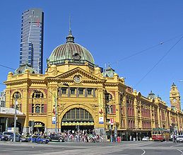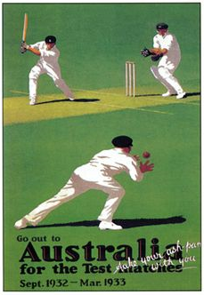

- I am very pleased to be able to announce that the next CALC Conference will be in Melbourne, Australia in March 2017. The precise dates will be fixed when we have the dates for the Commonwealth Law Conference.
- Melbourne is a beautiful city and is considered to be the sporting capital of Australia. If you haven’t been before, it is well worth a visit. If you have been, you will know that it is worth going again.
- Some of you may have attended the very successful CALC Conference that was held in Melbourne about a decade ago.
- We will start the planning for the conference very soon and I am very much looking forward to working with our colleagues in the Victorian Office of the Chief Parliamentary Counsel (which is led by CALC member Gemma Varley).
- As part of the planning for the conference, we will be taking into account the results from the survey that we conducted after the Edinburgh conference. In particular, there were some comments on the venue. In Edinburgh, we had to change the seating arrangement due to the unexpectedly large number of delegates. We will keep this in mind for the Melbourne conference when we are considering venues.

CHOGM 2015
- I will be representing CALC at the Commonwealth Heads of Government Meeting in Malta at the end of the month. In addition to CHOGM, I will be attending the related People’s Forum.
- I think that it is important for CALC to continue to lift its profile through attendance at events such as this.

Job and work advertisements
- We continue to have a steady stream of jobs advertised on the CALC website. Those offices that have used it have found it to be very successful in bringing information about their positions to the attention of drafters across the Commonwealth.
- If you would like to advertise through the CALC website (with an email sent to each of the 1,400 CALC members), please contact me (calc@opc.gov.au). There is a cost involved, but we think that it is very good value for the service that is provided.

New CALC website
- We are in the process of securing a domain specifically for CALC and will then look to move the CALC website from its current home on the website for my Office. This will be a much better long term arrangement.

Revised membership application form on CALC website
- We have updated the membership form on the CALC website. Could I suggest that you ask around in your office to see if there are any drafters who are not currently members and who would like to be?
- If any CALC members in your office are not getting the emails that we send out, please get them to send an email to calc@opc.gov.au and we will sort it out.

Recent issues of The Loophole
- John Mark Keyes has continued his work on The Loophole with another edition being released recently. If you have an article that would be suitable for publication, please contact us and we will look to get it in the next edition.

Peter Quiggin PSM
CALC President
November 2015

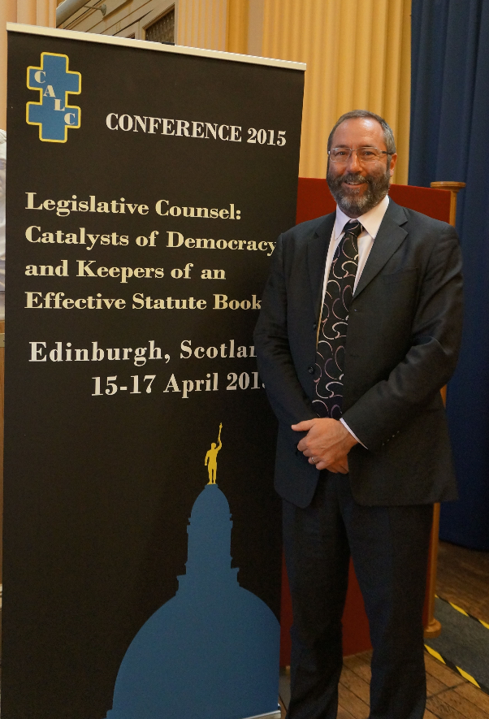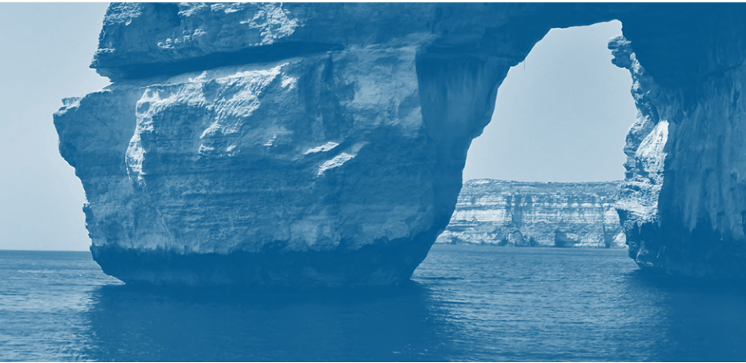

Drafting for Scotland – Scotland’s constitutional and legislative journey

A paper presented, in abridged form, at the CALC Conference in Edinburgh, April 2015, by Alex Gordon

I INTRODUCTION
The title of my presentation is ‘Drafting for Scotland in our Constitutional and Legislative Climate’. Since I submitted this as an idea, I have realised that it is a hopelessly ambitious topic for a 20-minute slot.
On one view, this means ‘absolutely everything’.
Instead, I propose to hop through some highlights of Scotland’s constitutional and legislative journey to the present day.
Especially if you are a first-time visitor, what is Scotland to you? Tartan, kilts and bagpipes. Whisky, haggis and shortbread. Castles, lochs and golf. The Loch Ness Monster.

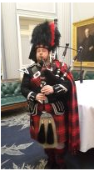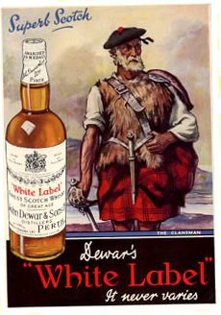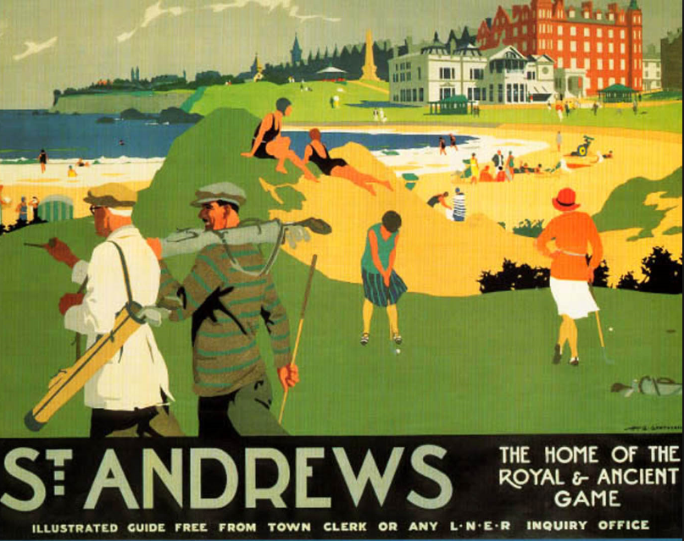

But Scotland has a lot more to it than tourism. Scotland is also a legal jurisdiction in its own right.

II UNION OF 1707

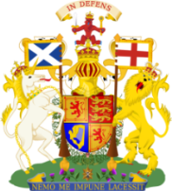

Scotland and England were separate countries before 1707, albeit sharing an island since the Ice Age and a monarch since 1603.
On 1 May 1707, Scotland and England were united by means of a separate Act of Union passed by each of the Scottish and English Parliaments. This was preceded by a Treaty of Union negotiated between the two countries.
It is worth examining the drafting.
In the Scottish Act of Union—
Article I provides:
‘That the Two Kingdoms of Scotland and England shall upon [1 May 1707] and
forever after be United into One Kingdom by the Name of Great Britain…’.
Article III provides:
‘That the United Kingdom of Great Britain be Represented by one and the same
Parliament to be [styled] the Parliament of Great Britain.’.
The brevity of each of these Articles is remarkable for the age.
In a few lines and in such simple terms, the pre-1707 Scottish Parliament voted itself out of existence.
The forging of the Union has been described by a modern historian (Simon Schama) as ‘one of the most astonishing transformations in European history’.

III SCOTS LEGAL SYSTEM

Uniqueness

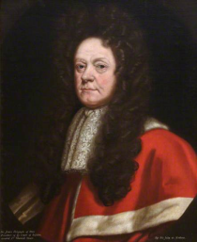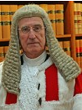

In accordance with the Union settlement, Scotland has retained its own courts and legal processes. These go back a long way.
The senior courts are the Court of Session in civil matters and the High Court of Justiciary in criminal matters. In modern form, the Court of Session was established in 1532 and the High Court of Justiciary was established in 1672.
Each of these courts is expressly preserved by the Act of Union. In addition—
we have our own rules of civil law e.g. contracts, family law and land law
(delicts instead of torts
interdicts instead of injunctions)
we have our own rules of criminal law, evidence, and procedure
(a third ‘not proven’ verdict at trial
juries of 15 not 12).
Much of our civil law derives from principles of Roman law as adopted by legal systems in mainland Europe. Many Scots jurists studied there in the 17th and 18th centuries, and these principles heavily influenced what have become known as their ‘institutional writings’. Even now, these writers and writings are often cited in judicial decisions over the application of our rules at common law.
See Compugraphics Ltd v Nikolic [2011] CSIH 34, a case about the operation at common law of servitudes over land.
In our criminal law, it is striking how much has never been reduced to – or reduced by – statute. For example, we have no Theft Act about dishonesty and no Offences Against the Person Act about violence. Theft and assault in Scotland are mostly prosecuted as crimes at common law.
See Stallard v HMA 1989 SCCR 248 about whether at common law, and without statutory intervention, a man could commit rape against his wife.

Even in areas of the law concerning such things as housing, schools and hospitals, Scotland has continued to have its own statutory regimes to a great extent.
However, some substantial areas of the law in Scotland have remained identical or similar to the law in England. Areas such as commerce and taxation are good examples. This is perhaps anticipated by the Articles in the Act of Union providing for freedom of trade and sharing of coinage.
We have had some successful exports over time. In the criminal sphere, one is the concept of diminished responsibility for moderating culpability. See Savage v HMA 1923 JC 49. In the civil sphere, one is the concept of negligence where a duty of care is owed. See Donoghue v Stevenson 1932 SC (HL) 31 & [1932] UKHL 100.
The point is that Scotland continues to have its own distinct legal system. It is worth observing that the EU’s 28 member states contain 29 legal systems when you count Scotland’s.
Scotland is in a very different position to, for example, Bavaria in Germany, Catalonia in Spain, or Corsica in France. No-one really argues that each of these states has more than one legal system even when fully recognising the regions with autonomy inside them.

Shared legislature
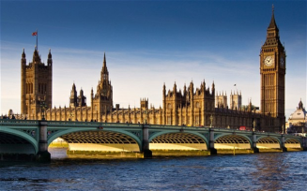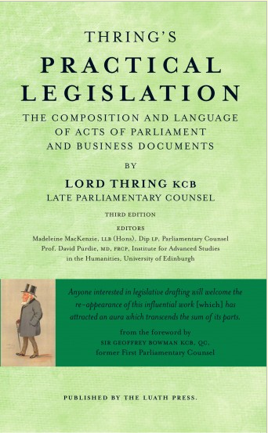

Before the emergence of the Scottish Parliament in 1999, Scotland shared the UK Parliament with the rest of the UK for all legislation for Scotland. A question is how well the UK Parliament was able to deal with legislative matters peculiar to Scotland.
Taking the 1980s and 1990s as a guide, typically there would no more than a handful of Scotland-only Bills at Westminster each year.
This was simply not enough to attend to all the areas of Scots law needing reform. Each year, it was always a challenge to find a legislative slot for a bespoke Scottish Bill.

Miscellaneous Bills
Very occasionally, a bespoke Scottish Bill would be in the form of a Miscellaneous Provisions Bill containing a collection of unrelated changes to the law. One example in 1990 invites the suspicion that it had a cap imposed on the number of sections, with the result that some sections in it have 15 or more subsections each as the provisions are crammed in.
Whatever the political and handling expediency, there is an absence of a coherent narrative behind such a Bill. Its ambit is just as the short title suggests, a miscellany of topics. My concern is that this risks, through making so many changes for Scotland by means seemingly designed as much for procedural convenience as anything else, obscuring the significance of the changes (and the miscellany certainly means that the short title is of little use for reference purposes).

Textual adaptation
For provisions for Scotland intended to extend also or mainly to England, the normal solution has been to incorporate them in shared Bills. Fair enough in a shared legislature, I suppose. Of course, this still happens in UK-based legislation today.
Where there are substantive and conceptual differences between jurisdictions, there are traps when seeking to identify the equivalent sense.
Do the various types of theft or assault involve the same actus reus and mens rea in each jurisdiction? Is culpable homicide in Scotland the same in material respects to manslaughter in England? Is a servitude in Scotland comparable to a right of way in England? Does the owner of a house in Scotland subject to a standard security equate to the freeholder or the leaseholder (with or without a mortgage) of property in England?
As a Scots lawyer, I am not sure that I can properly answer these questions because they involve so much English law. I always need to be instructed clearly on the intended effect in Scotland, not merely asked to provide a neat translation of English expressions for the sake of extending – to this jurisdiction – a policy designed elsewhere.
Apart from substantive or conceptual differences, a technical problem arises when provisions need to refer to something for which there are differences in terminology according to jurisdiction.
Where a Scottish equivalent to a legal expression needs to be factored-in, it has not been unusual for this to be achieved by way of definitional device.
For example, by way of a subsection added at the end of a section along these following lines (invented by me for illustration):
‘( ) In the application of this section to Scotland, a reference to an injunction
is to be read as a reference to an interdict.’.

While this sort of translation works perfectly well in technical terms, I believe that the Scottish aspects of Bills should – as a matter of routine – be accommodated on a more equal footing from the outset.
As a matter of good and accessible law-making, a statement to the effect that X actually means Y (or dog somehow includes cat) is not ideal in most contexts anyway. This goes well beyond the justifiable use of a definitional gloss more generally to widen, narrow, describe or embellish an expression chosen initially as the mot juste.

You may be the owner of a copy of Lord Thring’s Practical Legislation (3rd edition 2015), co-edited by my colleague Madeleine MacKenzie. In it, there is a neat summary of Thring’s general rules of arrangement. Application to Scotland comes second last in a long list (although at least we are not stuck at the very bottom as Ireland is). Even if the position of Scotland in the list made some sense to Thring in the Imperial era, this element of his rules has no place in the modern world. Why leave the provisions for Scotland until the end? Surely Scots law should be accorded a status of more than an afterthought, addendum or oddity.
Maybe these things do not matter much. Then again, maybe they matter just enough.

Practice post-1999
I detect developments in the drafting of UK Bills since Devolution in 1999. Under the Devolution settlement, the UK Parliament continues to legislate for the whole of the UK. This includes doing so for Scotland, albeit mainly on matters reserved to Westminster. The developments include what I see as a more even-handed approach to the different jurisdictions in the UK.
A Miscellaneous Provisions Bill is not very likely to be required again because the Scottish Parliament has competence to legislate on the sorts of areas for which this kind of Bill was most commonly used.
In translating a reference for Scotland, these days it is very common to see an opening reference to a generic label followed by a two-limbed definition for England and Scotland. For example, the label ‘the relevant Ministerial authority’ later defined for England as ‘the Secretary of State’ and for Scotland as ‘the Scottish Ministers’. This sort of device neatly allows for the relevant Ministers for Wales and Northern Ireland to be listed too where appropriate.
For an example of a whole Bill structured carefully for the whole of the UK bit by bit, I would commend the Proceeds of Crime Act 2002. In particular, Part 2 of the Act. This deals with court orders for confiscating nefariously-acquired property. The Part is divided into three self-contained Chapters, one each for England and Wales, Scotland and Northern Ireland. The respective provisions for each jurisdiction could not be presented more helpfully. It matters not that the Chapters cover almost exactly the same ground under strikingly similar section titles.
Perhaps this is in growing recognition of the fact that no one of the UK’s jurisdictions need always be given primacy in drafting terms.

IV SCOTLAND ACT 1998

Brave new world

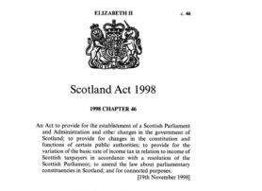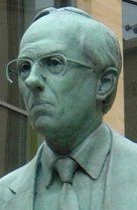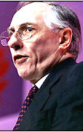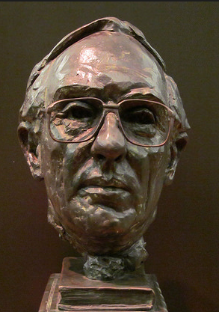

Let us turn to the Scotland Act 1998 as passed by the UK Parliament. For a Scottish Parliament with devolved powers within the UK, the opening proposition in section 1 is:

‘(1) There shall be a Scottish Parliament.’.

Admirably succinct, I am sure you agree. But let us have a look at the drafting.

Structure
In 1998, it seemed to my younger eye rather odd for this fundamental proposition to be followed – in the very same section – by provisions dealing with some details of electoral constituencies and regions.
Now time-served after the better part of 20 years drafting Bills, I have not changed my mind. I have a feeling that, nowadays, this proposition would be put into a section all of its own.
Not that there is anything wrong with section 1, of course. I am merely attempting to find bold and better ways of doing tried and tested things.

Use of shall
On the other hand, a fairly traditional approach might well be the best one even today.
Not everyone likes the use of the word ‘shall’. But perhaps even they will accept that it gives the right declaratory sense in this sort of context.
I have the late Donald Dewar – Scotland’s first First Minister – on my side. After reading the text out loud for the TV cameras, he announced ‘I like that’. I have convinced myself that he appreciated the niceties of the wording every bit as much as he admired the resulting granite and glass.

I do not mean to provoke argument over the merits of ‘shall’. That could fill all of the conference’s sessions. However, I would note that ‘shall’ happens to have fallen into disuse in our day to day drafting in PCO. Just as a new Parliament is going to have its own way of doing things, so is a new body of Parliamentary Counsel

Devolved competence
So what can the Scottish Parliament do by way of legislation? The sources of the Parliament’s legislative competence can be summarised briefly. Section 29 of the Scotland Act 1998 states what is outside legislative competence. It does so by reserving various matters to the UK Parliament. In particular, these are the matters covered by Schedules 4 and 5 to the Act.
Some headline reservations to the UK Parliament include foreign affairs and defence of the realm, as well as important financial, economic and business matters.
The Union is reserved, as is the continuing existence of each of the Court of Session and the High Court of Justiciary.
I do not have time to go any further into the details of devolved competence, but here are two key things to look for—
- matters are fully devolved to the Scottish Parliament if they are not expressly reserved (and not the other way round)
- the right of the UK Parliament to make laws for Scotland is preserved (including in devolved areas).
I can reveal that my favourite provision is the reservation of activities in Outer Space.

Changes since 1999
Devolution is not static, though.
As predicted in 1999, it has turned out to be a process rather than an event.
The Scotland Act 2012, as passed by the UK Parliament, amended the Scotland Act 1998 in some notable respects. For example, on taxation and borrowing.
Much of the current debate on powers for the Scottish Parliament is about what is often referred to as ‘fiscal autonomy’. That is, extensive control over matters of money and spending in Scotland in a more free-standing economic context. Already, PCO has been turning its hand to tax legislation for the first time.
No doubt there is more to come on this and other topics over time, but I will leave that to the politicians.
As if the reservation of Outer Space were not enough, the 2012 Act brought about the reservation of activities in Antarctica.
As an aside, something about naming. The 1998 Act established the ‘Scottish Executive’ as the body of Ministers exercising governmental power. An Executive, not a Government, by name. The 2012 Act formally renamed the Scottish Executive as the ‘Scottish Government’.
Does life imitate art or does art imitate life? Well, the Scottish Government had already been calling itself that since 2007.
As with the choice of ‘a Parliament’ over ‘an Assembly’ for the name of the legislature, the way in which an institution is described is inevitably regarded as important presentationally, publically and politically.

V SCOTTISH PARLIAMENT

Emerging Bills

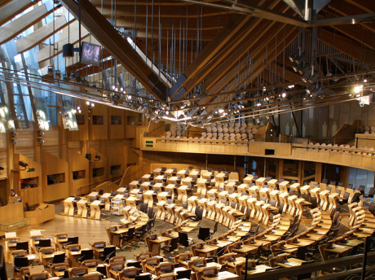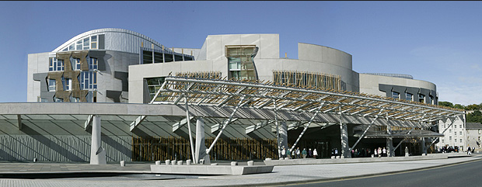

The thing about legislatures and legislators is that they have a habit of legislating.
So legislation – and a lot of it – is nigh inevitable.
Since 1999, well over 200 Bills have been introduced into the Parliament. The amount of legislation initiated by the Government has been fairly consistent despite the different challenges – for both officials and Ministers – of coalition, minority and majority administrations.

Politics aside, the fact is that the Parliament is a forum for serving all varieties of purposes relating to domestic law. It can do so according to priorities set close to home. Bread and butter is a pretty good meal if you have been underfed lately.
The opportunity of legislating has taken us in all sorts of directions. Despite what I have said about the richness of our legal heritage and the importance of our common law, legislation before the Scottish Parliament has over the years (if I may focus on criminal matters)—
- codified with amendments the law on sexual offending
- created statutory assaults aimed at protecting particular categories of person
- sought to abolish the requirement for corroborated evidence for proof of offences.

He and she
Early on, our Parliamentarians made it clear that they disliked what they perceived as sexism in the use of the masculine ‘he’ as a singular pronoun. Very soon, gender-specific terms were to be avoided altogether.
The availability of an interpretive rule incorporating the feminine was suddenly of no practical use. So we quickly moved to drafting in gender-neutral style.
We have been so successful in this that we no longer even have such an interpretive rule, as this was deliberately omitted from our interpretation legislation of 2010.
I suppose that I am mentioning this by way of anecdote. However, there is a serious point lurking. We must keep our audience happy. Here, the Parliamentary audience was informed and influential. So change came, and without much complaint from us.

Smoking ban

By passing legislation in 2005 for a ban on smoking in public places, Scotland led the way within the UK. This is regarded by many as demonstrating how well the Parliament is capable of making change domestically, without relying on policy considerations or legislative slots elsewhere.

Signs warning of the ban are pinned on walls everywhere. I am sure that you have seen some on your way here today. No doubt this is because the provisions imposing the ban state that the signs must be displayed ‘conspicuously’.
As a matter of intended and actual effect, you will appreciate the sense of ‘conspicuousness’ as subtly distinct from one of (say) ‘prominence’.
The legislation was drafted by a former First Scottish Parliamentary Counsel, John McCluskie QC CB. He has recently reminded me that the real issue was about making the ban apply to ‘enclosed public buildings’. I hope that he will forgive me if I draw heavily on his fuller recollection. Here goes.
If a building is ‘enclosed’, there would be no problem because nobody could get in either to smoke or be affected by someone else’s smoke. So the first thing was that ‘enclosed’ had to yield to things like doors and windows.
But, even then, what about premises that are not ‘enclosed’ but still retain sufficient of their own internal atmosphere that banning smoking in them would be the right thing to do? In other words, where should we draw the dividing line between, on the one hand, premises with enough in the way of permanently open exposure to the outside air such as a stand in a football or rugby stadium and, on the other, a relatively closed-in structure such as a bus shelter in the form of a tunnel. So let us try and hit that line by saying ‘wholly or substantially enclosed’. Let us avoid ‘mainly’ in case somebody persuades a court that it means anything over 50%.
But ‘substantially enclosed’ is hopelessly imprecise in this context. There would be uncertainty and argument in tens of thousands of cases, and enforcement of the offence would be a nightmare. We needed some kind of measurable test of the extent to which premises are enclosed so as to be susceptible to the ban.
The only obviously measurable test would be to strike a ratio of the internal surface area of the premises to the notional area of the opening or openings that are exposed to the outside air. A cursory glance round the conference venue would tell us that any attempt to measure its internal surface area would be so impracticable as to be virtually impossible. And how to measure the area of the opening? Of a surface that doesn’t actually exist, and might have very irregular edges?
Here we faced an example of the old saying that the best is the enemy of the good. We found a compromise. In the first place, recognising that our attempt to describe any such ratio might need in due course to be tweaked in the light of experience, we pushed the matter down to easily amendable subordinate legislation.
And second, we settled for a ratio that partakes more of the rule of thumb than the tape measure. We said that premises with a ceiling or roof would be ‘substantially enclosed’ if the area of the opening [(or the aggregate area of both or all openings)] was less than half the area of the walls.

Whatever the semantics, it is rather satisfying to see the very words of Scottish drafters in daily and public view.

VI CONSTITUTIONAL FUTURE

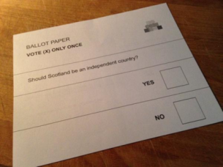

Independence Bill
Ahead of last year’s Referendum on the question of Scottish Independence, a Scottish Independence Bill was published in draft for everyone to see. As well as providing for an Independence Day, the Bill sets out an Interim Constitution for a newly-independent State.
The Bill was drafted in PCO. It is a unique experience for us to be involved in writing a new constitution.
It is worth touching on some of the detail of the Bill.
The Bill is an easy read of under 10 pages. It has short and simple sections, with a very tidy contents page to help you navigate around them.

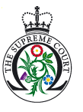

A Scottish judge of the UK Supreme Court said this about the Bill, during a debate in the House of Lords:
‘It is brilliantly drafted, readable by everyone, including primary schoolchildren, and is something that anyone who cares to read it will at once understand.’
Despite the sarcasm I sense to be dripping from this observation, I would seize it as a compliment on the plainness of the wording and the accessibility of the structure.
Section 5 of the Bill gives the new State its formal name. It is quite a relief to discover that its name is, er, ‘Scotland’.
Section 2 of the Bill declares: ‘In Scotland, the people are sovereign’. How would this sort of sovereignty operate? Does the context allow the luxury of not worrying too much about how it can be enforced?
Happily, the answer lies in sections 3 and 7. These sections tell us that we would have an elected government and a democratic parliament. These institutions were to exercise the people’s sovereign will on their behalf. Thank goodness for that.
Section 9 preserves the role of the Queen as Head of State. Although the people would be sovereign, the Queen would be the capital-S Sovereign. Of course, that model of monarchy and statehood seems to work well throughout the Commonwealth when viewed from afar…
Finally, section 35 brings us back to the start of today’s journey. That section dismisses the Act of Union 1707 by way of a consequential repeal. The words establishing the Union ‘forever after’ were themselves to be banished forever after.

Constitutional issues
Here is some further reading if you are interested in learning about Parliamentary sovereignty in the UK context, the limits on what an Act of the Scottish Parliament can do, and the status and amend-ability of the Act of Union and constitutional statutes generally.
Further reading—
(a) regarding the status and amend-ability of the Act of Union and constitutional statutes generally:
MacCormick v Lord Advocate 1953 S.C. 396;
Jackson v Attorney-General [2005] UKHL 56;
Thoburn v Sunderland City Council [2002] EWHC 195 (Admin)

(b) regarding the extent of the legislative powers of the Scottish Parliament:
Whaley & Anor v Lord Advocate [2007] UKHL 53;
AXA General Insurance Ltd & Ors v Lord Advocate & Ors [2011] UKSC 46;
Imperial Tobacco Ltd v Lord Advocate [2012] UKSC 61.

VII CONCLUSION
In addition to the matters of fundamental importance that I have already mentioned, the Independence Bill also includes provision relating to the wellbeing of children, the distinctiveness of island communities, and the importance of a healthy environment.
Sadly, there is a glaring omission on the part of the drafters. There is a complete absence of provision about one of the things of most concern to all of us in Scotland.
Among all the good ideas and hopeful aspirations, there is not a word – not one single word – promising better weather.

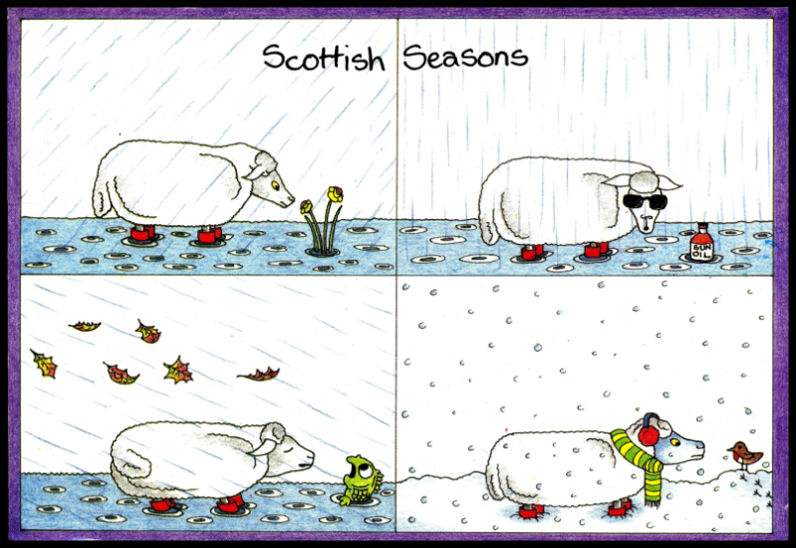

Alex Gordon
Parliamentary Counsel
Parliamentary Counsel Office
Scottish Government, Edinburgh

Falkland Islands Revised Laws Project—An Update
An update on the Project’s progress from Falkland Islands Law Commissioner, Ros Cheek
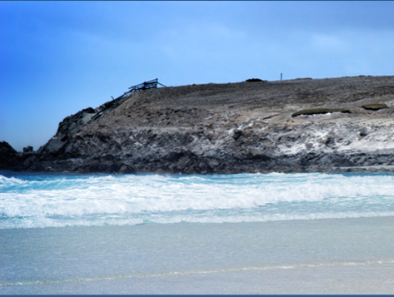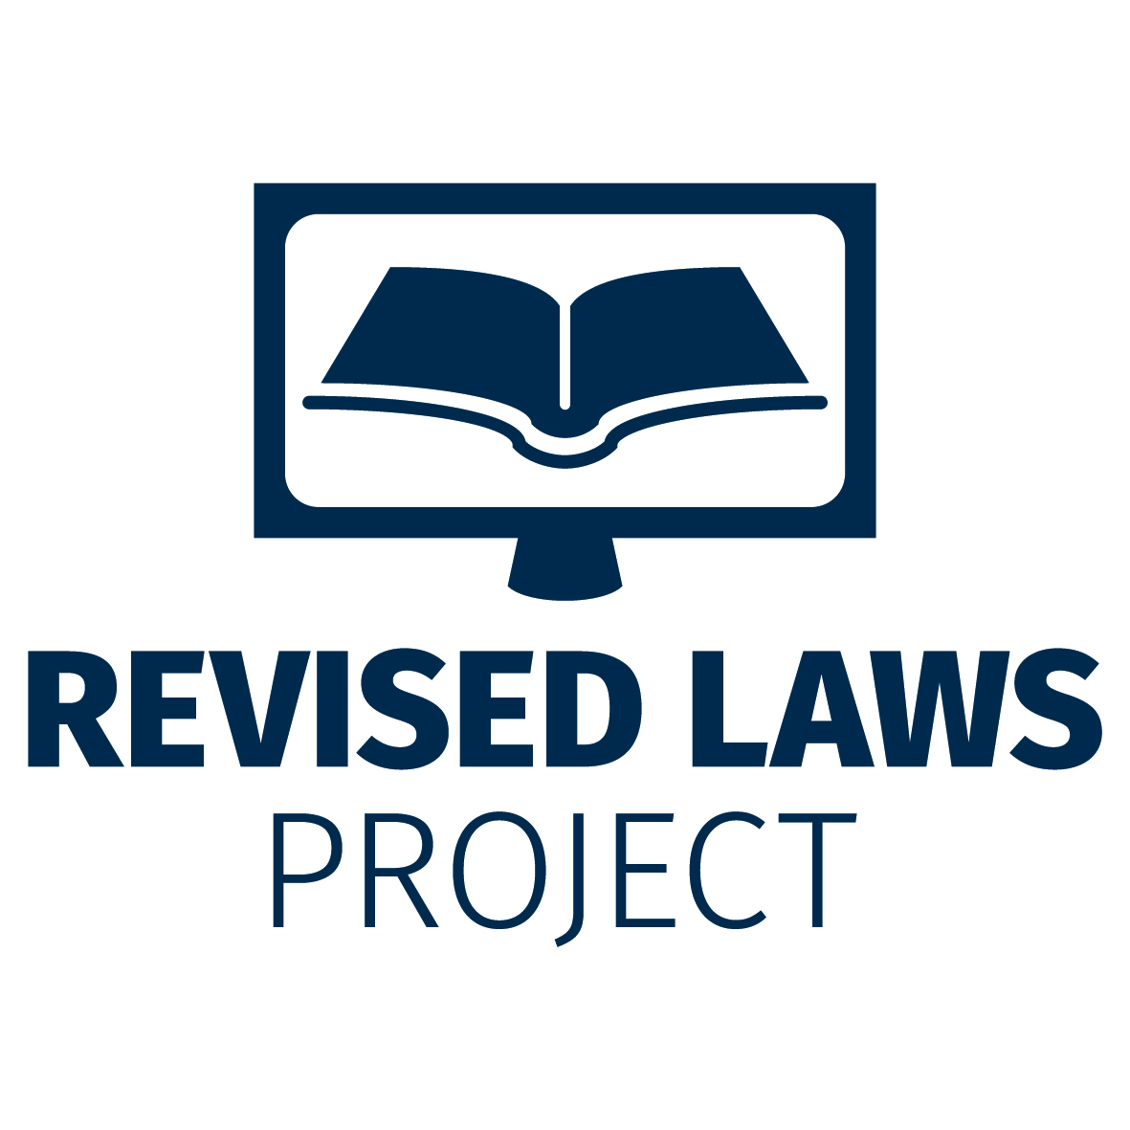

Background - the Falkland Islands
The Falkland Islands is a British Overseas Territory in the South Atlantic with a permanent population of 3,000. The archipelago is made up of more than 750 islands, with a total land mass of a little over 12,000km². The economy is principally based on fishing, tourism, and agriculture, with offshore mineral resources currently being explored. Although characterised to a degree by its remote and rural aspects, the Islands’ community is modern and well developed, with the rule of law strongly established alongside a maturing democracy with good respect for human rights.

Falkland Islands law
Falkland Islands primary legislation is passed by the eight Member elected Legislative Assembly, and the Executive Council is responsible for passing secondary legislation.
A significant number of United Kingdom laws also apply in the Falkland Islands; either directly, or, more commonly, because they have been adopted by the Falkland Islands Legislative Assembly as a way to legislate efficiently in a small jurisdiction with limited resources. However, this pragmatic solution to limited policy and law making capacity does present particular challenges; both in terms of ensuring that our law remains relevant and appropriate, and that it is accessible. Accessibility to Falkland Islands statutes generally is relatively poor.
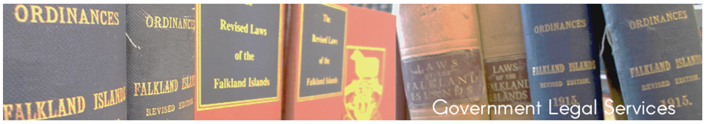

Past revision and publication
Several law revision projects between 1915 and 2005 didn’t result in lasting accessibility to the laws of the Islands, so this project aims to apply valuable lessons from the past when taking a new approach. In particular, getting the balance right between ambitious but realistic goals is perceived as being key to achieving long lasting accessibility. We are keen to take the opportunity for bold and innovative solutions presented by our unique circumstances, and to avoid the burden of maintenance of complex publication systems which are designed for larger jurisdictions, and which we simply cannot sustain.

Law Revision Expert Advisory Committee
We are also keen to learn from others’ experiences of revision and publication. The Law Revision Expert Advisory Committee has been established to help to monitor and support the project; providing strategic advice to the Project Board (Executive Council). We have been overwhelmed by the strength and depth of applications from CALC members for membership of the Committee, so we are also establishing a wider consultancy group to try and benefit as much as reasonably practicable from the expertise so generously volunteered.

Project objectives and work streams
The principal project objective is to publish an on-line statement of the laws of the Falkland Islands by March 2017. This will consist of the full, up to date, text of local legislation, together with a list of the United Kingdom legislation which applies in the Falkland Islands. On-line access will be free. The on-line publication will also be authoritative as at “Day 1” of publication.
The main project work streams involve; (a) settling the legislative text; and (b) finding the right technical solution for on-line publication. But the project is not only concerned with ensuring optimum publication of the law that we have; it will also include detailed recommendations to the Legislative Assembly to update the application of adopted United Kingdom law; on the basis that the adoption of United Kingdom law was largely “frozen” more than a decade ago.

Progress to date
A full project initiation document was presented to Executive Council for approval in September. The Law Revision (Paving) Bill was then passed by the Legislative Assembly in October - formally mandating the preparation of the legislative text.
Initial work on the legislative text was, in fact, already underway; and the list of Falkland Islands laws (ie the precursor to compilation of the full text) was completed in early November. Test runs on preparation of the text of Ordinances have just been carried out. It is estimated that completion of the text, involving roughly 200 Ordinances and 350 secondary instruments, will run through until April 2016. This will not involve a sophisticated consolidation, which is considered too ambitious in the light of previous lessons learned and the availability of resources.
The next task involved in preparation of the legislative text is to identify the United Kingdom statutes which currently apply in the Falkland Islands, and on the basis of analysis and wide consultation, to make detailed recommendations for the application of adopted United Kingdom law to be updated. This task will involve consideration of thousands of UK laws, and is expected to continue well into 2016.
Further work on the options for continuing to update the application of adopted United Kingdom law to the Falkland Islands into the future (ie after publication in 2017) is ongoing; this being the one aspect of the project plans which Executive Council wish to consider further. “Automatic updating” of adopted law has clear advantages for certainty and accessibility of the law, but involves a very broad acceptance of another jurisdiction’s policies; which obviously has its political challenges.
In the meantime, investigations for the technical publication solution are well underway, and it is hoped that the first meeting of the Law Revision Expert Advisory Group will involve input into the critical technical specification and procurement process.
A copy of the full project initiation document can be found on the project web-page, where regular updates will be posted during the project’s two year duration: http://www.fig.gov.fk/legal/index.php/law-commissioner/
Ros Cheek, Falkland Islands Law Commissioner, 17 November 2015

Items of Interest
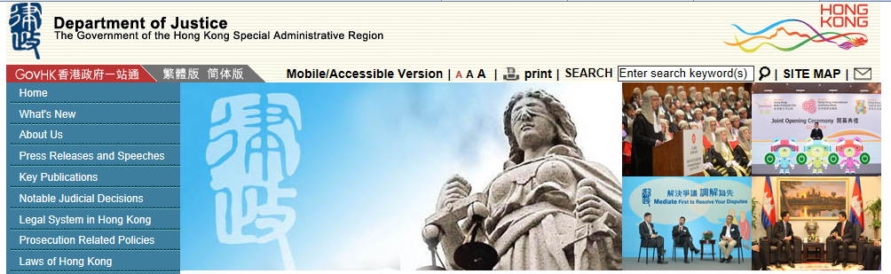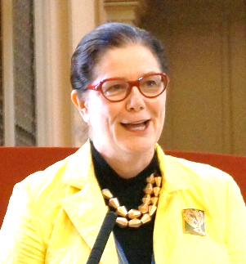

Hong Kong SAR: Department of Justice's law drafting division – new head
- CALC Council member, and former Queensland Parliamentary Counsel, Theresa Johnson, has been appointed as head of the HKSAR’s Department of Justice's law drafting division, effective on 4 January 2016. The HKSAR Secretary for Justice Rimsky Yuen welcomed the appointment, saying Theresa will bring rich drafting experience and expertise to the department. He also thanked outgoing law draftsman Paul Wan for his valuable contributions. Theresa is currently on leave before taking up the appointment. In Queensland, Paul McFadyen has been Acting Parliamentary Counsel 12 October 2015 – 20 November 2015; and Annette O’Callaghan will be Acting Parliamentary Counsel 23 November 2015 to 1 January 2016.

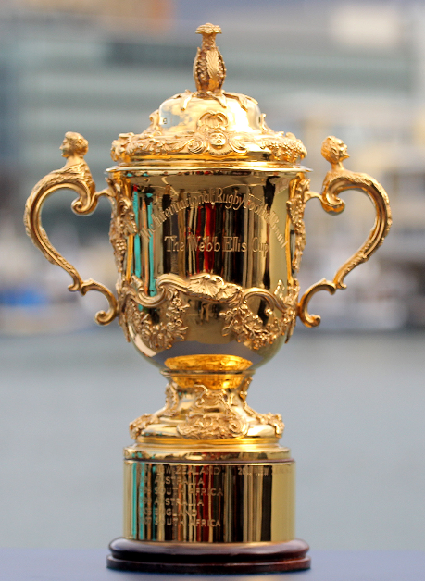

New Zealand: Rugby World Cup 2015 – some related legislation
- New Zealand’s keenness for rugby union was shown and enhanced by the RWC 2015.
Its Parliament changed, for the tournament, the Sale and Supply of Alcohol Act 2012 (NZ). The successful New Zealand team’s (the All Blacks’) pre-match protocols often include performing (dancing) a haka (a Māori ceremonial posture dance accompanied by chanting). Often they do the haka Ka Mate. That haka is the subject of a 2014 Act to give effect to certain provisions of the deed of settlement that settles the historical claims of (the New Zealand Māori tribe) Ngati Toa Rangatira.

New Zealand: first revision Bill – pre-legislative consultation
- In New Zealand, the Parliamentary Counsel Office and the Ministry of Business, Innovation and Employment are seeking, before it is introduced into Parliament, feedback on the first Bill to be developed under the revision programme: the Contract and Commercial Law Bill. The Bill's purpose is to revise contracts and commercial law statutes, combining them into a single statute, to make them more accessible, readable, and easier to understand. It is not intended to make policy changes. The Attorney-General announced the consultation on 21 October 2015.

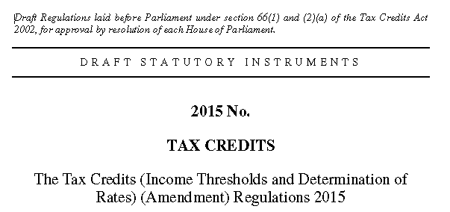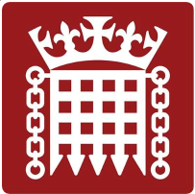

United Kingdom: House of Lords declines (for now) to approve draft tax credit regulations
- The draft Tax Credits (Income Thresholds and Determination of Rates) (Amendment) Regulations 2015 can be made by the Treasury using powers in the Tax Credits Act 2002 (UK) (see especially ss 13(2) and 65(1)). However, tax credit regulations of this kind are subject to parliamentary control by way of affirmative resolution—that is, the regulations cannot be made unless a draft of them has been laid before, and approved by a resolution of, each House of Parliament. On 15 September 2015, the House of Commons agreed (Ayes 325; Noes 290) a motion to approve the regulations. However, on 26 October 2015, the House of Lords (Contents 289; Not-Contents 272) agreed a motion that “this House declines to consider the draft Regulations laid before the House on 7 September until the Government, (1) following consultation have reported to Parliament a scheme for full transitional protection for a minimum of three years for all low-income families and individuals currently receiving tax credits before 5 April 2016, such transitional protection to be renewable after three years with parliamentary approval, and (2) have laid a report before the House, detailing their response to the analysis of the draft Regulations by the Institute for Fiscal Studies, and considering possible mitigating action.”

- One political commentator described this as “a dramatic assertion” of the Lords’ authority, adding “Peers overrode the constitutional convention that the Lords does not oppose the government on financial matters on the basis that the tax credit cuts had been introduced as a statutory instrument, rather than as primary legislation (meaning they received less Commons scrutiny). But only five times over the last century has the Lords rejected statutory instruments and never over a fiscal measure.”

New Zealand: tertiary legislation – Access to Statutory Instruments Project (ASIP) begun
- In New Zealand, a project has begun to explore development and delivery of a comprehensive registration and publishing system needed to capture the tertiary level legislation that the NZ PCO does not currently draft or publish (other than via the “other instruments” link on www.legislation.govt.nz). The NZ PCO has already carried out initial enquiries and research on—
  - similar systems operated in neighbouring jurisdictions; in particular, the Commonwealth of Australia, New South Wales, and the Australian Capital Territory:
  - the feasibility of developing the information systems that support the PCO’s drafting and publishing service and the NZL website for these purposes :
  - the level of financial and staffing resources needed to make these developments (given PCO’s current appropriation):
  - the amendments that would be needed to various empowering provisions across the statute book and aspects of the Legislation Act 2012. Part of this work will also seek to simplify and clarify the current terminology used to describe different types and levels of New Zealand’s subordinate legislation.
This project is part of the NZ PCO’s continuing programme to improve access to legislation in New Zealand. It responds to a directive from Cabinet to investigate a means for ensuring access to all NZ legislation. It also follows PCO’s recent discussions with the Regulations Review Committee of New Zealand’s Parliament over that Committee’s inability easily to identify and track disallowable instruments that are not drafted and published by the PCO. The project also responds to issues identified in both the 2014 PIF Review of the PCO and Parts B and C of the Report of the Government Inquiry into the Whey Protein Concentrate Contamination Incident.

New Zealand: reflections on Speaker after ruling member’s Bill infringes ‘same question’ rule

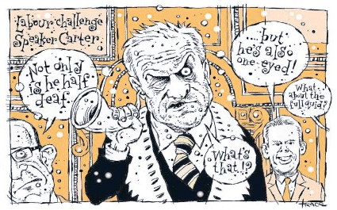

- In New Zealand, Deputy Speaker Hon Chester Borrows on 11 November 2015 delivered a ruling that questions of privilege arise from comments made by the Labour Party’s leader (Andrew Little), and by its senior whip (Chris Hipkins), and reported in newspapers, that may constitute a reflection on the Speaker in his capacity as Speaker. The Labour Party MPs’ comments followed a ruling made by the Speaker, Rt Hon David Carter, on 15 October 2015, that a member’s Bill (the Healthy Homes Guarantee Bill (No 2) in Andrew Little’s name) will be out of order for infringing the “same question rule” (2014 Standing Order 264) if that Bill’s first reading occurs in the House before 2016. This is because “the purpose and effect of the Bill are the same in substance as [another, earlier, member’s Bill,] the Healthy Homes Guarantee Bill [in the name of Phil Twyford], which was defeated [60−60] at its first reading on 18 March 2015”. Since March 2015, the Northland by-election may, some consider, have shifted numbers in the House so that there may be a majority in favour of Mr Little’s Bill. In ruling that questions of privilege arise, Hon Chester Borrows said “allegations that the Speaker acts on the instruction of the Government and interferes in parliamentary process for political reasons are serious matters that suggest that the Speaker is not only biased in performing his duties but is open to partisan manipulation.… It is for the Privileges Committee to determine whether such comments amount to contempt.” The Privileges Committee said in a report it made in September 2015 that “Reflections on the Speaker have been censured in New Zealand on only six occasions, the last of which was in 1998. [2014] Standing Order 410(o) has therefore been used only on rare and serious occasions. The rules about reflections on members have constitutional significance, and there is no evidence that they are being misapplied to inhibit the free speech of members, the media, or the public. Accordingly, we believe that the rules should be retained in their current form.” One commentator suggests the Privileges Committee, rather than recommending that the House fine Mssrs Little and Hipkins each a fine up to $1000, will instead recommend the House require them to apologise to the House for their comments.

Membership

New CALC members
The following have been recorded as members of CALC from June 2015.

Name |  | Country
Miller, Jacquie |  | UK
Ali, Abid |  | Pakistan
Griffiths, Ffion |  | Wales
Msiska, William Yakuwawa |  | Malawi
Jarvis, Susan |  | Antigua
Leonard, Goh Choon Hian |  | Singapore
Makoto, Hong Cheng |  | Singapore
Brady, Hugh L |  | USA
Kitegi, Mary Awuor |  | Kenya
Powderly, Liza Maree |  | Australia
Ryan, Ellie |  | Australia
Helfrich, Helen |  | Isle of Man
Hang, Tay Li |  | Singapore
Geldart, Joanne Susan |  | Isle of Man
Owen, Peter William |  | New Zealand
Wilson, Kylie Chanel Ivonne |  | Samoa
Hakai, Lizatalei |  | Samoa
Viliamu, Mearold Solofa |  | Samoa
Clifford, Marion June |  | New Zealand
Aiono, Titilua |  | Samoa
Bond, Joann |  | Guyana
Mndzebele, Gcinaphi Phumelele |  | Swaziland
Horsford, Keri Natasha |  | Anguilla
Goulburn, Vivienne |  | United Kingdom
Sirame, Irene |  | Seychelles
Sefo, Terina |  | Samoa
Taub, Liron |  | Canada
Bittman, Simone |  | Canada
Fernbach, Andrew |  | Australia
Enright, Donal |  | Ireland
Sheridan, Norman |  | UK
Whitehead, Richard |  | Jersey
Sitali, Masiliso |  | Zambia

Secretary Contact Details
If you wish to contact the CALC Secretary, Ross Carter, regarding membership or other CALC matters (for example, to suggest or send items or ideas for this CALC Newsletter), his email address is:
ross.carter@parliament.govt.nz

Alex Gordon is a Parliamentary Counsel at, and member of, the Parliamentary Counsel Office in Edinburgh. He is one of the original members of PCO having been in the office since the Scottish Parliament was established in 1999. From 1997 to 1999, Alex worked at the now-disbanded Lord Advocate’s Department in London. From 1990 to 1997, he was in the Prosecution Service in Scotland. Alex is qualified as a solicitor in Scotland. He studied law at Glasgow University from 1985 to 1990.
A History of Britain (Series 2 (BBC, broadcast 2001)). The quotation does not appear in Schama’s book on which the programme is based.
Thring’s Practical Legislation: The Composition and Language of Acts of Parliament and Business Documents Lord Thring KCB, edited by Madeleine MacKenzie and David Purdie (3rd edition, Edinburgh, Luath Press 2015), 108 pages, £7.99. Reviewed by Ronan Cormacain (2015) 3(1) The Theory and Practice of Legislation 131−133: http://www.tandfonline.com/doi/full/10.1080/20508840.2015.1044238, and by Daniel Greenberg (2015) 36(3) Statute Law Rev 308−309: http://slr.oxfordjournals.org/content/36/3/308.full.pdf+html.
Editor: Alex Gordon cheerfully credits, and thanks warmly, John McCluskie for supplying these next few paragraphs of text! Alex says: “If you ever meet him, you can ask John McCluskie about including ‘knowingly’ in connection with ‘permit’ and favouring an un-split infinitive in ‘knowingly to permit’ (see the ‘no smoking’ sign). He enjoys these things.”
Editor: See The Prohibition of Smoking in Certain Premises (Scotland) Regulations 2006, reg 3(3)(c) (definition of “substantially enclosed”): http://www.legislation.gov.uk/ssi/2006/90/pdfs/ssi_20060090_en.pdf. Compare, in New Zealand, the Smoke-free Environments Act 1990 (NZ), s 2, concepts of “open area” and “internal area”, which involve “substantially enclosed” (not itself defined), and are illustrated in Cancer Society of New Zealand Inc v Ministry of Health [2013] NZHC 2538: http://www.nzlii.org/nz/cases/NZHC/2013/2538.pdf. See also the newspaper story at http://www.stuff.co.nz/national/health/73611713/wellington-cafe-fined-1850-for-putting-a-roof-on-its-outdoor-smoking-area.html
Editor: Lord Hope of Craighead, HL Hansard, 24 June 2014, 24 Jun 2014 : Column 1219: http://www.publications.parliament.uk/pa/ld201415/ldhansrd/text/140624-0003.htm#14062472000279
A brief background to the Falkland Islands revised laws project was given in Ross Carter’s July Loophole article; “Revising our Statute Books - Developments and Prospects in New Zealand”: http://www.opc.gov.au/calc/docs/Loophole/Loophole_Jul15.pdf.
http://www.news.gov.hk/en/categories/admin/html/2015/09/20150909_103341.shtml
http://www.rugbyworldcup.com/
Sale and Supply of Alcohol (Rugby World Cup 2015 Extended Trading Hours) Amendment Act 2015: http://www.legislation.govt.nz/act/public/2015/0069/latest/DLM6559202.html
http://www.allblacks.com/Teams/Haka
Haka Ka Mate Attribution Act 2014: http://www.legislation.govt.nz/act/public/2014/0018/latest/DLM5954403.html
http://www.pco.parliament.govt.nz/consultation-cclb/
http://beehive.govt.nz/release/consultation-contract-and-commercial-law-bill-begins
http://www.publications.parliament.uk/pa/ld201516/ldhansrd/index/151026.html#start_grand
George Eaton, “House of Lords defeats the government over tax credit cuts”, New Statesman, 26 October 2015: http://www.newstatesman.com/politics/uk/2015/10/house-lords-defeats-government-over-tax-credit-cuts See also the analysis of A. Tucker, ‘Tax Credits, Delegated Legislation, and Executive Power’ UK Const. L. Blog (5th Nov 2015) (available at http://ukconstitutionallaw.org/)), http://www.theguardian.com/politics/2015/nov/05/george-osborne-can-find-44bn-without-cutting-tax-credits-says-thinktank, http://www.lrb.co.uk/v37/n22/martin-loughlin/short-cuts, and R. B. Taylor, 'The House of Lords and Constitutional Conventions: The Case for Legislative Reform' U.K. Const. L. Blog (16th Nov 2015) (available at http://ukconstitutionallaw.org/))
PCO’s Access to Subordinate Instruments Project (ASIP): http://www.pco.parliament.govt.nz/pco-news
See, for example, the Regulations Review Committee’s remarks in its 2 November 2015 report on the Subordinate Legislation Confirmation Bill (28—2) : “We support the recently announced Access to Subordinate Instruments project in the Parliamentary Counsel Office. This project aims to develop the office’s systems so that all delegated legislation is available on the New Zealand Legislation website. This is a considerable project that will improve accessibility to the law. We look forward to receiving updates as the project progresses and providing our own input and expertise where necessary.”: http://www.legislation.govt.nz/bill/government/2015/0028/latest/d56e2.html
http://www.ssc.govt.nz/sites/all/files/pif-review-pco-nov14.PDF
http://www.dia.govt.nz/Government-Inquiry-into-Whey-Protein-Concentrate-Contamination-Incident
http://parliamenttoday.co.nz/2015/11/little-hipkins-sent-to-privileges/
http://m.nzherald.co.nz/nz/news/article.cfm?c_id=1&objectid=11529723, http://www.stuff.co.nz/national/politics/73059699/Labour-accuses-Speaker-of-massive-political-interference-over-veto-move
http://www.parliament.nz/en-nz/pb/debates/debates/51HansD_20151015_00000016/speaker%E2%80%99s-rulings-%E2%80%94-healthy-homes-guarantee-bill-no-2%E2%80%94compliance http://www.parliament.nz/en-nz/pb/debates/debates/51HansD_20151015_00000024/points-of-order-—-healthy-homes-guarantee-no-2-bill—compliance
http://www.parliament.nz/en-nz/pb/legislation/bills/00DBHOH_BILL66216_1/healthy-homes-guarantee-bill-no-2
http://www.parliament.nz/en-nz/pb/legislation/bills/00DBHOH_BILL12828_1/healthy-homes-guarantee-bill http://www.parliament.nz/en-nz/pb/debates/debates/51HansD_20150318_00000032/healthy-homes-guarantee-bill-—-first-reading
http://www.parliament.nz/resource/en-nz/51DBSCH_SCR65874_1/7df216643c8246cac53db601f86f39e375363bc2 at p 10.
http://www.parliament.nz/en-nz/about-parliament/how-parliament-works/ppnz/00HOOOCPPNZ_471/chapter-47-contempt#_Toc266975063
http://pundit.co.nz/content/can-bias-be-in-the-eye-of-the-beholder-and-can-you-call-it-like-you-see-it
Parliamentary Privilege Act 2014 (NZ), s 22: http://www.legislation.govt.nz/act/public/2014/0058/latest/DLM6136743.html

